GEF-8 REquest for FSP and MSP (2-steps) CEO Endorsement/Approval


TABLE OF CONTENTS

General Project Information 3
Project Summary 3
Project Description Overview 4
project outline 9
A. Project Rationale 9
A.1. Country context 9
A.2. Problem Statement 10
Drivers and root causes of climate vulnerability 10
A.3. Preferred solutions and associated baseline situation 21
A.4. Barriers to the implementation of the preferred solution 24
B. Project Description 26
B.1. Changes between the PIF and the PPG phase 26
B.2. Project’s Strategy 29
B.3. M&E plan 47
B.4. Institutional Arrangement and Coordination with Ongoing Initiatives and Project. 47
B.5. LDCF Core Indicators 52
B.6. Risks to Project Implementation 53
C. Alignment with GEF-8 Programming strategies and country/regional priorities 55
D. Policy requirements 56
D.1. Gender Equality and Women’s Empowerment: 56
D.2. Stakeholder Engagement 56
D.3. Private Sector 57
D.4. Environmental and Social Safeguards 57
E. Other requirements 57
E.1. Knowledge management 57
E.2. Socio-economic Benefits 57
Annex a: FINANCING TABLES 58
GEF Financing Table 58
Project Preparation Grant (PPG) 58
Sources of Funds for Country STAR Allocation 58
Focal Area Elements 58
Confirmed Co-financing for the project, by name and type 58
ANNEX b: EndorsementS 61
Compilation of Letters of Endorsement 61
ANNEX C: Project results framework 62
ANNEX D: status of utilization of Project Preparation Grant (PPG) 71
annex E: project map and coordinates and detailed description of the conditions in the target counties 72
ANNEX F: Environmental and Social Safeguards documents including Rating 80
ANNEX G: Budget Table 81
ANNEX H: Comment Audit Trail 91

General Project Information
Project Title: | Strengthening agricultural resilience through transformational livelihood adaptation in Liberia (SARTLA)
Region: | Africa | GEF Project ID: | 11447
Country(ies): | Liberia | Type of Project | Full-Sized Project
GEF Agency(ies): | UNDP | GEF Agency Project ID: | 9672
Project Executing Entity(s) and Type: | Environmental Protection Agency (EPA) | Government
GEF Focal Area(s): | Climate Change | Submission Date:
Type of Trust Fund: | LDCF | Project Duration (Months) | 60
GEF Project Grant: (a) | 8,932,420 | GEF Project Non-Grant (b)
Agency Fee(s) Grant: (c) | 848,580 | Agency Fee(s) Non-Grant: (d)
Total GEF Financing: (a+b+c+d) | 9,781,000 | Total Co-financing: | 104,688,106
PPG Amount (e): | 200,000 | PPG Agency Fee(s) (f): | 19,000
Total GEF Resources (a+b+c+d+e+f) | 10,000,000
Project Tags: | CBIT NGI SGP Innovation
Project Sector  (CCM only) | Climate Change adaptation sector
Rio Markers
- Climate Change Mitigation | No Contribution (0) Significant Objective (1) Principal Objective (2)
- Climate Change Adaptation | No Contribution (0) Significant Objective (1) Principal Objective (2)
- Biodiversity | No Contribution (0) Significant Objective (1) Principal Objective (2)
- Land Degradation | No Contribution (0) Significant Objective (1) Principal Objective (2)

Project Summary
Liberia’s smallholder fishers and farmers are experiencing increasing climate change related risks to their livelihoods. Flooding of agricultural land after heavy rainfall events, especially in combination with high average temperatures and the occurrence of extreme heat spells are a direct cause of post-harvest losses and the occurrences of crop pests and diseases. Marine heatwaves, and coastal storm surges lead to a deterioration of fish stock, coastal erosion and coastal flooding. These hazards are projected to increase in frequency, intensity and duration. The capacity of smallholder farmers and fishermen and micro, small and medium sized enterprises (MSME’s) in agriculture and fishery to absorb or overcome climate related damages, or to reduce climate related risks is low. Land, forest and coastal degradation, inadequate extension services, limited infrastructure and insufficient financial incentives and mechanisms have namely already held back smallholder agriculture and fishery sectors in terms of production, value chain development and sustaining livelihoods and food security. Alternative livelihood options in sustainable ecotourism for example are still underexplored. The project’s objective is ‘building climate resilience in natural-resource dependent rural communities of Liberia through systems-based, transformational adaptation in the agricultural, fisheries and ecotourism sectors.’ It will increase smallholder adaptive capacity by restoring natural resources, strengthening extension services, strengthening access to finance, and strengthening sustainable value chains. It will employ a combination of interventions that focus on i) the adoption of resilient and regenerative practices among farmers and fisherfolks to improve productivity while at the same time reducing environmental impacts, ii) linking local livelihoods to sustainable value chains, developing alternative livelihood strategies such as those linked to eco-tourism, and fostering market access through business skill training, and iii) providing an enabling innovative finance environment that fosters private sector engagement, links actors along the value chain and scales the development of sustainable enterprises based along the value chain. The project is expected to bring 3640 ha of land and coastal areas under improved management for climate resilience, to train or make aware an overall of 81,800 people in the seven target counties of climate change impacts and appropriate adaptation responses, mobilize 500.000 (US$) investment from private sector sources and incubate or accelerate 30 MSMEs enterprises engaged in climate change adaptation and resilience action with technical assistance, financial matchmaking, and/or direct financing.

Project Description Overview

Project Objective: | Building climate resilience in natural-source dependent rural communities of Liberia through system-based, transformational adaptation in agricultural, fisheries and ecotourism sectors  Indicators and targets (mid-term; end of project targets):  Mandatory Indicator 1: # direct project beneficiaries disaggregated by gender (individual people): [33,153 (14,466 men and 18,687 women); 99,460 (43,400 men and 56,060 women i.e 56.36% of women)]  Indicator 2: LCDF Core indicator 2: Area of land/coastal or marine area managed for climate resilience (hectares): (800 ha; 3,640.00 ha)  Indicator 3: LCDF Core indicator 3: Total number of policies, plans, and frameworks that will mainstream climate resilience  Sub indicators:  - 3.4 Number of institutional partnerships or coordination mechanisms established or strengthened: (1; 3)  Indicator 4: LCDF Core indicator 4: Number of people trained or with awareness raised  Sub indicators:  - 4.1 Number of people trained or made aware of climate change impacts and appropriate adaptation responses (sex disaggregated) at different target groups): [40,900 (18,400 men and 22,500 women); 81,800 (36,800 men and 45,000 women)]  Indicator 5: LCDF Core indicator 5: Number of private sector enterprises engaged in climate change adaptation and resilience action  Sub indicators:  - 5.1 Amount of investment mobilized (US$) from private sector sources: [0; 500,000 USD (non-grant financing secured)]  - 5.4 Number of MSMEs incubated/accelerated with technical assistance, financial matchmaking, and/or direct financing: (7; 30)
Project Components | Component  Type | Project Outcomes | Project Outputs | Trust Fund | (in $)
 |  |  |  |  | GEF Project Financing | Co-financing
Component 1: Investment in conserving the agro-ecological landscape and food production systems | Technical assistance | Outcome 1 Improved management of the agro-ecological landscape and climate resilient food production technologies for farmers and fishers  Indicator 6:  2.1 Hectares of agricultural land managed for climate resilience: (200 ha; 1,140 ha)  2.4 Hectares of forests managed for climate resilience (100 ha; 500 ha)  2.6 Hectares of freshwater area (wetlands): (500 ha; 2,000 ha)  Indicator 7:  Number of farmers and fishermen trained in sustainable and climate resilient land and fishery production and management practices either directly or through improved extension services: (100 farmers, 50% women, directly and 200 farmers, 50% women, through improved extension services; 50 fishermen and 100 fishermen through extension services) | Output 1.1. Comprehensive land use plan developed in the agroecological landscapes to guide the coordination and implementation of nature-based solutions and climate resilient food production | LDCF | 461,500 | 5,408,788
 | Technical assistance |  | Output 1.2: NbS is implemented on 1000 ha of degraded forest and 600 ha of wetland ecosystems to safeguard ecosystem services | LDCF | 1,180,000 | 13,829,619
 | Technical assistance |  | Output 1.3. Sustainable and climate-resilient agriculture and fisheries systems established in vulnerable rural communities through capacity-building, demonstration projects, and community-led adaptation strategies. | LDCF | 535,000 | 6,270,209
 | Technical assistance |  | Output 1.4. Extension services are enhanced and extension workers’ capacity is built for NbS and Climate-Resilient Livelihoods in Fisheries and Agriculture | LDCF | 212,000 | 2,484,643
 | Technical assistance |  | Output 1.5. A communication strategy is developed and implemented for disseminating best practices and lessons learned from the project | LDCF | 334,000 | 3,914,485
Component 2: Livelihoods and value chain development | Technical  assistance | Outcome 2. Alternative, climate-resilient livelihoods, including ecotourism, supported by improved market access and value-added services in agricultural and coastal areas  Indicator 8:  Number of individual entrepreneurs or cooperatives that are making use of the agricultural or fishery business hubs (incl. skills trainings, etc.): (0, 1,000)  Indicator 9:  % increase in income for women and youth led eco-tourism businesses: (10% for both youth and women,30% for both youth and women) | Output 2.1 Sustainable climate-resilient livelihoods and agricultural and fisheries value chains and enterprise development in target communities through provision of training and start-up inputs | LDCF | 2,426,500 | 28,438,619
Component 2: Livelihoods and value chain development | Technical  assistance |  | Output 2.2 Alternative livelihoods including ecotourism established (with participation of at least 50% women) and linked with agricultural and fisheries value chains | LDCF | 821,000 | 9,622,133
Component 3: Innovative finance | Technical  assistance | Outcome 3 Innovative financing architecture incentivizes private sector investment in climate-resilient agricultural technologies, livelihoods, and enterprises  Indicator 10:  Number of calls launched via the private sector engagement facility: (2, 5)  Indicator 11:  Number of partnerships established with larger commercial, agro-processing and ecotourism operators: (2, 5) | Output 3.1. Establishment of private sector engagement facility with new funding windows opened under UNDP Growth Accelerator Platform | LDCF | 1,396,000 | 16,361,143
Component 3: Innovative finance | Technical  assistance |  | Output 3.2. Partnerships established between private sector (MSMEs cooperatives) partners, communities and other stakeholders for Access to Markets and Access to Finance | LDCF | 443,500 | 5,197,827
 |  |  | Output 3.3. Partnerships established with larger commercial agriculture, agro-processing, and ecotourism corporations for climate resilient livelihoods |  | 450,500 | 5,279,867
M&E** | Technical  assistance | M&E | M&E | LDCF | 250,000 | 2,930,004
Subtotal |  |  |  | LDCF | 8,510,000 | 99,737,337
Project Management Cost (PMC)*** (if this is an MTF project, please report separate PMC lines for each TF). ***If amount requested is above limits, a pop-up menu should open for the Agency to provide an explanation*** |  |  |  | LDCF | 422,420 | 4,950,769
Total Project Cost |  |  |  |  | 8,932,420 | 104,688,106

project outline

Project Rationale

Country context
Liberia is located on the Atlantic Coast of West Africa, with a population 5.25 million people by 2022 and an area of 111,369 km2. Approximately 53% of the population currently lives in urban areas, growing at a rate of 3.0% per year, and approximately 70% or the population lives in coastal areas. Despite considerable development efforts, 52.3% of Liberia’s population is classified as multidimensionally poor, with an additional 23.3% at risk of such poverty. In rural areas the poverty rate is close to 72%.
Liberia experiences a predominantly equatorial climate and is one of the world’s wettest countries with consistently warm temperatures year-round. Due to its geographic location and ecosystem conditions, Liberia is exceptionally biodiverse thanks to hosting about 50% of the remaining Upper Guinean dense forest within its borders, and counting numerous Ramsar sites. Liberia’s beaches provide important habitat and nesting grounds for sea turtles (including four endangered species) and other species.
About 70% of the Liberian population is engaged in agriculture, fisheries, and forestry, together accounting for 36.2% of GDP in 2022. The fisheries sector alone provides nearly 65% of the animal protein needs of the country and represents 3.2% of the GDP. Approximately 86% of the total capture is from marine fisheries while the remaining 14% of fisheries occur inland and through aquaculture. In 2022, 30.2% of Liberian households were engaged in agriculture - 76.1% were engaged in crop production, 11.7% in aquaculture, 8.1% in livestock, and 4.1% in poultry.
Despite having a rich endowment of natural resources and enough fertile land and fishing grounds to drive economic growth, land, forest and coastal degradation, inadequate extension services, limited infrastructure and insufficient financial incentives and mechanisms have led to underperforming smallholder agriculture and fisheries in terms of production, value chain development and sustaining livelihoods and food security.
Liberia’s economic sectors and households are moreover highly exposed to climate change. Coastal and riverine floodings and coastal erosion due to sea-level rise and increase intensity and frequency of storm surges have resulted in increased rates of inundation, erosion, and other coastal hazards that threaten coastal settlements, infrastructure, and health and sanitation in communities like West Point, Monrovia, Robertsport, and Harper. Liberia’s coastlines are characterized by the presence of numerous informal settlements where livelihoods and living areas of households are at direct and increasing risk from climate change. Fish stocks are at high risk of being negatively affected by rising ocean temperatures, and the physical environment is being degraded by storm surges and compound flooding. The IPCC’s 6th Assessment Report projects and reconfirms that West Africa will be one of the regions most affected by climate change. In the future, Liberia will likely experience higher temperatures and more extreme heat, an increased incidence of extreme precipitation events and associated flooding. Coastal zones will experience further sea-level rise, coastal erosion and flooding.
Poorly regulated human activities have significantly degraded the country’s ecosystems. Ecosystems are currently under threat from construction purposes, road building, landfill, fuel wood collection, mining and urban expansion, and pollution. Climate change is contributing to further shrinking the resource base that underpins livelihoods for both farmers and fishermen. Degraded lands and coastal areas are moreover extremely vulnerable to any additional physical stressors coming from climate change, and in particular to extreme weather events.

Problem Statement
The country’s economic dependence on natural resources and the high level of poverty makes it particularly sensitive to adverse climate change impacts, particularly in coastal zones, and in agriculture, and fishery sectors. The ND-GAIN index classified Liberia as highly vulnerable to climate change ranking in 177 out of 185 countries, with the country’s low level of adaptive capacity a major contributing factor.
The capacity of smallholder farmers and fishermen to absorb or overcome climate related damages, or to proactively plan to reduce climate related risks is particularly low. Households in rural areas and informal coastal settlements have low literacy rates and are typically poor, resulting in having little knowhow, tools and material at their disposal to reduce their physical exposure to flooding, storm surges or extreme heat or to engage in alternative income opportunities other than low input and often rudimentary fishing and farming. Smallholders face numerous challenges, including lack of fertilizer; poor breeding stock; and inadequate irrigation, extension services, credit, machinery, transport, storage, and marketing infrastructure. Severe weather conditions, including heavy rains, exacerbate these weaknesses, damaging roads and facilities, restricting market access, and causing post-harvest losses.
Women are particularly vulnerable to climate change due to their critical roles in agriculture and fisheries. Approximately 80% of the agricultural labor force is led by women and they are responsible for 93% of food production. As the gender analysis highlights, women face higher disparities due to higher rates of illiteracy, gender and social norms that prevent and limit women’s access to land, economic resources, financial instruments, and more generally education. The combination of women’s heavy involvement in subsistence farming, and their limited control over key decisions such as land use, crop choice, and income distribution, women become more vulnerable to environmental impacts. It is estimated that 30% of agricultural households are headed by women. This has significant implications for the allocation of resources, access to agricultural inputs, and the prioritization of farming activities especially.

Drivers and root causes of climate vulnerability
The following underlying drivers and causes of vulnerability can be identified in the Liberian context:
Population increase: Liberia’s population increased from 3,476,608 in 2008 to 5,250,187 in 2022. A growing population combined with a high dependency on natural resources and the lack of alternative livelihood opportunities adds pressure to the available natural resources and contributes directly to environmental degradation.
Environmental degradation: Unplanned urbanization and the expansion of logging, mining and agriculture has led to an increase of deforestation, mangrove destruction and unsustainable practices, as well as forest degradation and fragmentation. In 2021, 90% of the rural households in Liberia used wood for cooking, which had contributed to deforestation and forest degradation (including mangrove forest degradation). Nearly every coastal community has a sand pit and engages in beach sand mining. This is causing coastal erosion, shoreline recession and associated loss of land. The uncontrolled dumping and burning of garbage are common as a form of final disposal throughout the country. Apart from generating emissions these practices negatively impact human health and pollute the nearby ocean, thereby affecting coral reefs and mangroves and affecting the livelihood of Liberians whose livelihoods are directly and indirectly linked to fishing and eco-tourism. Toxic substances from mining activities, pesticides and agrochemicals from farming, and untreated or poorly treated industrial waste are discharged into Liberia’s water bodies and soil. Dependence on firewood is a major cause of deforestation in most parts of Liberia, including in all the 7 target counties of this project, while burning of agricultural waste biomass (as a practice to clear the land for next sowing season) is a key source of air pollution and fire hazard in the target counties which also leads to land degradation
Poverty is a significant background factor contributing to climate change vulnerability in Liberia. More than half of the population lives in poverty, with almost 40% of the population experiencing food poverty or some type of income insecurity. In addition, the rate of extreme poverty in rural areas is significantly higher than in urban areas. The population in urban areas in Liberia reached 54.5% in 2022, while the rural population represented 45.5%.
Limited adaptive capacity: Small scale producers and cooperatives lack access to finance, loan and micro-credit scheme and find it difficult to access traditional financial services due to their unstable income, the seasonal nature of their business and the lack of sufficient collateral. Lack of technical capacities and knowledge. According to a 2021 study, less than 30% of Liberia’s population is climate change literate.
Note
Unfavorable agricultural and fisheries policies: Liberia’s agricultural policies have historically favored large concessions and traditional practices. Vast tracts of land were allocated to foreign agribusiness and logging concessions, leading to extensive deforestation and land grabs. The concession-oriented strategy had as a side effect that communities lost access to land and forests, driving them into unsustainable practices such as slash-and-burn cultivation. Inadequate extension services and limited access to credit, make it hard for smallholders to adopt new sustainable techniques. Looking at the fisheries sector, although a Fisheries Law and regulations exist (updated in 2019), enforcement has been weak. Industrial vessels (often foreign owned) have operated with insufficient oversight, depleting fish stocks that coastal communities rely on. Unsustainable overfishing has led to persisting conflicts between artisanal fishers and industrial fleets over access to coastal waters and resources.
Historical trends and climate projections
Due to the country’s geographical characteristics, Liberia has identified coastal and riverine floodings; coastal erosion; and sea-level rise as serious climate-related hazards risks which are already proving challenging today. In the future, the country will likely also experience higher temperature and more extreme heat; increased incidence of extreme precipitation events and associated flooding; while coastal zones will likely be adversely affected by increasing ocean temperatures; coastal erosion and flooding; and relative sea level rise (c.f. Figure 1). The historical climate trends and future projections in terms of climate-impact drivers are further detailed below.
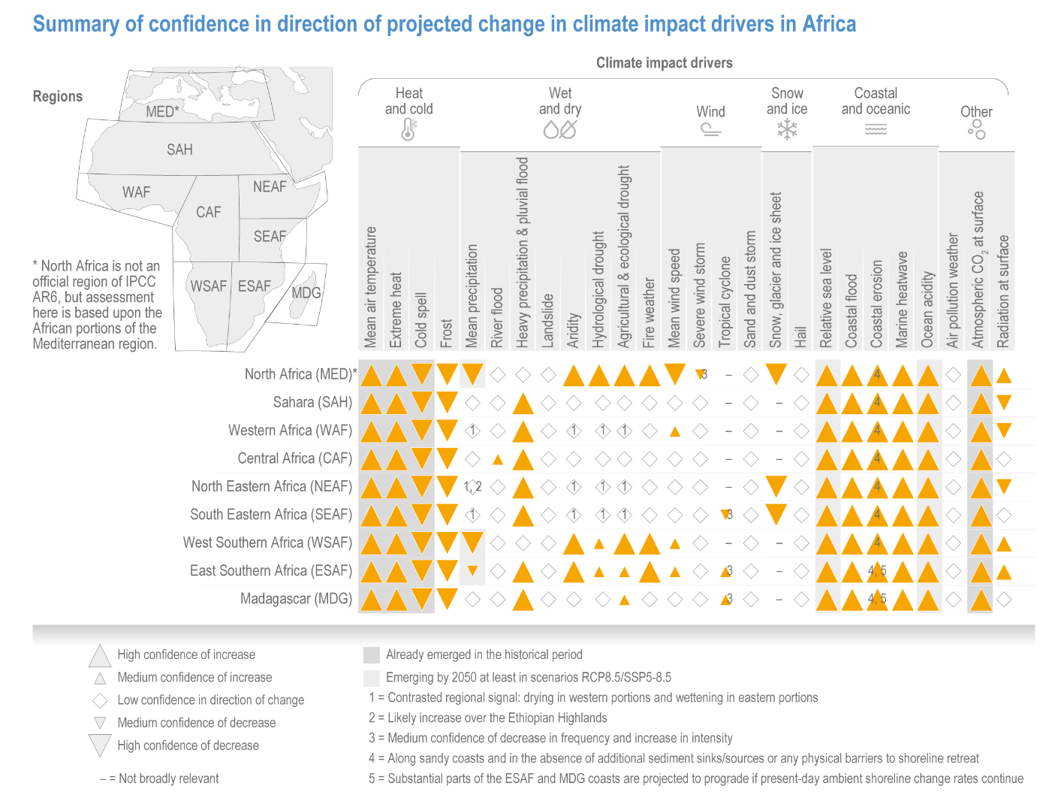
Figure 1. Summary of confidence in direction OF projected change in climate impact drivers in Africa, taken from IPCC AR6 WGII

Mean air temperature and extreme heat – Liberia has historically experienced a Tropical Monsoon Climate, with an average mean surface air temperature of approximately 25.1°C over the 1991-2020 period. Between 1960 and 2006, the mean annual temperature has increased by approximately 0.8°C, at an average rate of 0.18°C per decade.
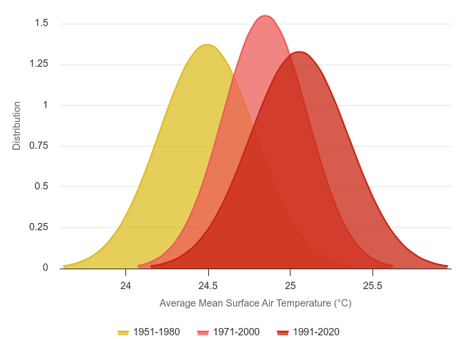
Figure 2. Distribution of historical 30 years average mean surface air temperatures in Liberia
Liberia will likely experience an increase in mean air temperatures of 1.5°C between 2040 and 2059 under SSP2-4.5, up to approximately 2°C under SSP5-8.5, with respect to the 1995-2014 baseline period. Warming rates are expected to be higher and most rapid in the northern inland regions as opposed to the coastal zones.
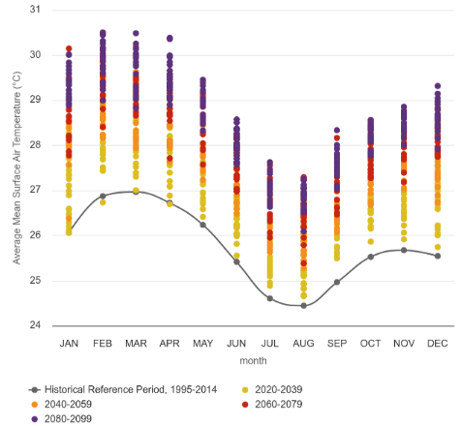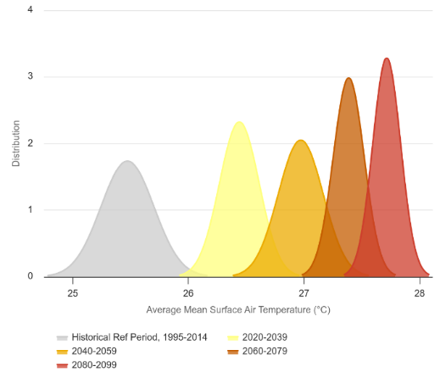
(a)
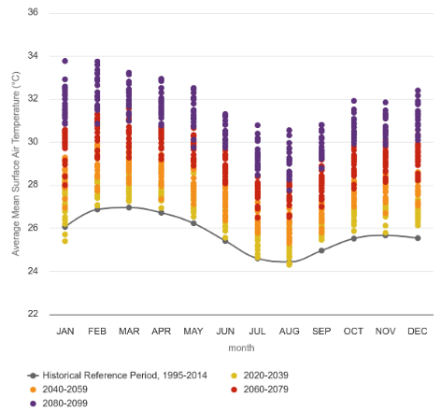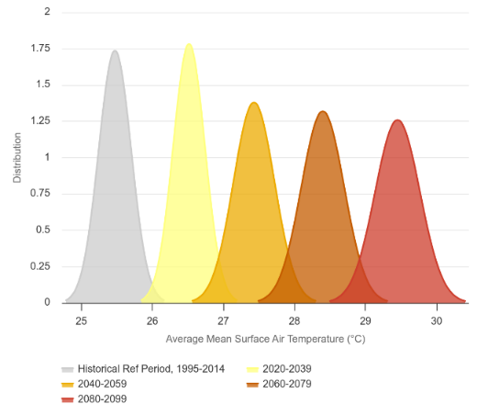
(B)
Figure 3. Projected mean temperature Change under SSP2-4.5 (a) and SSP5-8.5 (b)
In terms of extreme heat, during the historical period (1995-2014) there were on average less than one day per year with extreme heat index >35°C. Climate projections, however, suggest that extreme heat days will increase significantly across the country, with the Northern, Western, and some Eastern areas of the country expecting the most drastic changes. Hotter seasons are also projected to start earlier and end later.
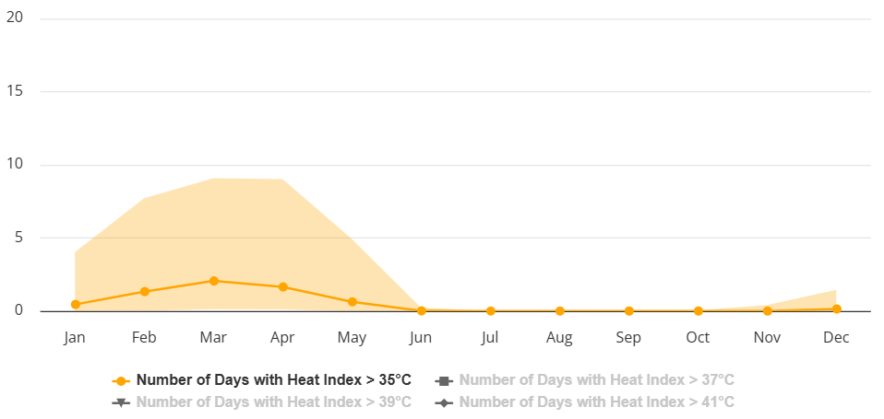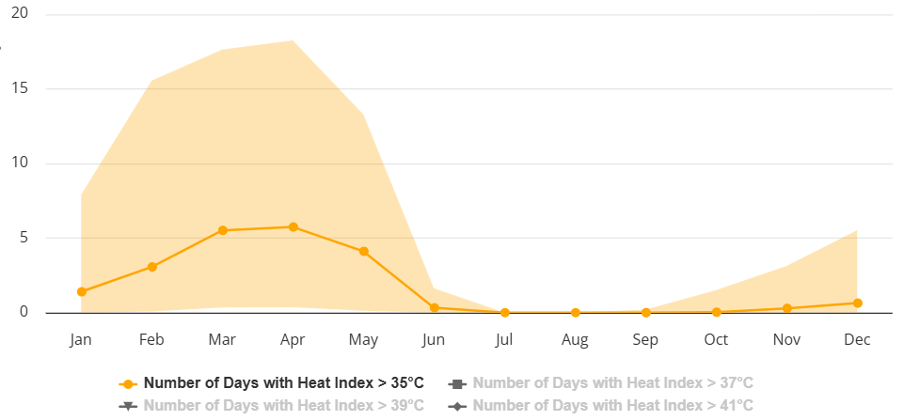
Figure 4. Projected Number of Days w/ Heat Index >35°C, 2040-2059, Liberia – SSP2-4.5 (left) & SSP5-8.5 (Right)
Mean precipitation - Liberia is one of the wettest countries in the world, with the heaviest rainfall occurring from May to October, and the peak rainfall occurring from June to September. The country’s average annual rainfall is 2,467mm. Rainfall is highest along the coast but decreases towards Liberia’s interior plateaus and low mountains. Moreover, Southern areas of the country receive rain year-round, while the rest of the country experiences two seasons due to the West African Monsoon. Between 1971 and 2020 some Counties experienced significant increases in precipitation per decade, while others experienced decreases. The counties on the coast were significantly wetter in Summer and Fall months, such as Montserrado County, which observed an increase of ~76mm per decade during Summer months and a general increase of ~51mm precipitation per decade, while Grand Kru County observed an increase of ~40mm per decade during Fall months. On the other hand, Winter months were significantly drier further South. Maryland County observed a decrease of ~36mm precipitation per decade during Winter months. During Spring, Central and Northern Counties were drier such as Lofa, which observed a decrease of ~35mm per decade during these months and an average annual decrease of ~72mm per decade.
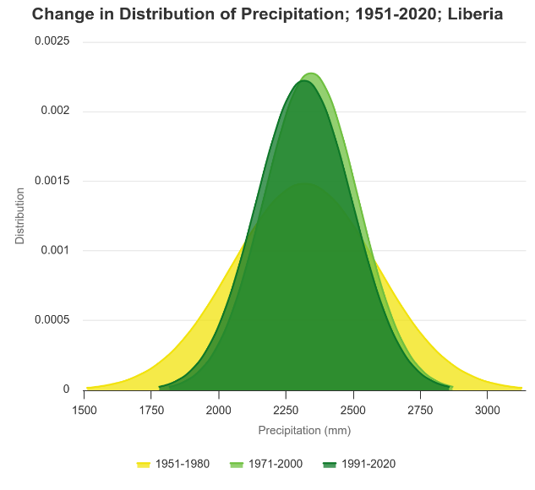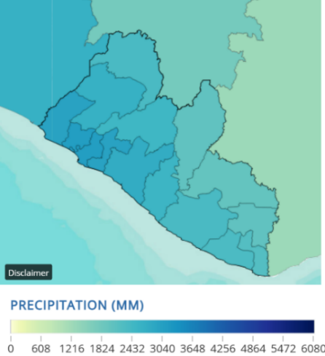
Figure 5. Distribution of 30-year avG precipitation (left) and Observed precipitation 1991-2020 (right)
Changes in average annual rainfall in Liberia by the 2040-2059 period, with respect to the historical reference (1995-2014) (c.f. Figure 6), is uncertain. When looking at projected changes as percentages, model projections present a range of possible futures, without any significant signal in any specific direction.
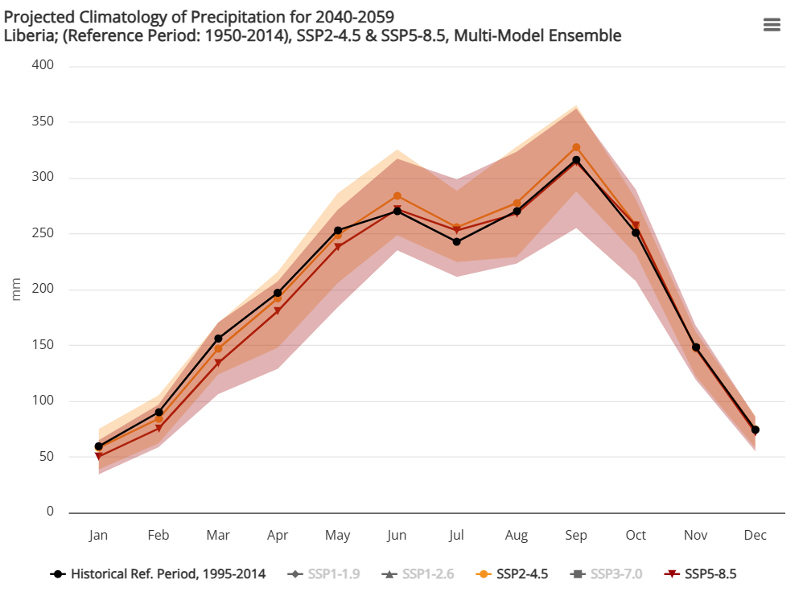
Figure 6. Projected Climatology of Precipitation under SSP2-4.5 & SSP5-8.5 for Liberia
Heavy precipitation and pluvial flood – Floods have historically been among of the most frequent natural hazards in Liberia, which occur during rainy seasons (i.e. are therefore pluvial floods – associated directly with intense precipitation events), and are costly in terms of both human and economic loss. Riverine flood risks in particular are high throughout Liberia and impacts have worsened in recent years. In 2017 alone, more than 100,000 people were affected by floods in the country.
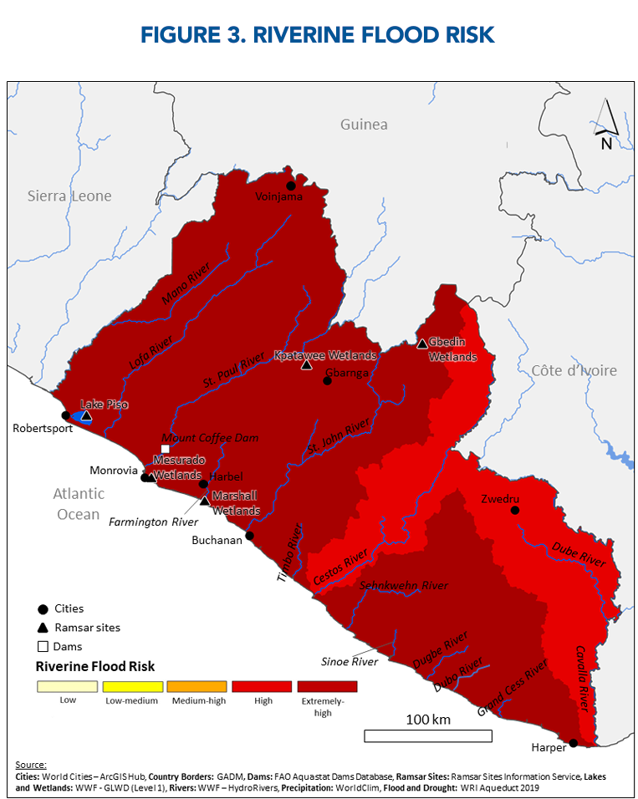
Figure 7. Current (2019) Estimated Riverine flood risk

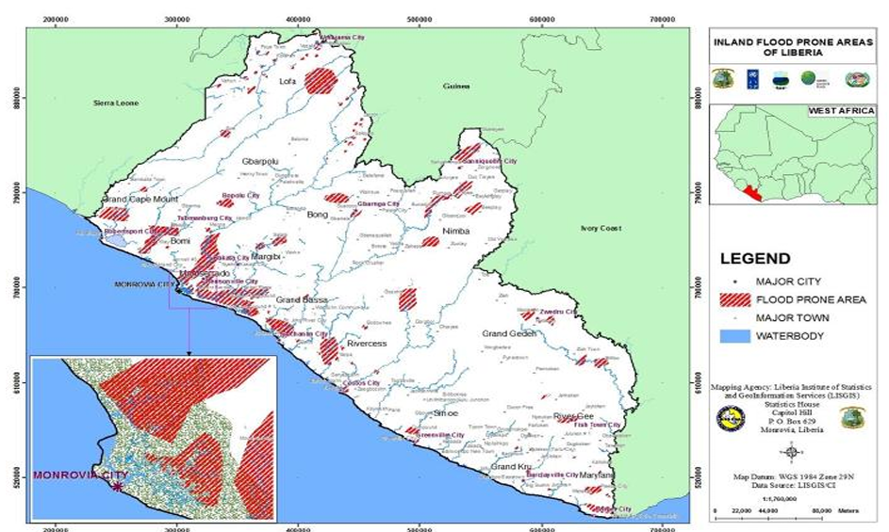
Figure 8. Flood-Prone Areas of Liberia (2019)

Increased flooding poses one of the greatest natural hazard risks in Liberia because its extensive hydrographic network, which makes the country highly vulnerable to flooding after heavy rainfall. As such, despite little change projected for average annual rainfall in Liberia, an increase in extreme rainfall intensity is expected by mid-century, meaning that the precipitation will be more likely to be concentrated in extreme events. The most significant changes are projected between June and September (c.f. Figure 9), and are more important in the northern parts of the coastal zone. Similarly, when looking at changes in the return period of the largest 5-day cumulative precipitation, 10-year events become significantly more frequent (c.f. Figure 10), thereby increasing the risk of pluvial flooding in many parts of the country.
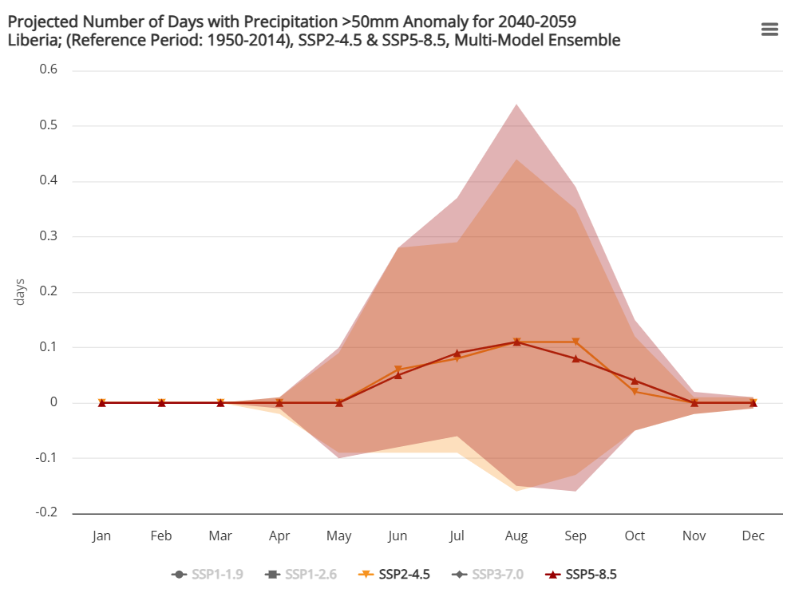
Figure 9. Number of Days w/ Precipitation >50mm under SSP2-4.5 & SSP5-8.5, 2040-2059 Anomaly From 1995-2014 Period for Liberia

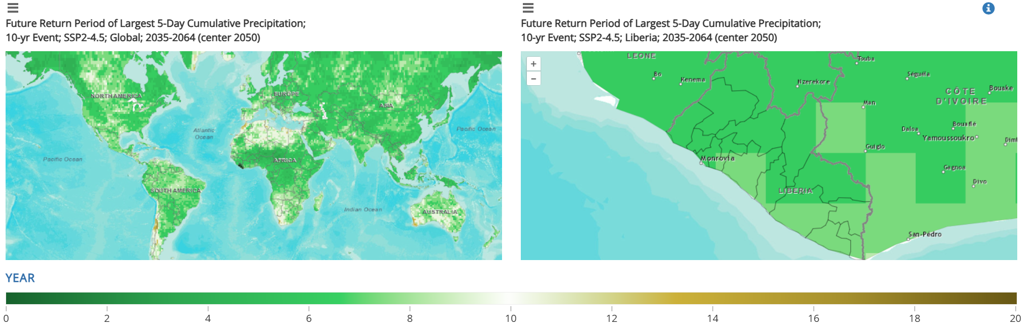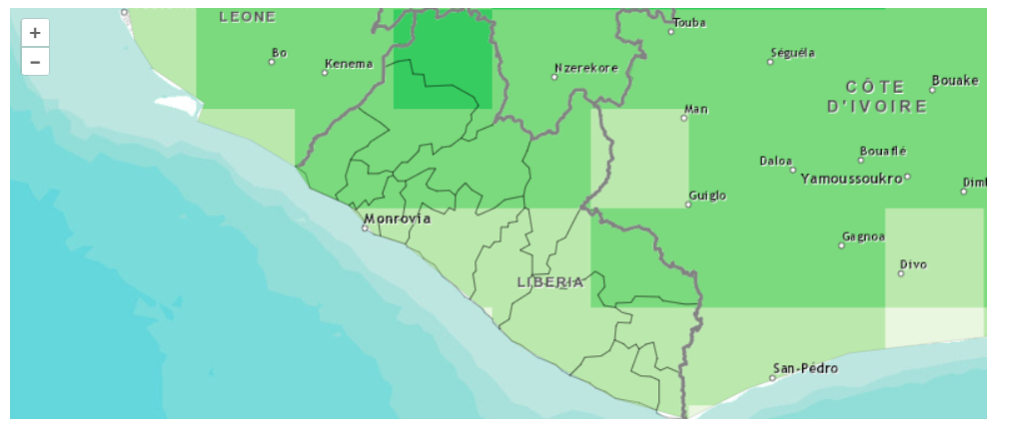
Figure 10. Future Return Period of Largest 5-Day Cumulative Precipitation; 10-yr Event; SSP2-4.5 (Left) SSP5-8.5 (Right); Liberia; 2035-2064 (center 2050)

Aridity and drought - Given its historical precipitation patterns, Liberia has not faced significant drought risk in the past over most of the country. This being said, one cannot exclude the possibility that in the future, changes in drought risk may take place. While projected changes to the Standardized Precipitation Evapotranspiration Index (SPEI, c.f. Figure 11) show an overall drying trend in the country associated with increasing evaporative demands, values remain overall in the “normal” range (i.e. -0.99 to +0.99).
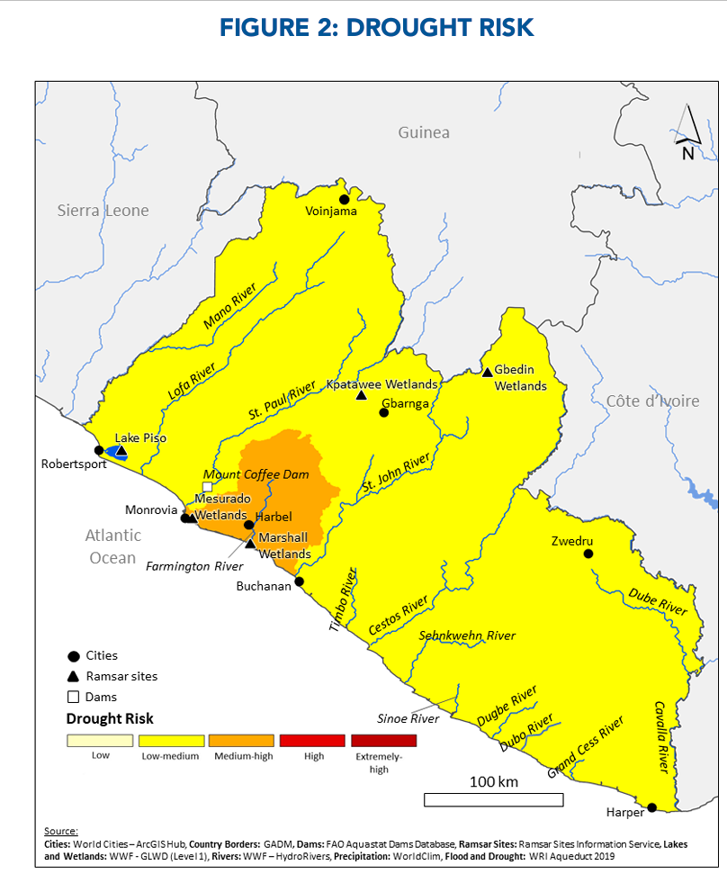
Figure 11. Current (2019) Estimated Drought risk

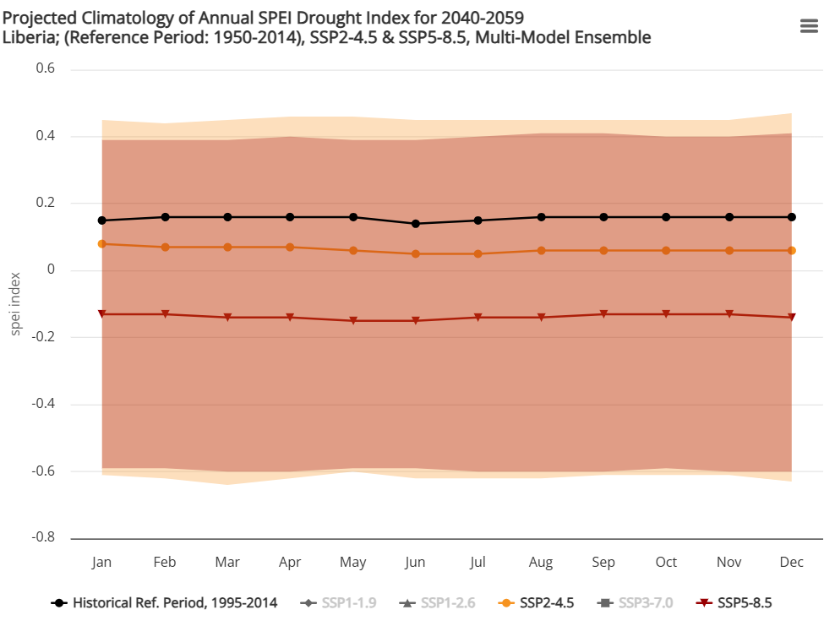
Figure 12. Projected Climatology of Annual SPEI Drought Index for 2040-2059, Liberia, reference period 1995-2014; SSP2-4.5 & SSP5-8.5

Relative sea level – Over the past two decades, the Liberian coast has been experiencing an average relative sea level rise (SLR) rate of >2–5 mm per year, of which the climate-induced contribution has been estimated globally to range between 39-49% (with the remainder of the rapid rate changes attributed largely to human-induced subsidence through groundwater abstraction; flood management infrastructure; sediment compaction from urban infrastructure; sand mining; etc.). With climate change, sea level in the country is projected to rise 0.13-0.43 m by 2050 and 0.18-0.56 m by the 2100s, relative to the sea level from 1980-1999.
Coastal Floods – Low-lying coastal zones are especially at risk from the interaction of heavy rainfall events with increased sea level rise and coastal erosion . Data from Think Hazard shows that most of the Liberian coastal zones currently faces medium coastal flood risk (c.f. Figure 15). This risk is expected to increase, driven by climate-induced sea-level rise.
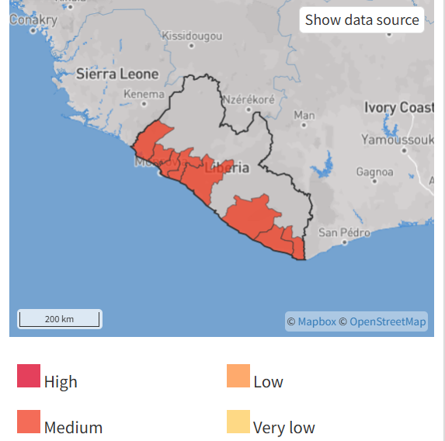
Figure 13. Current Coastal Flood Risk Map - Liberia
Indeed, recent studies have found that the odds of coastal flooding increases exponentially with sea-level rise, whereby fixed amounts of sea-level rise of only ~1–10 cm can double the odds of flooding. Combining these growth rates with established sea-level rise projections, the odds of extreme flooding double approximately every 5 years into the future. Projections suggest that a 1-meter increase in sea level rise could submerge about 95 km² of Liberia’s coastal zone by the end of the century. About half of this inundation is expected on sheltered coasts (shorelines facing smaller bodies of water) and shoreline retreat areas.
Coastal erosion - The size of the observed changes in coastal erosion or accretion can differ strongly between coastal stretches, and as such it is difficult to establish a clear historical trend for all of Liberia. Overall, global studies using satellite data show that the coast of Liberia has experienced a net loss of land (erosion) over the 1984-2015 period. While many anthropogenic factors are to blame for this net loss of land, storms and relative sea level rise are also contributing factors. As such, it is expected that coastal erosion will continue to be exacerbated by RSLR with a changing climate.
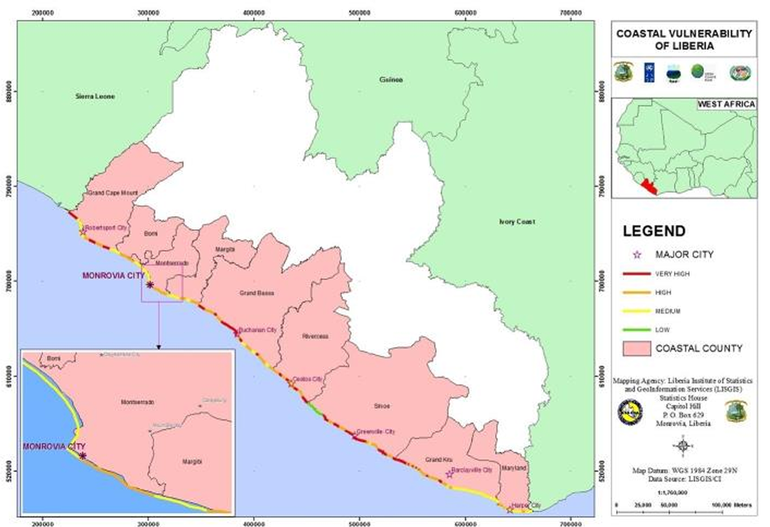
Figure 14. Coastal Erosion Severity Map – Liberia (2020)

Marine heatwaves - From 1925 to 2016, global average marine heatwave frequency and duration increased by 34% and 17%, respectively, resulting in a 54% increase in annual marine heatwave days globally, with the coast of Liberia being no exception to this trend. Projections for the future are stark: the coast of Liberia could increase from approximately 30-33 days of marine heatwaves (1961-1990) per year, by more than 200 additional days per year under RCP8.5 for the 2031-2060 period.
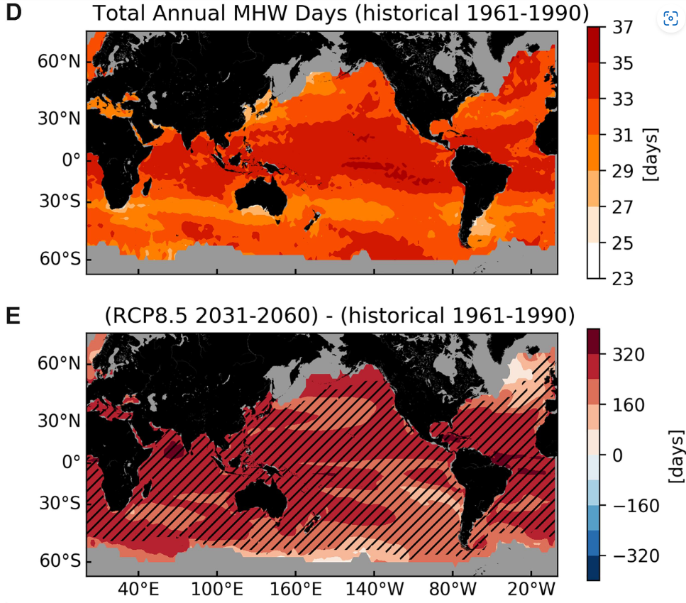
Figure 15. Historical and Projected (RCP8.5) annual marine heatwave days (taken from Oliver et al. 2019)
Possible future without intervention:
It has been estimated that with no adaptation measures, climate change could increase poverty in Liberia by 2–6% over the baseline by 2030 and 13-17% by 2050, creating 170,000 - 330,000 and 830,000 - 1.3 million new poor respectively.
Sea level rise and associated coastal flooding lead to coastline erosion, damage to houses and infrastructure, and pollution of mangroves, land and aquifers. More than 230,000 people are estimated to be at risk. 2,150 km² will be lost by sea level rise by the end of the century. Damages and loss (infrastructure and land) for major cities such as Monrovia; New Kru Town; River Cess; Buchanan; and Robertsport were estimated at $250 million in the National Adaptation Plan (NAP, 2017). Coastal flooding is projected to reduce GDP by 4.0% by 2050. The projected rise in sea level will likely increase migration to higher lands and/or result in shock waves of migration to the interior when coastal inhabitants seek refuge from flooding. Inland flooding is projected to reduce GDP by 3.3% by 2050 and could lead to an increase of waterborne disease outbreaks such as cholera, other diarrheal diseases, malaria, and dengue.
While Liberia is not a drought-prone country historically, there is a possibility of multiple types of droughts and changes in the production seasonality. The supply of potable well water and irrigation water could be adversely impacted by increasing drought risk. A dry or lower-precipitation shock to the economy is expected to potentially reduce GDP by 4.3% by 2050.
Fishing and fish farming communities are particularly at risk from climate change, as they are dependent for their livelihoods and food security on climate sensitive sectors.
For farming communities, a dry and hot scenario would negatively affect crop yields. A wet/warm scenario is expected to result in increased erosion which could cause declines in agricultural production by removing valuable nutrients from the topsoil. Flooding of lowland areas could disrupt agricultural systems and crop yields. Pest and disease territories will expand due to pest outbreaks in geographical areas previously not favorable, leading to more losses of food. Higher temperatures cause shorter life cycles of insect pests and diseases, which may foster reproduction and buildup of field and storage pests and diseases. Increasing average temperatures and moist conditions following periods of heavy precipitation or floods would be expected to favor mold growth, increasing the risk of fungal growth and mycotoxin contamination of stored crops. Finally, climate change increases the risks of post-harvest losses (PHL) if no adequate cooling (especially important for fresh produce) and dry storage facilities (to prevent harvest from molding) are present. Climate shocks such as erratic rainfall, frequent floods, temperature rise and droughts will result in increased bacterial and fungal spoilage of stored foodgrains, increased insect and pest attacks and damaged transport/storage infrastructure resulting in increased PHL. Rice is highly sensitive to increased humidity, temperatures, and intense rainfall, which also favor pests. Rising temperatures may make northern areas of Liberia suitable for rice, but intense rainfall and flooding could erode nutrient-rich topsoil, reducing arable land.
For fishing communities, rising sea temperatures and an increased incidence of marine heatwaves could increase biodiversity and mangrove loss and reduce overall fish stocks due to higher mortality rates, diminished reproductive capacity, and migration of species to cooler waters. This is projected to significantly affect food security and key livelihoods (e.g. reduced earnings from fish exports or losses of food for consumption, including from mangroves). Moreover, an increased frequency of intense precipitation could lead to more frequent loss of fishing days caused by bad weather. Freshwater fisheries will be affected through increased sedimentation from extreme events, lower water levels from drought which could change the magnitude and timing of high and low river flows, and other biophysical processes including eutrophication. This hydrological variability could adversely affect fish habitats, reproduction, growth, recruitment, and mortality. Many of the inland fish species will fail to enhance their distribution to the more suitable water conditions hence failing to survive. They could also be an increased risk of species invasions and the spread of vector borne diseases. Climate impacts will influence aquaculture production through changes in salinity and temperature of water habitats, for example, affecting biological productivity. For fisheries also goes that climate change increases the risks of post-harvest losses (PHL) with fresh catch going bad faster in hotter temperatures, if no adequate cooling facilities are present.
Flooding and heat stress affecting key infrastructure such as roads and bridges (important for physical market access), but also electricity cables (important for cooling and drying facilities) further add to the climate risks for small holders and fishers.
Finally, climate induced or amplified loss of coastal and inland natural resources, loss of species, increase of exotic invasive species and degradation of landscape puts Liberia’s emergent (eco)tourism sector at risk. A loss of the destination’s attractiveness will particularly reduce opportunities related to surf-based and deep-sea fishing activities, sites of natural beauty, and wildlife tourism. SLR will pose risks to sandy beaches and shoreline recession and erosion will pose risks to existing and future local infrastructures, including roads, hotels, restaurants, and airports. Increased flooding could come with an increase of waterborne outbreaks such as cholera, and higher mosquito incidences and related vector-borne diseases such as dengue and malaria.
Climate impacts are expected to be disproportionate between men and women, coastal and inland areas, and rural and urban areas. Gender disparities pose challenges for women to access key resources, such as agricultural inputs like quality seeds, fertilizers, and modern farming equipment, financial services and credit, as well as land ownership and control, crucial determinants for investing in climate-resilient practices and to recover from climate shocks.
The SARTLA project aims to intervene in a total of seven counties: three Inland counties (Bong, Lofa, Nimba), and four coastal counties (Grand Cape Mount, Margibi, Maryland, Montserrado). Each county has distinct characteristics and climate and environmental challenges as described in Annex E. The counties were selected based on their high vulnerability to climate change and the potential to stimulate inclusive growth and contribute to poverty reduction. The commonality between the counties is the heavy reliance of the population on smallholder agricultural or fishery activities, the level of degradation of natural resources, their exposure to climate hazards such as heat, droughts and flooding, the need and potential for investments in smallholder agriculture and fishery value chains, the potential for eco-tourism development, and the overlap and complementarity with several exiting government and donor projects that will provide co-financing to leverage the results of the project at hand. More specifically, the three inland counties are selected based on the vulnerability of their food systems to climate change. These counties are also known as the breadbasket of Liberia and climate risks hence pose food security challenges beyond local food systems. The four coastal counties were selected based on their high exposure to climate hazards such as sea level rising, coastal erosion and coastal flooding. These counties also have high potential for eco-tourism development which can provide alternative livelihoods to fisherfolk. All selection criteria were confirmed during PPG field visits to the counties. Without intervention, unsustainable production practices and climate change will accelerate the decline of natural resources which underpin the livelihoods of and provide crucial ecosystem services such as physical protection from climate hazards to the majority of its population in these counties, exacerbating poverty levels and food insecurity.

Preferred solutions and associated baseline situation
To address current adverse impacts and mitigate future climate-related risks on food production systems and natural resource-based livelihoods in Liberia, a variety of actions have been identified to cope with the above set of challenges and to align to national plans and commitments. An important source in identifying actions and solutions were the extensive consultations that took place during the PPG phase, between national, district and community level stakeholders and the team involved in the Project design. The consultations were part of the stakeholder engagement process that has ensured a participatory design approach. These solutions and specific baseline actions taken in support of their implementation, are reviewed below.
Liberia has ratified the United Nations Framework Convention on Climate Change (UNFCCC), Convention on Biological Diversity (CBD), and the United Nations Convention to Combat Desertification (UNCCD). The country’s ratification of the Paris Agreement and its submission of a Nationally Determined Contribution (NDC, 2021) underscores its commitment to reducing GHG emissions and promoting climate resilience.
To strengthen these commitments, the Government of Liberia’s has implemented a series of comprehensive reforms, policies programmes and plans. The project is aligned and supports these commitments.
The preferred solution will focus its interventions on accelerating sustainable climate-resilient production and development options in agriculture, fisheries, and ecotourism in both inland and coastal counties, and on strengthening and improving access to finance, equipment, inputs and market information for entrepreneurs, and stimulating private sector engagements and investment in sustainable value chains whilst also conserving and restoring the environment. These interventions will 1) reduce the exposure of agricultural and fisheries entrepreneurs to adverse climate hazards (e.g. through land planning and subsequent land and coastal zone restoration), 2) increase levels of adaptive capacity of these entrepreneurs (e.g. by increasing their knowledge and know-how of sustainable agricultural and fishing practices, engaging them in diversified livelihood opportunities such as eco-tourism, and increasing their business skills and access to finance) and 3) reduce sensitivity of these entrepreneurs by making their agricultural and fishing practices more climate resilient.
Critical ecosystems need to be restored to safeguard ecosystem services that underpin local livelihoods and economies. Introducing and strengthening sustainable land-use practices and fostering alternative and sustainable income generating alternatives can then further support ecosystem functioning and ecosystem services, also through reduced use of these services. Restoring and maintaining ecosystem function will lay the foundations for climate resilience (through reduced exposure) and will lower the risks of severe impacts from projected climate hazards such as sea level rise, flooding and heat waves to rural upland and coastal communities.
Nature-based solutions (NbS) have been identified as the preferred approach, integrating key economic sectors and priority development areas to sustainably leverage the power of ecosystem services to reduce exposure and strengthen the adaptive capacity of vulnerable populations. This approach requires not only restoring degraded ecosystems, but also safeguarding ecosystems in the long term through working with local authorities and communities and the private sector to address the drivers of degradation and incentivize sustainable livelihood practices among vulnerable communities, including marginalized, excluded groups, youth and women. Key areas of intervention include the adoption of climate-resilient agricultural and fisheries practices and the management of the landscape that improve productivity of food systems, while reducing degrading pressure on surrounding ecosystems. These will reduce both exposure of crops and fishing grounds as well as reduce the sensitivity of crops and fish stock to climate hazards. These actions should be supported by the development of sustainable alternative livelihoods that will further reduce the sensitivity of rural and coastal communities to climate hazards, with a focus on productive and inclusive value chains and green enterprises. Strengthening agricultural value chains will be achieved through building community and individual capacities via technical assistance, capacity building, climate resilient production practices and building access to markets via de-risked private sector investments (from both MSMEs and larger commercialized corporations), strengthening extension services, as well as enhancing access to market and finance measures(further enhancing adaptive capacity). Incentives to restore degraded ecosystems will be crucial to prevent degradation at early project stages, when sustainable land or fishery management practices may not pay off yet for local communities. The ecotourism industry provides considerable opportunities for sustainable development, creating new markets for sustainable produce and green enterprises, especially for coastal counties, and offering pathways to increase adaptive capacity through alternative income and livelihood opportunities The ecosystem services provided through restoration and conservation of natural systems extend beyond the regulating services essential for adaptation (e.g. through reduced exposure to floods, coastal erosion, and heat spells) to include cultural services and scenic beauty that would support the development of the ecotourism sector, further incentivising the conservation of natural systems and creating win-win scenarios. The potential of ecotourism in the country has been widely acknowledged, also because of its cross-sectoral linkages with other sectors, such as agriculture, transport, handicrafts and artisans, fishing, food and beverages, and infrastructure, among others. Liberia’s rich natural capital, along with its rich indigenous cultures, history and heritage means there is a high tourism potential for the country.
Inclusive and participatory approaches will ensure early buy-in of local communities, county level authorities and national level practitioners and policy makers and will increase the chances of ownership, behavioral change and long-term sustainability of these approaches. Private sector actors need to be engaged, included and linked up with local communities and producer groups, and incentivized to contribute to and drive ecosystem restoration and sustainable practices and investments in ecotourism so that smallholder communities have diversified livelihood options which will make them less sensitive to adverse climate impacts on agricultural or fishery related activities.
A preferred solution will also follow a gender and youth sensitive approach, addressing unequal access rights to natural resources and existing skewed career and financial access opportunities along agricultural and fisheries value chains, and hence further addressing and adaptive capacity gap that exists for these stakeholders.
To achieve sustainable growth and resilience, Liberia needs to diversify the economy and shift away from heavy reliance on capital-intensive industries like mining. Emphasizing sectors with greater potential for job creation, productivity enhancement, and environmental sustainability, such as sustainable agriculture and ecotourism, is essential. By prioritizing inclusive growth strategies and building resilience against external (climate) shocks, and diversifying their livelihoods, Liberia can foster a more robust and diversified economy that benefits all segments of society. This approach not only aligns with the country's developmental goals but also reinforces its commitment to environmental restoration and conservation, gender equality, and inclusive prosperity.
The proposed project offers a multidimensional solution to increase climate resilience through addressing environmental degradation, promoting sustainable land and fisheries management, and fostering inclusive socio-economic development of communities and target groups highly exposed to climate hazards, now and in the future. The project’s approach encompasses strengthening local planning, fostering cross-sectoral collaboration, supporting and mobilizing investments in sustainable and climate-resilient values chains and green enterprises rooted in restored and sustainably managed ecosystems. Innovative finance mechanisms will unlock private sector investment.
A participatory approach fostering collaboration between government agencies, local communities, and private sector actors will ensure sustainability and success of the interventions. Each actor will play a complementary and mutually strengthening role in the project. Local communities will be central beneficiaries to the conservation and restoration activities. They will be responsible for implementing site-specific activities such as mangrove and wetland reforestation, and agroforestry. As the primary land and seascape managers they are also the producers of the primary crops and fish species that provide the very basis of the ecosystem-based value chains. The project will include activities that build their producer and post-harvest skills as well as their micro and small-scale business skills. Staff in national and local government institutions will be strengthened by the project, in their support and oversight functions for environmental protection and extension services for sustainable land-use practices, and eco-tourism development. Through targeted growth accelerator support, the project will incentivize private sector actors to provide crucial support and coordination of sustainable agricultural and fisheries MSMEs and cooperations, thereby further fostering value chain development.
The project will therefore work closely with community leaders and landowners to ensure that agreements are in place to designate certain lands for conservation and restoration purposes. This will involve the establishment of Participatory Land Use Planning (PLUP) committees with communities to ensure transparency and avoid conflicts over land use. In addition, but outside the scope of this project, the government will need to establish legal frameworks to secure land for conservation. This will include aligning interventions with the Integrated Coastal Zone Management (ICZM) framework and other national policies to ensure land is designated for environmental protection and managed accordingly.
In coastal areas restoration activities under the project will focus on mangrove planting and constructing natural barriers to prevent coastal erosion. Restoration techniques will involve planting the site-specific native mangrove species (mostly Rhizophora racemosa) and implementing or strengthening protective by-laws against illegal logging and unsustainable use of mangroves. Restoration of wetlands and riverbanks will involve replanting native vegetation, protecting waterways from agricultural runoff. These interventions will enhance water quality, improve biodiversity, and mitigate flood risks in these communities. Agroforestry and forest restoration techniques will include introducing climate-resilient tree species (bearing e.g. fruits of economic value) and integrating them into farming systems. This will ensure that reforestation is sustainable and to the benefit of local farmers. Local farmers will receive training on agroforestry methods that provide both ecological and economic benefits, such as producing timber, fruit, and other non-timber forest products (NTFP).
The sustainability of the initiative will be contingent on the viability of business opportunities created and expanded. The project therefore includes activities that foster viable financial and technical capacity development within MSMEs, assisting communities to formalize livelihoods and businesses and actively engage, develop and expand markets. Business tools and guidance will be provided to local entrepreneurs and cooperatives.
Knowledge management and capacity development will be central to the approach to enable actors to engage in and benefit fully from project interventions both in the short, but also in the long term, and to provide the learnings to be able to finetune and replicate the project’s successes in additional counties and potentially across the entire country. Periodic assessments will be conducted to evaluate the economic benefits of the interventions on local livelihoods, including income from eco-tourism, agricultural productivity, and fisheries.

Barriers to the implementation of the preferred solution
Although the need for innovative and integrated adaptation solutions is well recognized in Liberia, several barriers currently constrain efforts to successfully shift development pathways in the country.
Barrier 1: Insufficient capacity for integrated planning for adaptation at local level
Despite having the above-mentioned strategies, policies and plans in place, staff in government institutions often lack the capacity to effectively design and implement more effective adaptation strategies and support programs, particularly at the sub-national and local levels. At County and District level administrative structure critical capacity to ensure effective land use planning and implementation of ecosystem restoration and adaptation activities at local levels, is largely absent. Implementation and awareness regarding property rights (e.g., access to land, security of tenure, and utilization) and land administration are weak, and the country continues to lack a land-use policy.
Barrier 2: Limited knowledge and skills for adaptation action amongst subsistence farmers and fisherfolk and inadequate extension services to support the rollout of climate-resilient practices
Consultations during the PPG phase revealed that local communities themselves do recognize changes in the climate and environmental degradation but lack an understanding of the full extent of local climate risks, the interplay with unsustainable practices and the effective local actions possible to reduce these. Households typically engage in charcoal production and sand mining for supplementary income particularly when primary agriculture or fisheries livelihoods are unproductive. Understanding of mangrove ecosystem services is low, and mangrove forest conservation is perceived or regarded as not important. Without a deeper understanding of ecosystem services and the nexus between environmental degradation and climate risks, communities have been found reluctant to forego traditional or natural resource-based survival practices in favor of more sustainable practices. The uptake of alternative, resilient practices is further constrained by a lack of practical knowhow and limited access to the necessary inputs required to restore ecosystems or practice more sustainable farming or fishing. The capacity of local extension services to provide the necessary technical support to roll out training on resilient practices is limited and agents often lack the financial and practical means to reach communities. They are insufficiently trained on climate change impact chains and the co-benefits of climate-resilient and adaptation practices and have limited technical knowledge about best practices for climate-resilient activities and NbS.
Barrier 3: Limited capacity of farmers/communities to engage in producing high volumes of high-quality agricultural and fisheries commodities and value-adding activities
The uptake of climate-resilient practices in the agricultural and fisheries sectors is further constrained by the limited development of value chains in the target counties. Overall, local communities do not have the skills to develop agricultural and fishery value chains or maximize the value of their products. Smallholder farmers lack access to the necessary inputs (e.g. climate-resilient or improved seeds) and infrastructure such as water-efficient irrigation infrastructure powered by solar pumps. Artisanal fisherfolk do not have access to suitable non-destructive fishing gear or resources for the adoption of sustainable aquaculture. Inadequate post-harvest storage and processing capacity further results in postharvest losses and reduced market value of agricultural and fisheries produce, as products do not meet quality requirements and standards necessary for access to high-value markets. Currently, Liberian farmers face up to 14% of PHL. Losses occur mainly in the early and middle stages of the food supply chains, during drying, storage, processing and in transportation. Limited information and information sharing between actors along the value chains on available products, markets, as well as best practices and key lessons further limits development potential.
The challenges for main crops can be summarized as:
- The rice value chain in Liberia is disintegrated, with most cultivation aimed at subsistence. Despite the highest annual per capita rice consumption in Africa (133 kg/year), Liberia produces only 40% of its local rice needs, importing 300,000 metric tons a year, at a cost of US$ 200 million. High transportation costs deter investment, making it hard to compete with imports. Most households use simple technology for processing, and only 7-21% of domestically grown rice is sold in the market (World Bank 2019). Women play a crucial role, comprising over 50% of the agricultural workforce, and managing 79% of cultivated land per household (LISGIS 2018a).
- Cassava is the second most important staple in Liberia after rice and is therefore a vital crop, both for food security and economic stability. Liberia produces over 600,000 tons of cassava per year. Cassava is grown in over 250,000 households across Liberia, predominantly smallholders. It is crucial for rural livelihoods and is often harvested when rice supplies are low, providing a critical food source. Despite its importance, the cassava sector faces challenges such as post-harvest losses, low yields, and rudimentary processing techniques. However, ongoing efforts to improve processing infrastructure and introduce high-quality cassava products offer significant opportunities for boosting livelihoods, particularly for women, and enhancing Liberia's agricultural output​.
- Liberia's horticulture (fruits and vegetables) sector has been characterized by small-scale subsistence farming, with households growing fruits/vegetables primarily for their own consumption. With the expansion of urban areas and the growth of urban populations, there has been increasing demand for fresh fruits/vegetables in Liberia's urban markets. This has led to greater market integration, with farmers seeking to access urban markets and capture value along the horticulture value chain. Additionally, efforts have been made to add value to horticulture products through processing, packaging, and branding.
Barrier 4: Limited business skills among local cooperatives and limited interest and engagement of private sector enterprises to invest in agricultural value chains
Small scale farmers and fisherfolk lack basic business skills and guidance to further promote and their produce or catch. Given the limited capacity of farmers/communities to engage in producing high volumes of high-quality agricultural and fisheries commodities and value-adding activities, very few private sector enterprises have invested in associated value chains, as they are perceived not to be profitable. Production and marketing of sustainable biomass briquettes can provide high energy dense, low emission alternative fuel source for these communities, while reducing their dependence on firewood and the need to burn agricultural waste biomass. Currently, there is limited formalized private sector investment in the biomass briquette production value chain in the target counties.
Barrier 5: Limited capacities to develop the ecotourism industry as a sustainable and climate-resilient alternative livelihood option for communities
The lack of knowledge and technical capacities as well as a poor identification of viable ecotourism initiatives have resulted in a lack of bankable business and projects to enhance ecotourism-related value chains and improve key infrastructure, which reduce the interest of financing opportunities in the sector. Unplanned development of the sector could result in habitat destruction, alteration of ecosystems, pollution, overexploitation of natural resources, biodiversity loss, among other issues, as well as an increase in social gaps. Therefore, a planned sector development is required to boost the ecotourism sector linked with increasing biodiversity protection and livelihood resources for people.
Barrier 6: Limited financial inclusion and financial products for communities, smallholders and climate-resilient MSMEs.
The development of MSMEs in Liberia is severely constrained by limited access to financial resources, especially for female and youth entrepreneurs. Limited capacity and capitalization of the proposed Agriculture Enterprise Development Bank and lack of blended finance instruments is a key barrier for increased access to affordable agricultural value chain financing. Given the limited public funds available, partnership with the private sector is essential but private financial institutions need to be incentivized. Currently, communities within the target counties have limited access to commercial loans and other products from banks and microfinance institutions due to a perceived low demand by these institutions for financial products and a perceived high cost of providing credit to communities in remote rural areas. Even where access to micro-finance is available, it remains largely inaccessible to many businesses and individuals due to the typically high interest rates on loans from NBCOs. MSMEs engaged in agriculture and related value chains, where returns are slow, unpredictable, and risk is perceived as high often don’t meet requirements to access finance from larger banks which offer better interest rates. The limited access to finance is further compounded by the low level of financial literacy among communities. Without access to financial services (credit or insurance), farmers and fisherfolks are unable to invest in climate-resilient technologies or diversify their livelihoods.

Project Description

Changes between the PIF and the PPG phase
During the PPG Phase, precisions about the location and context of the project interventions were added. One of the main finds was that several other projects currently being implemented in the county target cross-sectoral coordination mechanisms for integrated natural resource and agro-ecological landscape management.
Some restructuring and reformulation of the project outputs was done to better meet the project objective and to better reflect the nature of the activities grouped under them:

Components, Outcomes and Outputs as per PIF | Components, Outcomes, and Outputs after PPG | Comment
Component 1: Investment in conserving the agro-ecological landscape and food production systems | Component 1: Investment in conserving the agro-ecological landscape and food production systems | Unchanged
Outcome 1: Improved management of the agro-ecological landscape through nature-based solutions and climate-resilient food production technologies for small-holder farmers and fishers. | Outcome 1: Improved management of the agro-ecological landscape through nature-based solutions and climate-resilient food production technologies for small-holder farmers and fishers. | Unchanged
Output 1.1: Coordination mechanisms established to build institutional capacity for cross-sectoral coordination and integrated management of the agro-ecological landscape. | Output 1.1: Comprehensive land use plan developed in the agroecological landscapes to guide the coordination and implementation of nature-based solutions and climate resilient food production. | During the PPG mission, the consulting team found that that several other projects currently being implemented in the county target cross-sectoral coordination mechanisms for integrated natural resource and agro-ecological landscape management, but that integrated land use planning capacity and integrated land use plans at county level were missing. The team then advised to include an output that would address this challenge rather than duplicate what is being done by others.
Output 1.2: NbS implemented in degraded forest and wetland ecosystems to safeguard ecosystem services. | Output 1.2: NbS is implemented on 1000 ha of degraded forest and 600 ha of wetland ecosystems to safeguard ecosystem services. | The target surface of degraded forest and wetland ecosystems was incorporated into the title.
Output 1.3: Climate-resilient agriculture and fisheries practices promoted in vulnerable rural communities through training and awareness. | Output 1.3: Sustainable and climate-resilient agriculture and fisheries systems established in vulnerable rural communities through capacity-building, demonstration projects, and community-led adaptation strategies. | The output title was revised to add more detail on diversity of activities that will take place in the sectors of the intervention.
Output 1.4: Extension Services strengthened and diversified to deliver advisory services to farmers and fisherfolk on climate resilient practices. | Output 1.4: Extension services are enhanced, and extension workers’ capacity is built for NbS and Climate-Resilient Livelihoods in Fisheries and Agriculture. | The output title was revised to better emphasize priority actions, and capacity building in NbS and other practices to improve livelihoods practices.
Output 1.5: Communication Strategy developed to raise awareness and disseminate best practices for climate-resilient agriculture and fisheries. | Output 1.5: A communication and knowledge management strategy is developed and implemented for disseminating best practices and lessons learned from the project. | The output title was revised. to focus more on knowledge management as part of GEF-8 requirements, rather than just awareness raising
Component 2: Climate-resilient livelihoods, ecotourism, and value chain development | Component 2: Climate-resilient livelihoods, ecotourism, and value chain development | Unchanged
Outcome 2: Alternative, climate-resilient livelihoods, including ecotourism, supported by improved market access and value-added services in agricultural and coastal areas. | Outcome 2: Alternative, climate-resilient livelihoods, including ecotourism, supported by improved market access and value-added services in agricultural and coastal areas. | Unchanged
Output 2.1: Sustainable climate-resilient livelihoods and agricultural and fisheries value chains and enterprise development in target communities through provision of training, and start-up inputs. | Output 2.1: Sustainable climate-resilient livelihoods and agricultural and fisheries value chains and enterprise development in target communities through provision of training and start-up inputs. | Unchanged
Output 2.2: Alternative livelihoods established (with participation of at least 50% women) and linked with agricultural and fisheries value chains. | Output 2.2: Alternative livelihoods including ecotourism established (with participation of at least 50% women) and linked with agricultural and fisheries value chains. | The output title was revised to include ecotourism
Output 2.3: Business development tools and guidance delivered to build technical and financial capacity of MSMEs. |  | The third output under outcome 2 was eliminated as it duplicated activities under Output 2.1
Component 3: Innovative Finance | Component 3: Innovative finance | Unchanged
Outcome 3: Innovative financing architecture incentivises private sector investment in climate-resilient agricultural technologies, livelihoods, and enterprises. | Outcome 3: Innovative financing architecture incentivizes private sector investment in climate-resilient agricultural technologies, livelihoods, and enterprises. | Unchanged
Output 3.1: Establishment of private sector engagement facility with new funding windows opened under the UNDP Growth Accelerator Platform. | Output 3.1: Establishment of private sector engagement facility with new funding windows opened under the UNDP Growth Accelerator Platform. | Unchanged
Output 3.2: Partnerships established between private sector (MSMEs, cooperatives) partners, communities, and other stakeholders. | Output 3.2: Partnerships established between private sector (MSMEs, cooperatives) partners, communities, and other stakeholders for Access to Markets and Access to Finance. | Added the specification ‘for Access to Markets and Access to Finance”
Output 3.3: Partnerships with larger commercial agriculture, agro-processing, and ecotourism corporations facilitated for climate resilient livelihoods. | Output 3.3: Partnerships established with larger commercial agriculture, agro-processing, and ecotourism corporations for climate resilient livelihoods. | Modified: “facilitated” to ‘established”
 | Monitoring and evaluation activities. | We separated M&E from the other components as required under GEF-8.
 | M&E: Monitoring and evaluation framework established, and M&E activities conducted.
 | M&E Output 1.: Project M&E framework.
 | M&E Output 2.: Periodic M&E reports generated and submitted to UNDP SL and Mid-term Evaluation and Terminal Evaluation executed.

Project’s Strategy
The project’s Theory of Change can be summarized as: “If Liberia improves the integrated planning of and extension support for ecosystem restoration and sustainable climate resilient agricultural and fishing practices, builds business skills of small scale agricultural and fishery entrepreneurs and cooperatives, provides incentives for the private sector to engage and invest in value chain development, de-risks financial products offered by national financial institutions to MSMEs, and systematically shares obtained knowledge with all relevant stakeholders, then broad scale and inclusive development of a sustainable agricultural, fishery and ecotourism sector can be obtained generating long term climate resilience and benefits for nature and people at local, national and global scale.”
The project’s main objective is “building climate resilience in natural-resource dependent rural communities of Liberia through systems-based, transformational adaptation in the agricultural, fisheries and ecotourism sectors”, which will enhance the capacity of vulnerable population in different communities to respond to climate change impacts.
The project will focus on rice, cassava, and horticultural products, as well as on fish (marine catch and aquaculture), ecotourism and sustainable briquette production. To help lower the barriers to adaptation and climate resilience in rural communities, the project will implement a mix of interventions that will target i) the adoption of resilient and regenerative practices among farmers and fisherfolks to improve productivity while at the same time reducing environmental impacts and fostering restoration, ii) linking local livelihoods to agricultural and marine value chains, development of alternative livelihood strategies such as those linked to eco-tourism, and fostering market access through business skill training, and iii) provide an enabling innovative finance environment to foster private sector engagement, link actors along the value chain and scale the development of sustainable enterprises based on these value chains. Traditional knowledge will be taken as a starting point for discussions around sustainable land use, management and planning, at the onset of project activities in the communities. This will ensure that practices introduced by the project make maximal use of local systems of joint learning and navigating change. Behavioral change can namely only happen when (new) approaches make sense to communities, for example because they align with their belief, knowledge and identity systems or because they make sense as a response to understood changes in bio-physical realities. Knowledge management and capacity development will be central to the approach to enable actors to engage in and benefit fully from project interventions both in the short, but also in the long term, and to provide the learnings that can finetune and replicate the project’s successes in additional counties and potentially across the entire country. Periodic assessments will be conducted to evaluate the economic benefits of the interventions on local livelihoods, including income from eco-tourism, agricultural productivity, and fisheries.
The project will generate significant adaptive and socio-economic benefits:
The project will bring significant adaptive benefits by a.o.
- restoring 1,140 ha of agricultural land, 500ha of forests and 2,00 ha of wetlands, reducing exposure of livelihoods to climate hazards.
- Training 500 farmers (50% women) and 200 fishermen (50% women) directly and a further 700 farmers and 400 fishermen through improved extension services, in sustainable practices, thereby increasing their adaptive capacities
- Training 7000 entrepreneurs in agriculture and fisheries (of which 1,500 youth and 3,000 women)
It will bring socio-economic benefits through promoting income generating activities both in agriculture and fisheries as well as in alternative sectors such as briquette making or eco-tourism. It will promote inclusive value chain development, financial support mechanisms and the fostering of women and youth led entrepreneurs. It will strengthen private sector engagement and public-private partnerships at different scales in these value cains (including eco-tourism). All combined the activities under this project aim to promorte, develop and support a green growth economy in Liberia delivering restoration, climate adaptation, poverty reduction and food security benefits to wide layers of society.
The proposed solution is cost-efficient and effective:
The project has been designed to deliver maximum results with the available resources, and under the current conditions of limited extension services, limited infrastructure, limited access to financial products and physical remoteness of the some of the target counties and communities. In this context, this project will focus on filling the gaps to address factors that hinder the development and scaling up of environmentally sustainable smallholder and MSME driven agricultural and fishery value chains. It will assist in building a derisked and attractive environment for innovative financial investments through piloting activities that enhance private sector development, involvement and investment under Component 3. The project will tie the development of the agriculture and fisheries sector to the adoption of more sustainable land management practices and the restoration of critical ecosystems.
The approach through sustainable land management and climate resilient practices provides an integrated and effective NbS which can be cost-effective and generate social, economic, and cultural co-benefits while contributing to reducing pressures on the environment and reducing cumulative anthropogenic drivers of degradation and climate impacts. However, this approach can only be effective through a high degree of collaboration between all stakeholders, recognizing and leveraging the comparative advantages of other partners and initiatives. Trade-offs and synergies across sectors and scales in space must first be identified, to ensure sustainable impacts and dismantle siloes.
By involving altogether five government entities (EPA, MoA, MoCI, MICAT and NaFAA), each with substantial practical experience in specific results areas of the project, as well as with longer standing presence on the ground in the target counties, the project strategy ensures that it can build on the existing results, successfully tried processes, collaborations and especially trust and leveraging effects with local communities.
The project will ensure complementarity and synergies with other projects and initiatives implemented in the targeted areas of intervention. For example, to maximize efficiency and effectiveness under component 3, the UNDP Growth Accelerator program’s facility will be used for strengthening resilience of existing climate resilient agriculture and fisheries value chains, sustainable briquette production, eco-tourism value chains, access to finance, and social protection measures. GEF/LDCF resources will be deployed only for provision of TA, training and capacity building for selected private sector enterprises and community engagement as described under outcome 3, with capital grants (with matching resources invested by private sector partners) being provided from co-finance (UNDP TRAC resources). The GA program will recruit a service provider for launching challenge windows, selection of private sector enterprises (MSMEs, community cooperatives, NGOs, CBOs) partners, disbursement of capital grants, portfolio management and monitoring and evaluation activities. In addition, the project will seek to maximize collaboration with the existing LIFT program of the World Bank. See table 1 for more information.
The proposed solution offers opportunities for scaling up:
- The proposed project provides a blueprint for tailored (blended) finance of restoration and sustainable agricultural and fisheries practices in the Liberia context and beyond. If successful, the activities under component 3 will catalyze and attract additional investment and support from government agencies, private sector stakeholders, and NGOs interested in restoration initiatives, ecotourism and sustainable value chains. At the project's end, efforts will be made to ensure the continuity of the private sector engagement mechanisms either through securing funding for another phase or by identifying and engaging local entities to continue the process.
- The proposed project also provides a blueprint for participatory land use planning that can inform investments in ecosystem restoration and value chain development The land use planning activities under Output 1.1. are intended to be used as a starting point to set county-wide restoration targets which can be taken up by the activities under Output 3.3. Apart from identifying restoration areas as such, the land use master plans also serve as a guide for sustainable and climate proof investments in different types of land uses and value chains that can be developed under Output 1.3, Output 2.1. and further linked up to private sector engagement and innovative private finance led investments under outcome 3. The county land use master plan offers significant potential for scaling up through support from blended finance investors who could potentially support the processes for the regular updating of these.
The project objective (Sphere of Control) will be achieved through three (3) interlinked outcomes:
- Outcome 1: Improved management of the agro-ecological landscape through nature-based solutions and climate resilient food production technologies for small-holder farmers and fishers.
- Outcome 2: Alternative, climate-resilient livelihoods, including ecotourism, supported by improved market access and value-added services in agricultural and coastal areas.
- Outcome 3: Innovative financing architecture incentivizes private sector investment in climate-resilient agricultural technologies, livelihoods, and enterprises.
Subsequently, through both the project and complementary initiatives, five (5) Medium-Term Outcomes (MTO) can be identified (project Sphere of Influence):
- MTO 1: Liberia makes significant progress towards its restoration, land degradation neutrality, mitigation and adaptation targets
- MTO 2: Knowledge on sustainable and climate resilient agricultural and fishery practices is systematically shared with all relevant stakeholders, and effectively used in support of the country’s adaptation objectives to climate change.
- MTO 3: A diversified local economy reduces food insecurity and poverty
- MTO 4: The ecotourism sector contributes a significant share to Liberia’s GDP and drives restoration and conservation efforts.
- MTO 5: Liberia has a vibrant ecosystem of sustainable entrepreneurs and businesses who are linked to global markets for sustainable agricultural and fishery products
The ToC can be expressed through four (4) Transformative Pathways :
- Pathway 1, contributing to MTO 1, 2 and 3: By promoting climate-resilient farming and fishing practices (Output 1.3) that connect with and build on traditional knowledge and identities, and improving ecosystem services through integrated land use planning and restoration of degraded land, forests, wetlands and coastal ecosystems such as mangroves (Output 1.1. and 1.1.2), the project enhances agricultural and marine productivity and renders it more resilient against projected climate risks. The resulting sustained improved productivity directly improves the local food security situation. It also lays the basis for surplus production that can then be sold, generating additional income that enables households to further improve their food security as well as their broader economic situation, and lowers their sensitivity to climate hazards.
- Pathway 2, contributing to MTO 3 and 5 : Through trainings in post-harvest processing and the provision of storage, cooling and processing facilities (Output 2.1), the quality of the surplus produced is improved. Farmers and fishermen can moreover keep produce/catch longer, and sell at later points in time, contributing to a steadier income stream throughout the year and a reduction of post-harvest (income) loss. By supporting small scale aggregators, traders and processors (Output 2.1 and Output 3.1), the demand side can be made more reliable and market linkages further up the value chain improved. Better market linkages result in improved prices, further enhancing household earnings, and reducing their sensitivity to climate hazards. These earnings can, after covering food security, children’s education, health and other social needs, be invested by the farmers or fishermen into growing their business further.
- Pathway 3, contributing to MTO 1 and 4. By restoring degraded ecosystems (Output 1.2), the project creates opportunities for ecotourism and linked to this, the sustained management and conservation of these ecosystems. Ecotourism provides a multitude of alternative livelihoods for local communities, and increases adaptive capacity. Opportunities range from working as a local ecoguide or ecoguard, providing cateríng or other services to eco-lodges, working in the maintenance and upkeep of tourist facilities and infrastructure, to selling artisanal products and organising cultural events. A diversification of livelihoods into sustainable ecotourism activities (Output 2.2), not only increases adaptive capacity of households, it also inherently is less sensitive to climate hazards as it is rooted in restored ecosystems. It moreover reduces the pressure on ecosystems from unsustainable livelihood such as sand mining, logging, and others.
- Pathway 4, contributing to MTO 5: By promoting inclusive value chain development through the provision of targeted training, financial support mechanisms and the fostering of women and youth led entrepreneurs (Output 2.1) and through the strengthening of private sector engagement (Output 3.1 and Output 3.3) and public-private partnerships (Output 3.2) at different scales in these value cains (including eco-tourism), a green growth economy can take foot in Liberia delivering restoration, climate adaptation, poverty reduction and food security benefits to wide layers of society.
The ToC makes the following assumptions:
- A1. Knowledge generated through research and the integration of indigenous knowledge is integrated into adaptive management of project interventions to create innovation.
- A2. Local MSMEs can source sufficient finance to co-invest alongside the project-supported financial mechanisms.
- A3. The different national plans, policies, programs and initiatives to address climate change in Liberia are boosted by a good enabling policy environment at national and subnational level (e.g. access to reliable and timely climate information), which ensures alignment and correct applicability of the initiatives.
- A4. Road infrastructure and transport options are improved through government investments, enabling physical access to external markets.
- A5. Private sector financial institutions are interested in co-financing bankable initiatives participating in the UNDP Growth Accelerator (GA) program and increasing the availability of financial resources.
In addition, the following enablers can be identified:
- E1. Market conditions are conducive to promote active engagement of private sector in different economic sectors
- E2. Strong government capacity to speed up support for implementing NbS strategies and conservation efforts due to recognition of urgent actions to integrate climate in national planning.
- E3. Adequate infrastructure, including transportation, water, and energy access are enhanced or developed
- E4. Financial actors have an interest in supporting small-scale financing (loans) with lower interest rates
- E5. Actors from local communities – including men, women, youth – show interest to actively engage and participate in environmentally responsible livelihood skills, enhancing behavioral generational change

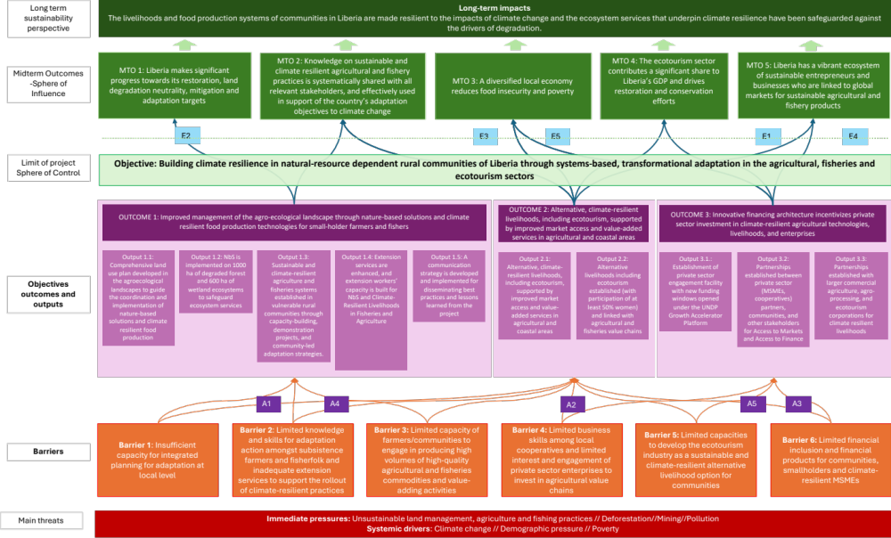
Figure 16. Theory of change
The project’s outcomes can be situated under three separate components, each with their specific outputs and suggested activities as follows:
Component 1: Investment in conserving the agro-ecological landscape and food production systems
This component focuses on long-term investments that ensure the conservation of (i) ecosystems critical for climate change adaptation and (ii) agro-ecological landscapes and food production systems.
Outcome 1: Improved management of the agro-ecological landscape through nature-based solutions and climate-resilient food production technologies for small-holder farmers and fishers.
First, this outcome will be achieved through a participatory and comprehensive land-use planning process (Output 1.1). Within this framework, ecosystems will be restored, and ecosystem services will be maintained through the implementation of nature-based solutions (Output 1.2). In parallel, vulnerable communities will be assisted to strengthen the sustainability of their livelihoods through the development of climate-resilient agriculture and fisheries systems (Output 1.3). The whole process will be supported by local extension services whose technical capacities will be strengthened to disseminate best practices in NbS and climate-resilient agriculture and fisheries (Output 1.4). Finally, lessons learned and best practices from the field will be captured, capitalised and disseminated for replication and scale-up in Liberia through the development and implementation of a communication strategy that will feed into national knowledge management platforms (Output 1.5).
Output 1.1: Comprehensive land use plan developed in the agroecological landscapes to guide the coordination and implementation of nature-based solutions and climate resilient food production
Participatory and adaptative comprehensive land use plans will be developed and endorsed at the administrative boundary of the project intervention sites to (i) coordinate Nature-based Solutions (NbS) across diverse landscapes and (ii) guide the introduction of climate-resilient practices that enhance food production while safeguarding biodiversity and ecosystems. For example, planning could lead will prioritise of restoration work in the woodlands of Zorzor, where PPG consultations revealed a high level of degradation despite being close to large areas of High Conservation Value (HCV). The planning process will be overseen and supported by the Liberia Land Authority (LLA) which will facilitate land use agreements providing clear documentation on land ownership and use rights (see note on land ownership in Annex E). The approach will incorporate a wide range of public and private stakeholders including community leaders and landowners, and will also integrate indigenous knowledge. Therefore, this output also comprises regular training activities on gender mainstreaming, incorporation of indigenous knowledge systems, social inclusion and other social and environmental standards. The project will support the establishment of Participatory Land Use Planning committees. The committees primarily serve an advisory and oversight role in land use activities through the consultative process at the district or clan level and are not typically funded. Their operations are closely coordinated with the Liberia Land Authority field officer. While they are not directly embedded within government structures for budget allocation, their integration into existing land governance frameworks helps ensure continued engagement and relevance beyond the project.
Activities include:
- Activity 1.1.1: Conduct detailed land use assessments across ecosystems and agroecological landscapes in intervention counties (Robertspot, Marshall, Zorzor, Kpatawee, Harper Virginia & Providence and Tappita) to map agricultural activities, fishing areas, and degraded lands and coastal areas.
- Activity 1.1.2: Identify and prioritize specific target communities for intervention guided by a Strategic environmental and Social Assessment that integrates environmental and social considerations into land use plans
- Activity 1.1.3: Engage the targeted communities, government agencies, and stakeholders in a series of participatory and inclusive land use planning workshops. Identify potential NbS interventions as well as market-gardening/fruit-growing area perimeters, agriculture and fishery hubs, production areas for briquettes.
- Activity 1.1.4: Conduct community consultations, including FPIC consultations, with communities in villages where potential NbS interventions have been identified and obtain consent and FPIC for the implementation of NbS interventions
- Activity 1.1.5: Formulate a comprehensive plan to address ecosystem degradation and meet community needs in each of the communities, based on the outcomes of the land use planning workshops and promoting the existing adaptation practices such as community-based forest management (Zorzor and Tappita), agroforestry and sustainable agriculture (Kpatawee and Tappita), mangrove conservation Initiatives (Roberspot), community-based coastal defense initiatives (Harper), or other indigenous practices and knowledge
- Activity 1.1.6: Support the establishment of PLUP implementation committees (composed of community representatives), responsible for the dissemination and adoption of the plan objectives within the concerned localities and supporting their implementation.
- Activity 1.1.7: Deliver annual training per county on gender mainstreaming, social inclusion, and other social and environmental standards
Output 1.2: NbS is implemented on 1000 ha of degraded forest and 600 ha of wetland ecosystems to safeguard ecosystem services.
Within this framework, ecosystems that play a critical role in climate change adaptation in Liberia will be restored based on the needs and intervention areas identified under Output 1.1. Restoration activities in forested areas will be carried out using both endemic, indigenous and commercially valuable species where appropriate. In parallel, fast-growing tree species will be planted to rapidly reduce the current timber harvesting pressure. Only indigenous species will be used in restoration efforts to avoid the potential introduction of invasive species that could negatively impact biodiversity of ecosystem services. The NbS will be implemented by local communities, overseen by PLUP implementation committees, using a participatory approach. This will ensure that the needs of the community, with particular attention to women, are taken into account in the selection of trees to be planted, intervention sites and their involvement in project activities (including working conditions).
Activities include:
Forest restoration:
- Activity 1.2.1: Train 300 (42 per county) local community members from different groups (farmer folks, fisherfolks, youth, women – min 40% women) on NbS practices, restoration techniques, including tree growing and planting.
- Activity 1.2.2: Conduct reforestation activities on 1000 ha of forested areas in Zorzor and Tappita (500 ha in each location), focusing on the planting of indigenous tree species (e.g. Rhizophora spp (Mangrove) are most dominant in the two landscapes and are mainly affected because of their use for fish drying) and commercially valuable species where appropriate
- Activity 1.2.3: Establish nurseries to produce forest, economic and mangrove tree species in every county. Involve local organizations and NGOs.
Mangrove restoration:
- Activity 1.2.4: Implement 1000 ha of large-scale mangrove restoration in Robertspot (500 hectares) and Harper (500 hectares). Coordinate with existing restoration initiatives (mangrove conservation Initiatives in Roberspot and community-based coastal defense initiatives in Harper). Replant native mangrove species, create natural barriers to prevent coastal erosion and develop community-led monitoring systems
Wetland restoration:
- Activity 1.2.5: Rehabilitate 1000 hectares of degraded wetlands (Wetland and Riparian Zone Restoration) in Virginia and Marshall City through reforestation and sustainable land use practices.
- Activity 1.2.6: Establish wetland conservation areas in Marshall, with community participation and intergovernmental coordination of Ministries, Agencies and Commissions
Reduce unsustainable practices:
- Activity 1.2.7: Implement a large-scale awareness raising campaign about unsustainable livelihood practices (mining, sand mining, deforestation, littering)
- Activity 1.2.8: Support the enforcement of local efforts for environmental protection in the target communities
- Community sensitization, traditional leadership involvement, and multi-stakeholder partnerships
- training of at least 5 local enforcement officers per community, of whom at least 2 are women, and providing resources for their enforcement activities, and legal training for community members
- Activity 1.2.9: Design and deliver a series of capacity building workshops on risks and best practice management measures related to biodiversity conservation, invasive species, human-wildlife conflicts, illegal wildlife trade and other emerging issues.
A map of intervention Sites for Conservation, restoration and Rehabilitation is included in Annex E.
Output 1.3: Sustainable and climate-resilient agriculture and fisheries systems established in vulnerable rural communities through capacity-building, demonstration projects, and community-led adaptation strategies.
Practical training and pilot demonstration plots will be implemented on the basis of the priorities identified under Output 1.1. The capacity building program aims to build local capacity to establish sustainable climate-resilient systems and ultimately help these communities adapt to climate change while improving food security and livelihoods. For instance, agroforestry is expected to enhance soil fertility and biodiversity by planting trees alongside crops, thus restoring tree cover, ecosystem functions and providing additional food and economic products. Sustainable Rice Intensification (SRI) method will improve rice yields while reducing water and input requirements. Indeed, SRI techniques use less water, fewer seeds, and no chemical inputs, which makes rice farming more resilient to climate extremes, such as droughts and floods. Another interesting livelihood option is small-scale mangrove-based aquaculture to both diversify fishermen revenues while encouraging mangrove conservation. Training programmes will be developed and implemented along the PLUPs and in collaboration with local extension services, local NGOs and government and private technical experts, , so that these can build on the pilots and expand activities (e.g. under Activity 1.4.3. and under component 2).
Activities include:
- Activity 1.3.1: Deliver yearly trainings to the PMU staff on UNDP and government social and environmental safeguards and procedures
- Activity 1.3.2: Establish 10 pilot demonstration sites for climate-smart agroforestry, sustainable rice intensification or small-scale irrigation coupled with high-value vegetable in Tappita, Zorzor and Kpatawee: 4 sites in Zorzor because of the size (2 areas for SRI and 2 for climate-smart agro-forestry), Tappita 3 sites (2 SRI and 1 climate-smart agro-forestry), Kpatawee 2 sites ( all SRI), and Harper 1 site (SRI) (as the only coastal site). These pilot sites are to be anchored in the agricultural colleges - Tubman University, University of Liberia, Cuttington/Bong Community College, Lofa County Community college (See also Output 1.4).
- Activity 1.3.3: Train 500 farmers (50% women) in techniques that improve soil health, water retention, and crop yields. Considering the sizes of the key priority intervention sites for agriculture: Zorzor (200), Tappita (150), Kwatawee (75) Harper (75).
- Activity 1.3.4: Implement sustainable small-scale fisheries systems based on FAO Voluntary Guidelines for Securing Sustainable Small-Scale Fisheries and considering indigenous and traditional knowledge in Marshall, Robertsport, and Harper. Provide materials as per NaFAA standad requirements and provide training on climate-resilient fishing practices. The training should be 2 training each per project intervention sites for fishermen, and 2 each fish mongers per project intervention of the 4 coastal counties.
- Activity 1.3.5: Promote livelihoods such as mangrove-based aquaculture (crab, tilapia and toad farming in Marshal). Procure the equipment, provide technical training in sustainable practices.
Output 1.4: Extension services are enhanced and extension workers’ capacity is built for NbS and Climate-Resilient Livelihoods in Fisheries and Agriculture
The current limited technical capacity and knowledge transfer of rural extension service workers will be strengthened to ensure that best practices in NbS and climate-resilient and climate smart agriculture and fisheries are effectively communicated and adopted by local communities. Extension staff will then be able to provide ongoing support to local farmers and fishers, ensuring the adoption of climate-smart practices across the project sites. Specific attention will be paid to train extension officers to also take indigenous knowledge into account.
Activities include:
- Activity 1.4.1: Conduct an assessment and provide recommendations to establish a research programme at the University of Liberia, to bridge gaps in knowledge related to climate change adaptation options in the agriculture and fisheries sectors and implementation of adaptation measures, and sustainable practices, including NbS. Establish link with the interventions supported by the project, and the indigenous knowledge that can be accessed through the project.
- Activity 1.4.2. Develop and run a one year Mentorship Program for Women and persons with disability in Climate and Agricultural Research at the University of Liberia.
- Activity 1.4.3: Develop a capacity building program (theory and practice) at 7 vocational training centers across the project intervention sites on NbS, sustainable agriculture, and fisheries. Involve relevant research institutions from the previous activity to build the content and collect the most innovative solutions to address climate change challenges and enhance the resilience of smallholder farmers to environmental shocks, also considering indigenous techniques or knowledge systems. Build on past successful experiences available on EKMS.
- Activity 1.4.4: Deliver the capacity building programme to 50 extension workers (40% women). Deliver training certifications for the participants.
- Activity 1.4.5: Support trained extension workers in conducting 15 workshops and hands-on demonstrations across seven counties, reaching 700 farmers and fishers (50% women). Include topics such as climate-smart farming, agroforestry, mangrove conservation, and sustainable fisheries management, as well as indigenous practices.
Output 1.5: A communication and knowledge management strategy is developed and implemented for disseminating best practices and lessons learned from the project
The project will develop and implement an effective communication and knowledge management and sharing strategy to scale up successful climate resilient and NbS practices. A knowledge management plan will ensure effective capturing of best practices, lessons learned and technical tools from the project, in overview databases and technical reports. To ensure sustainability, the project will work with and strengthen the existing Liberian platform (EKMS). A robust communication strategy will ensure the broad dissemination and sharing of this captured knowledge to encourage adoption of best practices across sectors, actors and counties in Liberia via this EKMS. Learnings and best practices can also be shared beyond Liberia, through the ongoing South-South and global platforms, such as Africa Solutions Platform, the UN South-South Galaxy knowledge sharing platform and PANORAMA.
Activities include:
- Activity 1.5.1: Develop and implement a comprehensive knowledge management and communication strategy for capturing and disseminating project results, lessons learned and best practices (including project website linked to the national platform EKMS)
- Activity 1.5.2: Produce multimedia content, including videos, infographics, and case studies, showcasing successful NbS interventions and climate-resilient practices. Disseminate through radio, mobile apps, social media, and community-based platforms, and explore knowledge sharing beyond Liberia, through postings in more regional and global fora and platforms.
- Activity 1.5.3: Revitalize and use existing knowledge sharing platforms such as the EKMS for widespread knowledge sharing to make all capitalization, communication research articles and projects outputs including PLUPs available on platforms
- Activity 1.5.4: Train local stakeholders in all project sites in accessing and utilizing the EKMS platform, ensuring that knowledge on NbS and climate resilience is widely available and easily accessible to all community members
- Activity 1.5.5: Train 25 Journalists on environmental education.
Component 2: Climate-resilient livelihoods, ecotourism, and value chain development
Outcome 2: Alternative, climate-resilient livelihoods, including ecotourism, supported by improved market access and value-added services in agricultural and coastal areas
Effective value chain development is key to increasing the resilience of small-scale producers in the agricultural and fisheries sectors. Through trainings in post-harvest processing and the provision of storage, cooling and processing facilities (Output 2.1), the quality of the surplus produced is improved. Farmers and fishermen can moreover keep produce/catch longer, and sell at later points in time, contributing to a steadier income stream throughout the year and a reduction of post-harvest (income) loss. The activities under this outcome improve market access by supporting farmers and fishermen create products that meet the quality-standards of higher-value markets and by supporting the development of a reliable demand by training and technical assistance to small scale aggregators and traders. . Better market linkages result in improved prices, further enhancing entrepreneur and household earnings. These earnings can cover food security, children’s education, health and other social needs, or be invested by the farmers or fishermen into growing their business further. To this end, the project will support green micro and small-scale entrepreneurs along the agricultural and fisheries value chains, specifically targeting sustainably produced products (using practices promoted under Component 1). The proposed activities are informed by a detailed value-chain mapping exercise conducted during PPG, which explored existing value-chains, what services are available, what gaps exist, and the challenges that constrain the development of resilient value chains, including technical capacity of potential value-chain actors as well as access to finance, inputs and energy.
In addition to livelihoods directly within the agriculture and fishery value chains, the project will support the establishment of complementary alternative livelihoods in target communities (Output 2.2). These alternative livelihoods provide an (additional) source of income for households, allowing them to cover food and other living costs, and making them more resilient (by reducing their sensitivity and potentially their exposure as well). Once households experience the positive effects of an income stream originating from natural landscapes and ecotourism they will be incentivizes to maintain restoration and conservation efforts (Outcome 1). Specifically, the project will support local communities to identify and develop unique travel experiences within the natural spaces around them — providing alternative livelihood options that incentivize the conservation of natural resources. These travel experiences will largely target domestic or regional tourism, as well as adventure tourism, where the infrastructural challenges are less of a barrier.
Output 2.1: Sustainable climate-resilient livelihoods and agricultural and fisheries value chains and enterprise development in target communities through provision of training and start-up inputs
Activities include:
In fishing communities:
- Activity 2.1.1: Support the existing or formation of additional fishing and aquaculture micro and small entrepreneur groups
  - Activity 2.1.1.1: Support the formation of producer entrepreneur groups, when not existing yet
  - Activity 2.1.1.2: Support the formation of input entrepreneur groups, when not existing yet
  - Activity 2.1.1.3: Support the formation of small-scale processing, aggregators and trader entrepreneur groups, when not existing yet
- Activity 2.1.2: Establish one integrated fishing and aquaculture business hub at an accessible location (the location will be determined under Activity 1.1 - land use plan)
  - Activity 2.1.2.1: Build climate resilient processing, aggregation and storage units or warehouses at this hub. Include workshop setups and maintenance areas and equipment such as solar dryers, smoking kilns, solar powered ice production units, solar powered refrigerators etc. Address potential requirements for procuring materials or hiring technical expertise to facilitate the inclusion of persons with disabilities.
  - Activity 2.1.2.2: Establish a business model for use of the facilities at the agri-business hubs by the different entrepreneur groups
  - Activity 2.1.2.3: Foster collaborations between government and private entities, so that the hub will function as self-sustaining (in connection with activities under Output 3.2)
- Activity 2.1.3: Provide technical training at the hub
  - Activity 2.1.3.1: Provide technical training at the hubs for the producer groups (targeting 150 people per year, totaling 450 people in the course of three years) on the use of machinery and equipment, and on post-harvest processing techniques
  - Activity 2.1.3.2: Provide technical assistance and training on storage, aggregation and transportation
  - Activity 2.1.3.3: Provide training programs at the hubs for young people and women (altogether 75 per year, totaling 225 over the course of three years) to become technicians who can operate and maintain machines
- Activity 2.1.4: Provide business (operations, financial management, bookkeeping), marketing and branding skill trainings to all groups. Include training on business models that reinvest part of the profits into the maintenance of the hub. Provide trainings on securing Bank/Microfinance loan and repayment for financing capital costs and working capital.
In farming communities:
- Activity 2.1.5: Conduct an agricultural production assessment in selected 7 counties to determine the optimal locations for establishing hubs, usuing criteria such as the quantity and efficiency of crop production (highly productive areas) and practical factors such as soil porosity, accessibility, infrastructure and market demand requirements. Also take into account the land use plans developed under Output 1.1.
- Activity 2.1.6: Support the formation of micro and small entrepreneur groups
  - Activity 2.1.6.1: Support the formation of farmer entrepreneur groups where they do not exist already
  - Activity 2.1.6.2: Support the formation of input providing entrepreneur groups where they do not exist already
  - Activity 2.1.6.3: Support the formation of small-scale processing, aggregators and trader entrepreneur groups where they do not exist already
- Activity 2.1.7: Establish 3 agribusiness hubs at accessible locations based on the result of Activity 2.1.5.
  - Activity 2.1.7.1: Build climate resilient processing, aggregation and storage units or warehouses in each of the hubs. Include workshop setups and maintenance areas and machinery and equipment such as tractors, harvesters, threshers, ting and grading machines and packaging equipment. Address potential requirements for procuring materials or hiring technical expertise to facilitate the inclusion of persons with disabilities.
  - Activity 2.1.7.2: Establish a business model for use of the facilities at the agri-business hubs by the different cooperatives
  - Activity 2.1.7.3: Foster collaborations between government and private entities, so that the agri-hubs will function as self-sustaining (in connection with activities under Output 3.2)
- Activity 2.1.8: Provide technical training at the hubs
  - Activity 2.1.8.1: Support the input groups with technical training and kick-starter support to deliver improved seeds and fertilizers at the hubs
  - Activity 2.1.8.2: Provide technical training at the hubs for the farmer groups (150 people every year at each hub, totaling 1350 people in the course of three years) on the use of machinery and equipment, and on post-harvest processing techniques
  - Activity 2.1.8.3: Provide training programs at the hubs for young people and women (75 people every year, at each of the three hubs, totaling 675 people) to become technicians who can operate and maintain machines
- Activity 2.1.9: Provide business (operations, financial management, bookkeeping), marketing and branding skill trainings to all groups. Include training on business models that reinvest part of the profits into the maintenance of the hub. Provide trainings on securing Bank/Microfinance loan and repayment for financing capital costs and working capital.
- Activity 2.1.10: Train 50 staff members comprising of regional agricultural specialists from the Ministry of Agriculture in climate smart agriculture for key crops (rice, vegetables) at the hubs
Output 2.2: Alternative livelihoods including ecotourism established (with participation of at least 50% women) and linked with agricultural and fisheries value chains
This output aims to support micro and small entrepreneurs in the establishment, enhancement and financing of ecotourism activities in the 7 target counties of this project, but particularly in Grand Cape Mount (particularly near Robertsport), Bong (around Gbarnga), Montserrado (closer to the coastline in and around Monrovia), and Maryland. In addition, it also supports micro and small entrepreneurs in establishing sustainable briquette production as an alternative livelihood. The raw material for the briquettes can come from agricultural waste (e.g. from rice husk from the sustainable rice intensification pilots and entrepreneurs supported under Output 1.3 and Output 2.1).
Activities include:
Ecotourism activities:
- Activity 2.2.1: Provide capacity building for 15 technical staff at the government tourism body in Monrovia on managing and driving the tourism interventions identified by the communities, including tourism promotion
- Activity 2.2.2: Use the result of the land use mapping conducted under Activity 1.1. and conduct an awareness campaign and support the local communities in areas earmarked during the mapping for ecotourism to identify unique travel experiences within the natural spaces around them. These will focus on non-extractive activities that draw on the benefits of the rich faunal and floral diversity of forest and wetland ecosystems. The awareness campaign also alerts communities to the detrimental effects of destructive practices (i.e. lowering the potential for ecotourism).
- Activity 2.2.3: Engage existing initiatives/community groups in the target communities involved in the management of local forest and protected areas and support communities in identifying opportunities including guided tours, bird watching, kayaking, as well as the cultural elements, including historical tours, cultural heritage events and homestays.
- Activity 2.2.4: Support interested households or micro-entrepreneurs in these communities in setting up eco-tourism activities and provide technical training (biodiversity knowledge in flora and fauna of identified hotspot; water sports such as kayaking, managing nature camps etc.) and necessary equipment
- Activity 2.2.5: Provide business (operations, financial management, bookkeeping), marketing and branding skill trainings to these entrepreneurs. Include training on business models that reinvest part of the profits into the maintenance and conservation of the natural areas. Provide trainings on securing Bank/Microfinance loan and repayment for financing capital costs and working capital.
- Activity 2.2.6: Identify opportunities for local producers supported under Output 2.1. to cater for local restaurants and hotels, promoting farm-to-fork short and sustainable food chains
- Activity 2.2.7: Engage the project safeguards team throughout the process to ensure that training on ecotourism development aligns with the environmental safeguards and that ecotourism livelihoods do not cause harm to natural environments.
Sustainable briquette producing activities:
- Activity 2.2.8: Conduct an awareness raising campaign to introduce new technologies to communities for improving access to sustainable energy and alternative fuels for cooking and heating using energy-efficient cookstoves, biofuel and sustainable charcoal pellets and briquettes.
- Activity 2.2.9: Facilitate the formation of briquette entrepreneur groups or support the existing groups. The project can support 1 (max 2) briquette production units per county, particularly in those counties with sufficient rice production (given that rice husk will be the primary biomass waste to be used for briquette production). The location of the briquette producing units should be identified under Activity 1.1. Additional briquette production units, where necessary, need to be setup by private sector with largely their own source of capital (e.g. by private sector targeted under Output 3.3.).
- Activity 2.2.10: Provide the groups of entrepreneurs with equipment. Technical training of entrepreneurs on production of efficient biomass briquettes, as per the design, specifications and quality standards prescribed by Government of Liberia standards. also include safety training for handling equipment. Technical training of entrepreneurs on sourcing sustainable raw materials, components and parts for sustainable charcoal/biomass briquette production
- Activity 2.2.11: Training of entrepreneurs on business operations, financial management, bookkeeping and risk management as well on managing customer-facing business functions such as marketing, sales, distribution, installation, after-sales customer service.
Component 3: Innovative finance
Outcome 3: Innovative financing architecture incentivizes private sector investment in climate-resilient agricultural technologies, livelihoods, and enterprises
The key goal of component 3 of SARTLA project is to unlock financing for climate resilient livelihoods and value chain investments and private sector engagement in the project’s target counties. This Component will design and operationalize sustainable, and climate resilient livelihood development and improvement initiatives focused on private sector driven innovative businesses and engagement models under UNDP’s existing Growth Accelerator (GA) program in Liberia. Specifically, funding windows will be launched for private sector engagement and investment under GA program for this project’s activities under component 3, that would offer technical assistance, capacity building and co-investments for Micro, Small and Medium Enterprises (MSMEs) and entrepreneur groups to partner with communities in this project’s target counties and develop profitable value chains and investments. In addition, this component will aim to establish a private sector engagement platform for better data sharing and co-ordination amongst various private stakeholders and financial institutions (Output 3.1). The private sector engagement platform will enable information sharing and communication for various climate-related projects and programs between UNDP, Government of Liberia and private sector enterprises in Liberia. This platform will target the sharing of information and provides an opportunity for engagement between financial institutions, the private sector, and development institutions such as UNDP, in addition to Government of Liberia (EPA).
Many lessons and tools used to support cash and high value crops can be adapted to staple crop value chains. However, these approaches need to be tailored to the different commodity structures.
Output 3.1: Establishment of private sector engagement facility with new funding windows opened under the UNDP Growth Accelerator Platform
This output will focus on establishing a private sector engagement facility with a specific focus on climate change investments in Liberia and to be set up under the existing challenge mechanism of UNDP Liberia’s Growth Accelerator program (GA) for MSMEs (Figure 1). The UNDP Liberia MSMEs Growth Accelerator Program (GA), implemented in partnership with the Ministry of Commerce and Industry works with businesses, and agricultural cooperatives, Micro, Small and Medium Enterprises (MSMEs) focused on Clean/Renewable Energy and agricultural value chains. The GA is designed to help revenue-generating small and medium-sized enterprises and commercially viable agricultural cooperatives to scale-up their operations and contribute substantially to national economic development through increased revenues and job creation. A subcontractor recruited by GA will run this private sector engagement facility as well. The subcontractor will be engaged for launching call for proposals, receiving and evaluating project proposals received (together with investment committee members) and managing, monitoring and reporting, in addition to seed capital grant disbursements. GEF/LDCF resources will be deployed only for provision of TA, training and capacity building for selected private sector enterprises and community engagement as described in this section, with capital grants (with matching resources invested by private sector partners) being provided from co-finance (UNDP TRAC resources). Figures provides detailed description of this arrangement are included in the ProDoc.
Activities include:
Private sector engagement platform:
- Activity 3.1.1: Set up as an independent private sector engagement platform by the government of Liberia through the environment affairs department with operationalization assistance from UNDP. Main objectives are data sharing, facilitating communication amongst various private stakeholders across ongoing or potential projects related to climate change adaptation, resilience, and mitigation in Liberia. Secure engagement from both domestic and international private sector entities, as well as domestic and international financial institutions. convene hybrid (online + physical) meeting of the platform at least once per quarter, with specific results related to private sector engagement and investment to be achieved every quarter defined in advance.
Private sector engagement facility under the UNDP GA program:
- Activity 3.1.2: Support setting up a climate change focused private sector engagement facility under the existing challenge fund mechanism of UNDP Liberia’s growth accelerator program (GA), with a focus on supporting private sector investments that aim to develop climate resilient livelihoods and value chains in the 7 target counties of this project
- Activity 3.1.3: Establish funding windows under the GA and provide technical support to private sector entities, cooperatives, MSMEs and community-based organizations for climate resilient agriculture value chain development, sustainable briquettes, fisheries and aquaculture, ecotourism value chain development, and access to finance. Seed funding for these entities will be provided through UNDP TRAC cash co-financing.
- Activity 3.1.4: Provide technical support for MSME/private sector enterprises in areas such as logistics, deployment of new technology and equipment, establishment of processing units or any such post-harvest management activities that enhance the value of agricultural and fishing products and boost income level of farmers and fishermen.
Output 3.2: Partnerships established between private sector (MSMEs, cooperatives) partners, communities, and other stakeholders for access to markets and access to finance
Preference will be given to women managed businesses/groups/CSOs/NGOs where at least 30 percent of the management personnel are women, as well as businesses/groups/CSOs/NGOs which are managed by youth under 30. This partnership will be established between communities/farmers on the one side with 30% beneficiaries being women (community mobilization etc.) and extension services, CBOs and private sector enterprises (MSMEs and entrepreneur groups) selected via GA challenge windows (as described in Output 3.1 above) on the other side. The focus will also be on the development of a market information hub and the introduction of technologies that will increase access to and strengthen high value markets. Support will be provided to the selected private sector enterprises selected via GA challenge modality. TA and capacity building assistance will be provided to communities and private sector entities involved in climate resilient agriculture, ecotourism, fisheries and aquaculture, access to finance, and sustainable briquette production. The focus will be on collaboration with different existing cooperatives to increase the productivity of agriculture, agro-processing and value chain activities, as well as provision of equipment such as briquette production equipment, cassava processing units, rice processing units, fruit processing units etc. Communities will also be provided with storage facilities via community based organizations and farmers groups, while also training them on collective marketing of their produce for a fair price. The provision of equipment/energy efficient technologies from project resources will be only for pilot/demonstration purposes (Implemented under Activity 2.2.10) and associated access to finance mechanism (via MFIs etc.) will be developed via private sector engagement and access to finance interventions described under this output. Feasibility assessment of providing technical assistance and mobilizing capital for proposed Agriculture Enterprise Development Bank will also be conducted.
Activities include:
- Activity 3.2.1: Provision of TA to establish partnerships between communities and private sector. This activity aims to aggregate smallholder farmers and directly connect them to private sector entities involved in processing, exporting, and other activities across select value chains targeted by this project. Specific activities, such as facilitating the setting up of anchor farms and linking smallholder farmers to them, can be leveraged to help establish market linkages, which is already a priority under the Government of Liberia’s National Agriculture Development Plan (NADP 2024-29).
- Activity 3.2.2: Increase access to technology and markets for briquette cooperatives by facilitating the links between the private sector technology providers, briquette marketers, distributors and cooperatives in target communities and will allow scaling-up of rural procurement from local production units of sustainable charcoal.
- Activity 3.2.3: Facilitate access to finance to communities, private sector and other value chain actors in partnership with World Bank Liberia Investment Finance and Trade (LIFT-P) Project. Collaborate with MOCI, World Bank and the 3 selected Participating Financial Institutions to leverage the expertise, interventions and outreach of LIFT-P project to facilitate access to finance to MSMEs, community cooperatives and other private sector and community enterprises that will be supported by this project under Outputs 3.1.1 and 3.1.2. Financial products tailored to the requirements of women-led enterprises will be introduced to enhance access to finance to women managed businesses/groups/CSOs/NGOs.
- Activity 3.2.4: Develop and implement an incentive model to encourage communities to undertake ecosystem restoration practices. The tiered model of World Bank LIFT-P project, where funds are routed from banks and MFIs to private sector enterprises and smallholder farmers, can be leveraged for this activity. The possible incentives under this model can include Interest Subvention on Loans, Subsidized Agro-Inputs or Conditional Cash Transfer.
- Activity 3.2.5: Conduct a feasibility study for the establishment of an Agriculture Enterprise Development Bank to enable the government to make necessary decisions
Output 3.3: Partnerships established with larger commercial agriculture, agro-processing, and ecotourism corporations for climate resilient livelihoods
The project will also play the role of facilitating linkages between communities and larger companies in the project’s target districts, directly supporting the commercialization and financial viability of interventions proposed under this Component. The project will identify larger private sector entities that are already involved in the processing of agricultural products and ecotourism businesses. These larger commercial corporations will not be provided with capital grants from UNDP co-finance, but only technical assistance for community mobilization and to enable them to build relationships with smallholder/local communities in the project’s target districts. Partnerships with larger corporations will also provide smallholder farmers with access to high productivity seeds, farming techniques and technologies and the development of a systemic ecosystem of access to markets (via guaranteed purchase of agricultural outputs and processed products), and access to finance for smallholder farmers. Domestic and international corporations that operate in the agricultural value chains in Liberia (especially the 7 target counties) will be engaged in this activity. These companies have an existing setup to process food and sell it domestically and/or export these commodities. Similar engagement interventions will be implemented between larger tourism operators/companies in Liberia (such as members of Liberia National Tourism Association), and local communities for setting up of newer ecotourism activities and infrastructure in the project’s target districts, thereby enabling newer economic activities and alternative livelihoods to communities. This activity would also be supported by the Ministry of Tourism and the recently established Liberia National Tourism Authority.
Partnership establishment:
- Activity 3.3.1: Provision of TA to establish partnerships between communities and agro-processing / export-oriented companies.
- Activity 3.3.2: Provide TA to establish linkages between private sector funded/developed sustainable briquette production units with local communities in the 7 target counties of this project.
- Activity 3.3.3: Provision of TA to establish partnerships between communities and eco-tourism ventures, including linking larger tourism operators with agricultural and fisheries supply chains developed under Output 2.1 to promote farm-to-table style supply chains for the tourism industry
Facilitating innovative finance:
- Activity 3.3.4: TA to a suitable national development finance institution (to be selected during implementation– likely to be Agriculture Enterprise Development Bank proposed in the National Agriculture Development Plan) to help upscale the private sector development and access to finance interventions envisaged under outputs 3.1.1 and 3.1.2. This will be done to ensure that the interventions targeted under these outputs are sustainable and the benefits of these interventions outlive the project.
- Activity 3.3.5: TA to a national development finance institution to be identified during project implementation (e.g. the Agriculture Enterprise Development Bank mentioned under Ouput 3.1.2) for mobilizing capital for blended finance investments into private sector and community driven climate resilient value chains and livelihoods. The mobilized capital will be managed by the suitable national development finance institution (supported by UNDP and EPA), possibly under a larger, follow-on GCF project. The rationale behind this is to provide technical assistance to the various stakeholders to be able to access much needed finance. It aims at making the climate resilient investments ecosystem self-sufficient by providing them with the necessary assistance to develop and use blended finance instruments. The assistance provided under this activity will also enable innovation of novel finance instruments targeted at climate resilient investments.
Safeguards:
- Activity 3.3.6: Subject selected private sector enterprises selected to Environmental and Social (E&S) safeguard criteria and also periodic E&S audits to ensure compliance with UNDP SES policy
- Activity 3.3.7: Deliver regular training once a year in each county on gender mainstreaming, social inclusion, and other social and environmental standards
- Activity 3.3.8: Ensure all value chain actors are fairly represented in public–private partnerships and on commodity associations or value chain committees

M&E plan
The budgeted M&E plan includes:
- Inception Workshop and Report: A budget of US$18,000 is allocated for conducting an inception workshop and preparing the associated report, setting the project’s initial direction and objectives.
- Progress reporting on GEF Core Indicators and Project Results: A budget of US$120,000 is set aside for reporting on progress made towards achieving GEF core indicators and project results included in the project results framework. This budget includes the cost of an M&E officer.
- Annual GEF Project Implementation Report (PIR): No specific budget is allocated for the preparation of the annual PIR.
- Monitoring of Environmental and Social Management Plans (ESMP), Gender Action Plan, Stakeholder Engagement Plan, and Grievance Redress Mechanisms: Costs related to monitoring safeguards management frameworks and gender action plans are included under Component 1 and 3, and it is covered by the staff cost of Safeguards, Gender and Stakeholder Engagement Specialist.
- Learning missions: A budget of US$30,000 is allocated for 20 monitoring trips to project sites, with each trip costing $1,500. These trips will be conducted by either the M&E officer or Project Coordinator over the project’s five-year duration.
- Independent Mid-term Review (MTR): A budget of US$ 35,000 is set aside for an independent mid-term review to assess the project’s progress and performance.
- Independent Terminal Evaluation (TE): A budget of $47,000 is allocated for an independent terminal evaluation to evaluate the project’s overall success and impact upon completion.
The total indicative cost of the M&E budget is US$250,000 which represents 2.8% of the GEF project grant.
The PIRs, the MTE and the FE include an analysis and review of all dimensions of the GAP and relevant gender dimension of the project.

Institutional Arrangement and Coordination with Ongoing Initiatives and Project.
Implementing Partner: The Implementing Partner for this project is the Environmental Protection Agency (EPA). The Implementing Partner is the entity to which the UNDP Administrator has entrusted the implementation of UNDP assistance specified in this signed project document along with the assumption of full responsibility and accountability for the effective use of UNDP resources and the delivery of outputs, as set forth in this document. The PMU will be located at the offices of the Ministry of Agriculture (MoA).
The project coordinator and administrative assistant, as well as the procurement, M&E and communications officers will be located at the Ministry of Agriculture’s offices in Monrovia to facilitate interaction with the Environmental Protection Agency, who is the Implementing partner of this project, and the other responsible parties.
The project’s governance structure will comprise: (i) the PSC (ii) the Implementing partner, and (iii) 4 Responsible Parties, one of which will house the Project Management Unit (PMU).

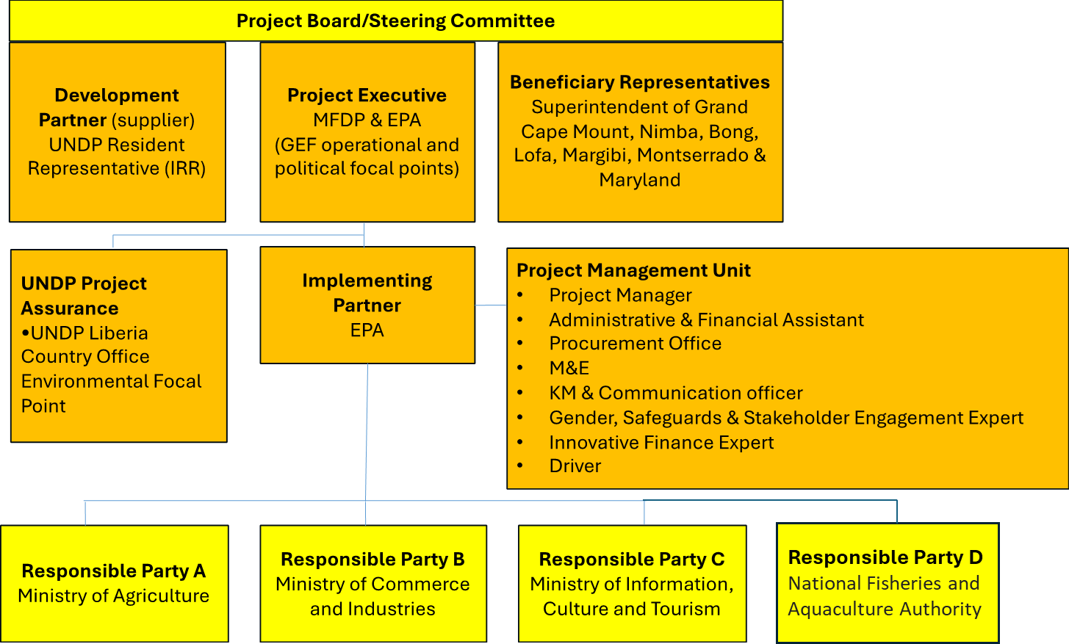

These responsibilities differ per Responsible Party and project component:
- Ministry of Agriculture (MoA)
  - Will host the PMU, and will sign a specific MoU with EPA for this.
  - The MoA will furthermore be responsible for facilitating the agriculture related activities under outputs 1.1.3, 1.1.4, 2.1.1. and 3.1.3.
- Ministry of Information, Cultural Affairs and Tourism (MICAT)
  - The MICAT will be responsible for facilitating the communication and ecotourism related activities under outputs 1.1.5, 2.1.2. and 3.1.3.
- Ministry of Commerce and Industry (MoCI)
  - The MoCI will be responsible for facilitating all private sector engagement and innovative finance related activities under outputs 3.1.1. and 3.1.2
- National Fisheries and Aquaculture Authority (NaFAA)
  - Under the project, the NaFAA will be responsible for facilitating fishery and aquaculture related activities activities under 1.1.3, 1.1.4, 2.1.1. and 3.1.3.
The PMU will organize technical implementation concertation meetings on a quarterly basis, assembling the project focal points from each responsible party to ensure coordination and concertation of activities and sharing of information as well as updating of timelines and work plans
Project stakeholders and target groups: The superintendents of the seven targeted counties will be part of the Project’s Steering Committee and will ensure that the interests of the target population in the counties is taken into account. Under Output 1.1, the targeted communities, government agencies, and stakeholders will be engaged in a series of participatory and inclusive land use planning workshops. Community consultations will be conducted, including FPIC consultations, with communities in villages where potential NbS interventions have been identified and obtain consent and FPIC for the implementation of NbS intervention and the establishment of PLUP implementation committees (composed of community representatives) will be supported, responsible for the dissemination and adoption of the plan objectives within the concerned localities and supporting their implementation.

Will the GEF Agency play an execution role on this project?
Yes No
If so, please describe that role here and the justification.
N/A

The project will leverage partnerships with a number of key stakeholders, including the private sector and other projects. As part of Component 2, the project will support MSMEs and build networks through a value chain approach and enable partnerships with various financial institutions under component 3. Furthermore, the project will seek to work collaboratively with other ongoing initiatives, as well as build on lessons learnt from recent initiatives, to enable scaling up as well as avoid duplication of efforts.
A central initiative that the proposed LDCF project will build on is the UNDP Liberia MSMEs Growth Accelerator Programme (Growth Accelerator Liberia), which is implemented in partnership with the Ministry of Commerce and Industry. The Growth Accelerator is designed to help revenue-generating small and medium sized enterprises and commercially viable agricultural cooperatives to scale-up their operations and contribute substantially to national economic development through increased revenues and job creation.
The projects will build on/leverage lessons learnt and coordinate with the following initiatives:

Lead Donor and Partners | Project Name, Location & Duration | Objectives and relevance for the GEF project, including entry points for collaboration | Funding Amount ($-equiv.)
Development partners  UNDP Liberia  European Union Delegation to Liberia  Swedish Embassy in Monrovia  Implementing partners  Ministry of Commerce and Industries  Forestry Development Authority | UNDP Liberia MSMEs Growth Accelerator Programme (Growth Accelerator Liberia)  2021 | Launched in 2021 and investing $1.3 million USD directly in 38 MSMEs and agricultural cooperatives, the GA is a business and agricultural cooperative accelerator, targeting impactful and innovative ventures and cooperatives in Liberia across all industries, providing essential business development training and mentorship.  The SARTLA project will set up a climate change focused facility under the existing challenge fund with a focus on supporting private sector investments that aim to develop climate resilient livelihoods and value chains in the 7 target counties of this project. | $1,300,000 in co-financing support
Development partner  International Development Association (IDA) of the World Bank Group  Implementing partners  Ministry of Commerce and Industries | Liberia Investment, Finance and Trade (LIFT) Project  2022-2027 | In May 2024, the Central Bank of Liberia (CBL), in collaboration with the Ministry of Commerce and Industry (MOCI), announced the signing of Participating Agreements (PAs) with 3 Financial Institutions for implementation The LIFT Project. The project supports MSMEs via access to finance for strengthening the country’s economy, and the Line of Credit aims to create access to credit to the tone of US$6 million for MSMEs to be channeled through competitively selected Participating Financial Institutions (PFIs).  It is proposed that the SARTLA project will collaborate with MOCI, World Bank and the 3 PFIs to leverage the expertise, interventions and outreach of LIFT-P to facilitate access to finance to MSMEs, community cooperatives and other private sector and community enterprises that will be supported under Outputs 3.2.1. and 3.2.2 | $40,000,000
Development partners  USAID  Implementing partners  EcoHealth Alliance (EHA) | Conservation Works Activity (CWA)  2021-2026 | CWA aims to conserve biodiversity while increasing sustainable economic growth in Liberia. It employs a One Health (OH) approach to promote the high value of Protected and Conserved Areas (PCAs) and conservation-compatible livelihoods and revenue generation, ensuring integration of conservation in land use management and enterprise decisions by emphasizing NbS that promote sustainable livelihoods, such as conservation-compatible revenue generation and the integration of conservation practices in land-use decisions.  Building on CWA OH, SARTLA can further enhance the ecological and human health benefits of its interventions, particularly in areas such as protected areas management, ecotourism, and agroforestry systems. The emphasis on community engagement and enterprise development under both projects presents opportunities for creating co-benefits that enhance rural incomes while preserving ecosystem services. | $20,000,000
Development partners  GCF  Implementing partners  Environmental Protection Agency | Enhancing Climate Information Systems for Resilient Development Project in Liberia (Liberia CIS)  2024-2029 | The main objective of this project is to establish a national institution with full mandate to enhance the resilience of Liberia’s social, economic, and environmental systems to climate induced hazards by strengthening the country’s adaptive capacities to integrate better long-term climate risk reduction and adaptation measures in national planning.  Both projects emphasize strengthening adaptive capacities: SARTLA at the community level in agriculture, fisheries, and ecotourism, and CIS at the national level through enhanced disaster risk knowledge, monitoring, and preparedness mechanisms. The shared focus on risk reduction, sustainable resource management, and integrating climate adaptation into broader planning presents opportunities for collaboration, particularly in areas such as community-based disaster preparedness, forecast-based financing, and improving rural resilience through the dissemination of climate risk information. | $11,431,969
Development partners  GCF  Implementing partners  Environmental Protection Agency | Monrovia Metropolitan Climate Resilience Project (MMCRP)  2021-2027 | MMCRP aims to enhance the resilience of the vulnerable coastal communities and infrastructure within the Monrovia Metropolitan Area (MMA) at West Point by constructing a rock revetment to protect the borough further against sea erosion, and increasingly frequent high-intensity storms, institutional capacity building and policy support for the implementation of Integrated Coastal Zone Management (ICZM) across Liberia, protect mangroves and strengthen gender-and-climate sensitive livelihoods to increase local adaptive capacity in Monrovia.  The two projects prioritize protecting ecosystems and livelihoods from climate-induced hazards—SARTLA through agro-ecological landscape conservation, value chain development, and innovative finance; and MMCRP through coastal protection, ICZM, and livelihood support in coastal communities. The emphasis on protecting mangroves in MMCRP aligns with SARTLA’s ecosystem-based adaptation approach, as well as the emphasis in both projects to integrate gender and climate-sensitive approaches. | $25,638,905
Development partners  World Bank  Implementing partners  Ministry of Agriculture | Smallholder Agriculture Development for Food and Nutrition Security (SADFONS)  2021-2026 | Overall project development objective to is to improve food and nutrition security and reduce poverty of targeted rural population in Liberia.  Both projects support the integration of sustainable agricultural practices to improve productivity and livelihood outcomes. Additionally, SADFONS’s focus on strengthening participatory farmer advisory services and building the capacity of the Ministry of Agriculture complements SARTLA’s objectives by ensuring that farmers have access to the knowledge, tools, and institutional support needed to implement climate-smart practices and expand their market opportunities. The two projects together could provide holistic support for climate adaptation, food security, and rural economic development. | $8,600,000
Development partners  World bank  Implementing partners  National Fisheries and Aquaculture Authority | Liberia Sustainable Management of Fisheries  2020-2026 | The project objective is to improve fisheries management and enhance livelihoods in selected fishing communities by: (a) improving governance and management reforms, developing human and institutional capacity, and improving policies, strategies, institutional and legal frameworks; (b) supporting activities that aim at increasing the national value addition provided by the fisheries sector toward improving conditions for industrial fish landing and for export of high-value fish species and fish products; and (c) supporting marine and inland fisheries production. Both projects can strengthen artisanal fisheries, particularly in Margibi and Maryland, by promoting sustainable fishing practices and increasing market access for high-value fish species. The emphasis on governance and policy reforms in the fisheries project complements SARTLA’s focus on landscape-level planning and ecosystem conservation could help ensure that coastal and inland fisheries are managed sustainably in the face of climate change. | $40,000,000
Development partners  UNDP, UNHCR, Denmark, Luxemburg, Norway, the Republic of Korea, Sweden, Switzerland  Implementing partners  Ministries of Commerce and Industries | Livelihoods and Employment Creation in Liberia  2021–2025 | The objective of the project is to contribute to reducing poverty and inequality in seven counties and to support the creation of income-generating opportunities for poor and vulnerable populations, including refugees and their host communities. The interventions of this project will be implemented under two components: i) supporting the creation of sustainable, viable and diversified livelihood opportunities for the youth, women and persons living with disabilities; and ii) strengthening business and enterprise development services.  The proposed SARTLA project will draw lessons from, and scale pilot initiatives implemented through the ‘Livelihoods and Employment Creation in Liberia’, with specific focus on aligning livelihood and business development strategies with climate adaptation efforts through the systems-based approach. | $7,820,000
Development partners  UNDP  Implementing partners  UNDP | UNDP Programme Support  Ongoing | UNDP plays an extensive supporting role in Liberia’s national development and currently provides ~USD60 million per year in grants. Several UNDP programmes pertain to coastal area development — the most relevant including: Liberian Decentralisation Support Programme (LSDP); Community-Based Recovery and Development; Micro-Finance — Improved Access by Women to Financial Services in Rural Areas; Disaster Risk Reduction Programme; Centre Songhai Liberia Initiative; as well as a project related to community-Based Forestry and Protected Area Management (CBFM) – Boosting Biodiversity Conservation and Improving Livelihoods of Forest-Fringe/Forest-Dependent Communities and Groups in Liberia. In this context, the SARTLA project will be in an excellent position to coordinate with these projects and find synergies. | $60,000,000
Development partners  GEF  Implementing partners  Conservation International | Reducing deforestation from palm oil and cocoa value chains  2021–2026 | This project will target the ‘Biodiversity’ and ‘Land Degradation’ GEF Focal Areas by combatting the degradation and deforestation of forested areas in northwestern Liberia by improving land-use management strategies, combined with a focus on ‘formal protected areas, community forestry, livelihoods and economic development’. The proposed LDCF project will draw lessons learned from land management and livelihood activities, with a focus of integrating best practices into a systems-based approach for climate resilience in Liberia. | $74,000,000
Development partners  AfDB  FAO  Implementing partners  Ministry of Agriculture | Smallholder Agriculture Development for Food and Nutrition Security (SADFONS)  2021-2026 | The objectives of the Project are to improve food and nutrition security and reduce poverty of targeted rural populations in Liberia. The objectives will be achieved through i) increased agricultural productivity and production of smallholder farmers (with a focus on food crops such as rice, cassava, and vegetables); ii) improved smallholders’ value addition, market access and income; and iii) strengthening the capacity of the government institutions, farmers and producer organizations. | $8,500,000
Development partners  Adaptation Funds  Implementing partners  IFAD  Ministry of Agriculture | Building Climate Resilience in Liberia’s Cocoa and Rice Sectors  2020-2026 | The objective of the project is to address key climate vulnerabilities in agriculture and water resources management in the rice and cocoa value chain, and hence contribute to immediate and longer-term development and resilience needs of poor vulnerable smallholder farmers in Liberia. Specifically, the projects will address: productivity; institutional capacity; alternative livelihoods for youth and women; and regulatory environment and institutional capacity. | $8,860,000
Development partners  GEF  Implementing partners  United Nations Development Programme  Environmental Protection Agency (EPA) | Enhancing the resilience of vulnerable coastal communities in Sinoe County of Liberia  2023-2029 | The project will address the vulnerability of coastal communities to these hazards by implementing a sea and river defense and risk management (SRDRM) approach to protect coastal assets and promote climate-resilient livelihood diversification. Long-term objectives include: i) introducing innovation and technologies into adaptation solutions and livelihoods that increase the resilience of coastal communities to climate change risks; and ii) using a systemic approach to mainstream climate change adaptation (CCA) and resilience options.  The proposed LDCF project will complement the efforts in Sinoe county, introducing a systems-based approach that will extend across other counties – including both coastal and inland counties to address the full extent of the agroecological landscape of Liberia. The strong private sector focus of the proposed project will help unlock finance for scaling successful livelihood practices. | GEF grant: $8,932,420  Cofinancing total: $11,473,510
Development partners  GEF  Implementing partners  Conservation International  Environmental Protection Agency (EPA) | Conservation and Sustainable Use of Liberia’s Coastal Natural Capital  2019–2025 | The objective of this project is to improve sustainable use and conservation of Liberia’s coastal natural capital by mainstreaming the value of ecosystems and their related services into Liberia’s development trajectory. Planned outcomes of the project include, inter alia: i) ensuring that the value of biodiversity and ecosystem services — particularly in coastal areas — is incorporated into national decision-making and development pathways by developing Liberia’s first national mangrove account under the Natural Capital Accounting (NCA) framework; and ii) developing community incentives for shifting away from unsustainable resource-use practices in favor of preservation, restoration and sustainable use. | GEF grant  $3,944,220
Development partners  UNDP  Implementing partners  UNDP | Energy and Environment (E&E) Programme  2020–2024 | The E&E Programme seeks to support the efforts of the GoL in achieving diversified and inclusive economic growth through investments in sustainable and eco-friendly agriculture, food security, job creation and enhanced resilience to climate change and natural disasters. The programme approach four thematic areas, namely: i) Livelihood Diversification, Disaster Resilience and Climate Change; ii) Biodiversity, Conservation Ecotourism and Land Management; iii) Renewable Energy Access; and iv) Waste Management. The results of this initiative are expected to carry beyond the timeframe of the E&E programme, providing value lessons and complementary outcomes that will align with the objectives of the proposed project. | $58,000,000

LDCF Core Indicators

Project Core Indicators |  | Expected at CEO Endorsement
1 | # direct project beneficiaries disaggregated by gender (individual people) | 99,460 (43,400 men and 56,060 women i.e 56.36% of women)
2 | Area of land/coastal or marine area managed for climate resilience (hectares)  2.1 Hectares of agricultural land managed for climate resilience  2.4 Hectares of forests managed for climate resilience  2.6 Hectares of freshwater area (wetlands) | 3,640.00 ha  2.1: 1140  2.4: 500  2.6: 2000
3 | Total number of policies, plans, and frameworks that will mainstream climate resilience  3.4 Number of institutional partnerships or coordination mechanisms established or strengthened | 3
4 | LCDF Core indicator 4 Number of people trained or with awareness raised  4.1 Number of people trained or made aware of climate change impacts and appropriate adaptation responses (sex disaggregated) at different target groups) | 81,800 (36,800 men and 45,000 women)
5 | Number of private sector enterprises engaged in climate change adaptation and resilience action  5.1 Amount of investment mobilized (US$) from private sector sources  5.4 Number of MSMEs incubated/accelerated with technical assistance, financial matchmaking, and/or direct financing | 5.1: 500,000 USD (non-grant financing secured)  5.4: 30

Risks to Project Implementation
Overall risk rating is Moderate.
A detailed breakdown of the risks is presented as:
Risk Categories | Rating | Planned mitigation measures
CONTEXT
Climate | High | Assessment: Extreme weather events such as floods or droughts may disrupt project activities.  Mitigation: Develop disaster preparedness plans, implement climate-resilient infrastructure, and establish early warning systems.
Environment and Social | Substantial | Assessment: Potential environmental risks include habitat disturbance, over-extraction of resources and community resistance to enforcement of bylaws. Mitigation: Conduct environmental assessments, promote sustainable resource use, implement community awareness campaigns, and enforce environmental safeguards.
Political and Governance | Moderate | Assessment: Governance-related risks include delays in stakeholder engagement and challenges with participatory governance.  Mitigation: Strengthen local governance structures and integrate grievance redress mechanisms.
INNOVATION
Institutional and Policy | Moderate | Assessment: Risks of inadequate policy alignment and institutional support.  Mitigation: Engage policymakers early, provide capacity-building for institutions, and align project interventions with national policies.
Technological | Moderate | Assessment: Limited capacity for technology adoption may hinder progress.  Mitigation: Deliver tailored training programs and provide technical support.
Financial and Business Model | Moderate | Assessment: Delays in funding and disbursement may impact activity timelines.  Mitigation: Ensure timely fund release and maintain buffer funding to address cash flow issues.
EXECUTION
Institutional capacity for implementation and sustainability | Substantial | Assessment: Low capacity within implementing teams or stakeholders may delay activity rollout.  Mitigation: Provide comprehensive training and mentorship programs.
Fiduciary: Financial Management and Procurement | Moderate | Assessment: Financial risks such as misuse of funds or misalignment with objectives.  Mitigation: Strengthen financial oversight and establish rigorous auditing mechanisms.
Stakeholder Engagement | Moderate | Assessment: Resistance or mistrust among communities may limit participation.  Mitigation: Conduct participatory planning workshops and establish feedback channels.
Other | High | Assessment: Risks of disruptions due to climate-induced hazards.  Mitigation: Integrate climate risk assessments into local-level project planning.
Financial Risks for NGI projects | N.A.
Overall Risk Rating | Moderate

Mitigation strategies and robust project management practices implemented under the proposed project will reduce residual risks, ensuring effective delivery of outcomes.
Safeguards Rating (endorsement level): Moderate

Alignment with GEF-8 Programming strategies and country/regional priorities
The project is aligned with the following Liberian policies, strategy and plans: the NDC and its investment plan; the National Policy and Response Strategy on Climate Change; the National Adaptation Plan; the National Biodiversity Strategy and Action Plan; the National Policy for Disaster Risk Management; the Liberia Land Degradation Neutrality Targets; the National Agriculture Development Plan (NADP) 2024-2030 (‘Liberians feed yourselves agenda’); the Liberia National Rice Development Strategy II 2018-2030; the Climate-Smart Agriculture (CSA) Program; the ARREST Agenda for Inclusive Development (AAID); the 2019 Fisheries and Aquaculture Management and Development Law; the National Tourism Plan and the Action Plan for Sustainable Tourism Development; Liberia’s Pro-Poor Agenda for Prosperity and Development (PAPD); the National Financial Inclusion Strategy (NFIS), 2020-2024.
The project is fully aligned with GEF-8 programming strategies. It has been designed to focus on two of the four themes of interest for LDCF under GEF-8, in recognition of the interdependency between human well-being and a healthy environment:
- Theme 1: Agriculture, Food Security, and Health
- Theme 3: Nature-Based Solutions
These becomes key in rural areas in Liberia where people’s livelihoods are deeply reliant on climate-sensitive natural resources. The project is also aligned with three Priority Areas and related entry points for the LDCF under GEF-8, namely:
- Priority Area 1: Scaling up finance – Through Component 3 directed towards innovative finance mechanisms, which includes the establishment of a private sector engagement facility (Output 3.1), as well as the access to finance developed with the development of partnerships (Output 3.2).
- Priority Area 2: Strengthening Innovation and Private Sector Engagement – Through the assistance of vulnerable communities to strengthen the sustainability of their livelihoods with development of climate-resilient agriculture and fisheries systems (Output 1.3), the development of local extension services to disseminate best practices in Nature-based Solutions (Output 1.4), the support for the establishment of complementary alternative livelihoods with a focus on women (Output 2.2), as well as the establishment of partnerships with larger commercial corporations for climate resilient livelihoods (Output 3.3).
- Priority Area 3: Fostering Partnership for Inclusion and Whole-of-Society Approach – Through a participatory and comprehensive land-use planning process to coordinate to NbS across diverse landscapes and introduce climate-resilient practices by Liberians to enhance food production while safeguarding biodiversity and ecosystems (Output 1.1), as well as the strengthen of capacities of different target groups to integrate sustainable climate-resilient livelihoods, value chains and enterprise development with the inclusion of women and youth.
Finally, the project adopts two of the three levers of transformation identified for LDCF:
- Lever of Transformation 2: Strengthened governance for adaptation
- Lever of Transformation 3: Knowledge exchange and collaboration
The project will contribute to key targets of the Kunming-Montreal Global Biodiversity Framework:
- Target 1: Plan and Manage all Areas to Reduce Biodiversity Loss
- Target 8: Minimize the Impacts of Climate Change on Biodiversity and Build Resilience
- Target 9: Manage Wild Species Sustainably to Benefit People
- Target 10: Enhance Biodiversity and Sustainability in: Agriculture, Aquaculture, Fisheries, and Forestry
- Target 11: Restore, Maintain and Enhance Nature’s Contributions to People
- Target 21: Ensure That Knowledge Is Available and Accessible to Guide Biodiversity Action
- Target 23: Ensure Gender Equality and a Gender-Responsive Approach for Biodiversity Action
The project is aligned with the United Nations Development Programme (UNDP) priorities, including the United Nations Sustainable Development Cooperation Framework (UNSDCF) and the United Nations Development Assistance Framework (UNDAF), through the strengthening of institutional and behavioral capacities to support the development of Liberians linked to sustainable responsible practices to be integrated in the different targeted sectors. This will support key issues and development challenges identified in the previous sections, as well as the information provided during the field mission. As part of the anticipated transformation, the project will facilitate the development of skills, abilities, and capacities among individuals and institutions, thereby enhancing behavioral changes. This will include the provision of support to women and youth, with a particular focus on addressing gender inequalities. Furthermore, the project will contribute to the following Sustainable Development Goals: SDG: SDG 1: No poverty; SDG 2: Zero hunger; SDG 5: Gender equality; SDG 7: Affordable and clean energy; SDG 8: Decent work and economic growth; SDG 12: Responsible consumption and production; SDG 13: Climate action; SDG 14: Life below water; and SDG 15: Life on land.

Policy requirements

Gender Equality and Women’s Empowerment:
We confirm that gender dimensions relevant to the project have been addressed during Project Preparation as per GEF Policy and are clearly articulated in the Project Description (Section B).
Yes No (If –and only if— NO is selected, a pop-up field should open for the Agency to provide an explanation)

- Does the project expect to include any gender-responsive-measures to address gender gaps or promote gender equality and women’s empowerment?
Yes No

If the project expects to include any gender-responsive measures to address gender gaps or promote gender equality and women empowerment, please indicate in which results area(s) the project is expected to contribute to gender equality:

closing gender gaps in access to and control over natural resources;
improving women’s participation and decision-making; and/or
generating socio-economic benefits or services for women.

- Does the project’s results framework or logical framework include gender-sensitive indicators?
Yes No tbd

Stakeholder Engagement
We confirm that key stakeholders were consulted during Project Preparation as required per GEF policy, their relevant roles to project outcomes has been clearly articulated in the Project Description (Section B) and that a Stakeholder Engagement Plan has been developed before CEO endorsement.
Yes No

Select what role civil society will play in the project:
Consulted only; Yes No
Member of Advisory Body; Contractor; Yes No
Co-financier; Yes No
Member of project steering committee or equivalent decision-making body; Yes No
Executor or co-executor; Yes No
Other (Please explain) Yes No

Private Sector
Will there be private sector engagement in the project?
Yes No

And if so, has its role been described and justified in section B “project description”?
Yes No

Environmental and Social Safeguards
We confirm that we have provided information regarding Environmental and Social risks associated with the proposed project or program, including risk screenings/ assessments and, if applicable, management plans or other measures to address identified risks and impacts (this information should be presented in Annex E).
Yes No (If –and only if— NO is selected, a pop-up field should open for the Agency to provide an explanation)

The overall Project Risk Classification is: Moderate

Other requirements

Knowledge management
We confirm that an approach to Knowledge Management and Learning has been clearly described during Project Preparation in the Project Description and that these activities have been budgeted and an anticipated timeline for delivery of relevant outputs has been provided.
Yes

Socio-economic Benefits
We confirm that the project design has considered socio-economic benefits to be delivered by the project and these have been clearly described in the Project Description and will be monitored and reported on during project implementation (at MTR and TER).
Yes

Annex a: FINANCING TABLES

GEF Financing Table
Trust Fund Resources Requested by Agency(ies), Country(ies), Focal Area and the Programming of Funds
GEF Agency | Trust Fund | Country/  Regional/ Global | Focal Area | Programming  of Funds |  | (in $)
 |  |  |  |  | GEF Project Grant (a) | GEF Project Non-Grant (for NGI only) (b) | Agency Fee (c) | Total  GEF Financing (a+b+c)
UNDP | LDCF | Liberia | Climate Change | LDCF country allocation | 8,932,420 |  | 848,580 | 9,781,000
Total GEF Resources |  |  |  |  | 8,932,420 |  | 848,580 | 9,781,000

Project Preparation Grant (PPG)
Was a Project Preparation Grant requested? Yes No
If yes: fill in PPG table (incl. PPG fee)

GEF Agency | Trust Fund | Country/  Regional/ Global | Focal Area | Programming  of Funds | (in $)
 |  |  |  |  | PPG | Agency  Fee | Total PPG Funding
UNDP | LDCF | Liberia | Climate change | LDCF Country allocation | 200,000 | 19,000 | 219,000
Total PPG Amount |  |  |  |  | 200,000 | 19,000 | 219,000

Sources of Funds for Country STAR Allocation
GFEF Agency | Trust Fund | Country/  Regional/Global | Focal Area | Source  of Funds | Total
Total GEF Resources

Focal Area Elements
Programming Directions | Trust Fund | (in $)
Programming Directions | Trust Fund | GEF Project Financing | Co-financing
CCA 1.1 | LDCF | 4,466,210 | 52,344,053
CCA 1.4 | LDCF | 4,466,210 | 52,344,053
Total Project Cost |  | 8,932,420 | 104,688,106

Confirmed Co-financing for the project, by name and type
Please include evidence for each co-financing source for this project in the tab of the portal
Sources of Co-financing | Name of Co-financier | Type of Co-financing | Investment  Mobilized | Amount ($) | Upload letters of co-finance
 | Ministry of Agriculture  Rural Economic Transformation Project (RETP) | Parralel co-fiancing | Investment mobilized | 54,000,000
 | National Fisheries & Aquaculture Authority (NFAA)  Liberia Sustainable Management of Fisheries Project | Parralel co-fiancing | Investment mobilized | 21,000,000
 | Government of Liberia Accelerated Community Development Programme (ACDP) | Parralel co-fiancing | Investment mobilized | 20,000,000
 | Environmental Protection Agency (EPA)  Green Climate Fund-Monrovia Metropolitan Coastal Resilient Project (MMCRP) | Parralel co-fiancing | Investment mobilized | 2,938,106
Donor Agency | Conservation International  Blue Ocean Programme | Parralel co-fiancing | Investment mobilized | 6,000,000
Donor Agency | UNDP | Cash | Investment mobilized | 750,000
Total Co-financing |  |  |  | 104,688,106

Description of the investment mobilized portion of the co-financing:
For MoA: The project supports improved productivity and market access for smallholder farmers and agri-enterprises for selected value chains. It will contribute to the achievement of Outcome 2, Output 2.1 of the SARTLA project: Sustainable climate-resilient livelihoods and agricultural value chains and enterprise development
For NaFAA: The project supports climate-smart fisheries management and improves the value-addition of fish and fish products and will contribute to Outcome 2, Output 2.1: Sustainable climate-resilient fisheries value chains and enterprise development
For the ACDP project: The ACDP is a Government of Liberia/UNDP flagship project that supports the increase in productivity and agro-pastoral production and will contribute to Outcome 2, Output 2.1 of the SARTLA project: Sustainable climate-resilient livelihoods and agricultural value chains and enterprise development through the provision of training and start-up inputs
For the EPA: Output 3 of the MMCRP is focused on protecting mangroves and strengthening gender- and climate-sensitive livelihoods to build local climate resilience in Monrovia. This will contribute to Outcome 1, Output 1.2: of the SARTLA for implementation of nature-based solutions to safeguard wetland ecosystems and services.
For CI: The project aims to promote the sustainable management of Liberia’s coastal and marine ecosystems. The project activities are dedicated to the conservation and restoration of marine and coastal ecosystem services to alleviate poverty, protect biodiversity, and mitigate and adapt to climate change. Through Enhanced education and outreach/public awareness and other activities, the project will contribute to the results under Output 1.3 of the SARTLA project: Sustainable and climate-resilient agriculture and fisheries systems established in vulnerable rural communities through capacity-building, demonstration projects, and community-led adaptation strategies.
For UNDP: the UNDP resources will be put towards grants for private sector actors to participants in the specific window of the GA, operated under the project under Output 3.1.

ANNEX b: EndorsementS

Name of GEF Agency Coordinator | GEF Agency Coordinator Contact Information
Name of Agency Project Coordinator | Agency Project Coordinator Contact Information

NGIs do not require a Letter of Endorsement if beneficiaries are: i) exclusively private sector actors, or ii) public sector entities in more than one country. However, for NGI projects please confirm that the agency has informed the OFP of the project to be submitted for Council Approval YES

Compilation of Letters of Endorsement
Please attach the Operational Focal Point endorsement letter(s) in this Annex. For SGP, use the SGP OFP endorsement letter format. For regional and global projects (as appropriate): please include a compilation of the signed LOEs in one PDF file in this annex.

ANNEX C: Project results framework
Please indicate the page number in the Project Document where the project results and M&E frameworks can be found. Please also paste below the Project Results Framework from the Agency document.
The Project Result framework can be found below as well as on page 36 of the Project Document (section V. Project Results Framework)
The M&E plan can be found on page 45 of the Project Document (section VI. Monitoring and Evaluation Plan).

PROJECT RESULTS FRAMEWORK

Contribution to the Sustainable Development Goal (s):
SDG 1: No poverty; SDG 2: Zero hunger; SDG 5: Gender equality; SDG 7: Affordable and clean energy; SDG 8: Decent work and economic growth; SDG 12: Responsible consumption and production; SDG 13: Climate action ; SDG 14: Life below water; SDG 15: Life on land .
Intended Outcome as stated in the UNSDCF Liberia 2020-2024 Country Programme Results and Resource Framework: By 2024, the most vulnerable and excluded groups have improved quality of life with right-based, gender-sensitive, inclusive, equitable access and utilization of essential social services in an environment free of discrimination and violence including humanitarian situations.
Applicable Output(s) from the UNDP Strategic Plan: This project is well in line with the three directions of change (structural transformation, leaving no-one behind, building resilience); 6-signature solutions (poverty and inequality, governance, resilience, environment, energy, gender equality) and all 3-enablers (strategic innovation, digitalization, development financing) of the UNDP Strategic Plan 2022-2025.
Project title and Quantum Project Number: Strengthening agricultural resilience through transformational livelihood adaptation in Liberia (SARTLA) – GEF ID 9672
Objective and Outcome Indicators  (no more than a total of 20 indicators) |  | Data Source | Baseline | Mid-term Target | End of Project Target | Data Collection Methods | Risks/Assumptions
Project Objective: | Building climate resilience in natural-resource dependent rural communities of Liberia through systems-based, transformational adaptation in the agricultural, fisheries and ecotourism sectors.
Project Objective: | Mandatory Indicator 1:  # direct project beneficiaries disaggregated by gender (individual people) | Project periodic reports  Project activity reports | 0 | Direct: 33,153 (14,466 men and 18,687 women) | Direct: 99,460 (43,400 men and 56,060 women i.e 56.36% of women) | PIRs  Annual reports  Activity reports | Assumption: Direct and indirect project beneficiary data will be collated and regularly maintained by the PMU  Risks: The identification of project activities to be implemented could be subject to political pressures.
Project Objective: | Indicator 2:  LCDF Core indicator 2  Area of land/coastal or marine area managed for climate resilience (hectares) | Project periodic reports  Maps of project areas and monitoring data | 0 | 800 ha | 3,640.00 ha | GIS mapping of landscapes under project intervention; review of land use practices from field reports | Assumption: Local communities support the project intervention  Risks: The identification of project activities to be implemented could be subject to political pressures.
Project Objective: | Indicator 3:  LCDF Core indicator 3  Total number of policies, plans, and frameworks that will mainstream climate resilience  3.4 Number of institutional partnerships or coordination mechanisms established or strengthened | Establishment of coordination mechanisms with the private sector | 0 | 1 | 3 | Reports  Interviews  Field observations | Assumptions Large-scale enterprises are willing to engage with MSMEs.  Linkages between large-scale enterprises and MSMEs are beneficial for both parties.  Risks Linkages may not be sustained after project termination.  Fluctuations in market prices or economic downturns (geo-political tensions, inflation, recession etc.) could negatively impact the partnerships.  Communities become over reliant on partnerships, making them highly vulnerable to changes in enterprise strategies or market conditions.
Project Objective: | Indicator 4:  LCDF Core indicator 4 Number of people trained or with awareness raised  4.1 Number of people trained or made aware of climate change impacts and appropriate adaptation responses (sex disaggregated) at different target groups: ) | Consultant reports  Workshop/training minutes and list of participants  Periodic reports  List of beneficiaries | 0 | 40,900 (18,400 men and 22,500 women) | 81,800 (36,800 men and 45,000 women) | Supervision and oversight missions  Interviews/Surveys | Assumption: Project beneficiaries are interested in and participate actively in project activities
 | Indicator 5:  LCDF Core indicator 5  Number of private sector enterprises engaged in climate change adaptation and resilience action  5.1 Amount of investment mobilized (US$) from private sector sources  5.4 Number of MSMEs incubated/accelerated with technical assistance, financial matchmaking, and/or direct financing | Project M&E reports | 0  0 | 5.1:0  5.4: 7 | 5.1: 500,000 USD (non-grant financing secured)  5.4: 30 | Conduct audits of the financial statements of supported entities.  Maintain records of loans and investments secured by the entities.  Annual reporting of technical and financial support provided to entities. | Assumptions Sufficient interest from private sector entities, CBOs, and cooperatives to participate in call for proposals.  Transparent selection of enterprises at application and selection stage ensuring high potential enterprises are supported.  Amongst the 30 entities supported with technical and financial resources, at least 10 entities demonstrate scalable results.  Non-grant financing is available and accessible to the required entities.  Risks Adaptation interventions may not be financially sustained after project termination.  Limited interest from private sector operators in project activities or value chains.  Resources provided remain insufficient to make a significant impact.  Climate shocks and changes in market conditions could deter the ability of entities to repay loans or attract further investments  Adverse economic conditions affecting lending and other financial products.
Project component 1 | Investment in conserving the agro-ecological landscape and food production systems
Project Outcome 1  Outcome 1: Improved management of the agro-ecological landscape through nature-based solutions and climate-resilient food production technologies for small-holder farmers and fishers. | Indicator 6:  2.1 Hectares of agricultural land managed for climate resilience  2.4 Hectares of forests managed for climate resilience  2.6 Hectares of freshwater area (wetlands) | Project periodic reports  Maps of project areas and monitoring data | 0 | 2.1: 200  2.4: 100  2.6: 500 | 2.1: 1140  2.4: 500  2.6: 2000 | GIS mapping of landscapes under project intervention; review of land use practices from field reports | Assumption: Local communities support the project intervention  Risks: The identification of project activities to be implemented could be subject to political pressures.
 | Indicator 7:  Number of farmers and fishermen trained in sustainable and climate resilient land and fishery production and management practices either directly or through improved extension services | Periodic reports  Supervision and oversight mission  Activity minutes/reports  Beneficiaries | 0 | 100 farmers (50% women) directly and 200 farmers (50% women) through improved extension services  50 fishermen and 100 fishermen through extension services. | 500 farmers (50% women) directly and 700 farmers (50% women) through improved extension services  200 fishermen and 400 fishermen through extension services. | Reports  Interviews  Field observations | Assumptions: Project beneficiaries are interested in and participate actively in project activities  Adequate financial, technical, and material resources are available to support the piloting and implementation of restoration and sustainable land management activities.  Capacity building efforts are conducted to empower local communities and stakeholders with the necessary skills and knowledge to implement and manage restoration and sustainable land management activities effectively.  Risks:
Outputs to achieve Outcome 1 | Output 1.1: Comprehensive land use plan developed in the agroecological landscapes to guide the coordination and implementation of nature-based solutions and climate resilient food production  Output 1.2: NbS is implemented on 500 ha of degraded forest and 2000 ha of wetland ecosystems to safeguard ecosystem services.  Output 1.3: Sustainable and climate-resilient agriculture and fisheries systems established in vulnerable rural communities through capacity-building, demonstration projects, and community-led adaptation strategies.  Output 1.4: Extension services are enhanced and capacity is built for NbS and Climate-Resilient Livelihoods in Fisheries and Agriculture  Output 1.5: A communication and knowledge management strategy is developed and implemented for disseminating best practices on NbS and climate resilient fisheries and agriculture
Project component 2 | Climate-resilient livelihoods, ecotourism, and value chain development
Outcome 2: Alternative, climate-resilient livelihoods, including ecotourism, supported by improved market access and value-added services in agricultural and coastal areas | Indicator 8:  Number of individual entrepreneurs or cooperatives that are making use of the agricultural or fishery business hubs (incl. skills trainings etc.) | Workshop/training minutes and list of participants  List of beneficiaries  Periodic reports | 0 | 1000 | at least 7000 (of which 1500 youth =>30 years old and 50% of them women, plus at least 3000 adult women per participating community) | Supervision and oversight missions  Interviews/Surveys  Interviews  Field observations | Assumptions: Active engagement and interest from women and youth micro-entrepreneurs in participating in project activities  Accessible markets and business opportunities for women and youth micro-entrepreneurs to sell their products or services within the value chains they operate in  Risks: Limited grant financing inaccessible to target beneficiaries.  Climate vulnerability and changes in market conditions could affect loan repayment capacity.
 | Indicator 9:  % increase in income for women and youth led eco-tourism businesses | Reports  List of beneficiaries  Workshop/training minutes and list of participants | 0 | 10% for both youth and women | 30%for both youth and women | Supervision and oversight missions  Periodic reporting  Interviews/Surveys  Field observations | Assumptions: Interest and motivation among women and youth to participate in eco-tourism skills training and capacity-building initiatives.  Engagement with key stakeholders at district level to support eco-tourism  Risks:
Outputs to achieve Outcome 2 | Output 2.1: Sustainable climate-resilient livelihoods and agricultural and fisheries value chains and enterprise development in target communities through provision of training and start-up inputs  Output 2.2: Alternative livelihoods including ecotourism established (with participation of at least 50% women) and linked with agricultural and fisheries value chains
Project component 3 | Innovative financing
Outcome 3:  Innovative financing architecture incentivizes private sector investment in climate-resilient agricultural technologies, livelihoods, and enterprises | Indicator 10:  Number of calls launched via the private sector engagement facility | Call documents | 0 | 2 | 5 | Periodic reports  Interviews/surveys | Assumptions  Transparent selection of enterprises at application and selection stage ensuring high potential enterprises are supported.  Risks  Limited interest from private sector operators in project activities or value chains.
 | Indicator 11:  Number of partnerships established with larger commercial, agro-processing and eotourism operators | Partnership agreements and contracts with large-scale enterprises  Project M&E reports | 0 | 2 | 5 | Periodic reports  Interviews/surveys  Annual reporting from large-scale enterprise on engagement activities.  Conduct market analysis to track the impact of partnerships on market access | Assumptions Large-scale enterprises are willing to engage with MSMEs.  Linkages between large-scale enterprises and MSMEs are beneficial for both parties.  Risks Linkages may not be sustained after project termination.  Fluctuations in market prices or economic downturns (geo-political tensions, inflation, recession etc.) could negatively impact the partnerships.  Communities become over reliant on partnerships, making them highly vulnerable to changes in enterprise strategies or market conditions.
Outputs to achieve Outcome 3 | Output 3.1: Establishment of private sector engagement facility with new funding windows opened under the UNDP Growth Accelerator Platform  Output 3.2: Partnerships established between private sector (MSMEs, cooperatives) partners, communities, and other stakeholders for Access to Markets and Access to Finance  Output 3.3: Partnerships established with larger commercial agriculture, agro-processing, and ecotourism corporations for climate resilient livelihoods
Project component | Monitoring & Evaluation
Outcome:  Monitoring and evaluation framework established and M&E activities conducted | Indicator 12:  MTR and TE delivered on time and according to expected quality (independent quality ratings S or better) | PIR produced  MTR produced  TE produced | 0 | MTR  2 PIR  independent quality ratings S or better  Gender action plan fully implemented and reported in PIRs, MTR and TE | TE  4 PIR  independent quality ratings S or better | MTR and TEGender Action Plan implementation reported | Risks: The project activities can be delayed or negatively impacted by the weak knowledge of GEF and UNDP project management procedures.
 | Indicator 13:  Stakeholder engagement plan fully implemented by end of project | Periodic reports | 0 | Stakeholder engagement plan updated | Stakeholder engagement plan fully implemented | Interviews | Risks: The project activities can be delayed or negatively impacted by the weak knowledge of the GEF and UNDP project management procedures.
Outputs to achieve Monitoring and Evaluation Outcome | M&E output 1: Project M&E framework  M&E output 2: Periodic M&E reports generated and submitted to UNDP LBR and Mid-term Evaluation and Terminal Evaluation executed

ANNEX D: status of utilization of Project Preparation Grant (PPG)
Provide detailed funding amount of the PPG activities financing status in the table below:

Project Preparation Activities Implemented | GETF/LDCF/SCCF Amount ($)
Project Preparation Activities Implemented | Budgeted Amount | Amount Spent To date | Amount Committed
International-71200 | 109,500.00 | 58,590.00 | 50,910.00
Local-71300 | 36,000.00 | 38,480.00 | -2,480.00
Supplies-72500 | 3,000.00 | 804 | 2,196.00
Training-75700 | 17,750.00 | 8,698.00 | 9,052.55
Travel-71600 | 27,750.00 | 11,680.00 | 16,070.00
Professional Services 74100 | 6,000.00 | 0 | 6,000.00
 | 200,000.00 | 118,252.00 | 81,748.00

annex E: project map and coordinates and detailed description of the conditions in the target counties

Latitude and Longitude of project sites
Geo Name ID  Required field if the location is not an exact site | Location Name  Required field | Latitude  Required field | Longitude  Required field | Location Description  Optional text field  (Figure 2)
Inland counties
 | Bong | 7.0025 | -9.4732 | Coordinates of the county capital: Gbarnga
 | Lofa | 8.4202 | -9.7538 | Coordinates of the county capital: Voinjama
 | Nimba | 7.3585 | 8.7092 | Coordinates of the county capital: Sanniquellie
Outland counties
 | Grand Cape Mount | 6.7507 | -11.3672 | Coordinates of the county capital: Robertsport
 | Margibi | 6.5300 | -10.3446 | Coordinates of the county capital: Kakata
 | Maryland | 4.3761 | -7.7007 | Coordinates of the county capital: Harper
 | Montserrado | 6.3144 | -10.8073 | Coordinates of the county capital: Monrovia

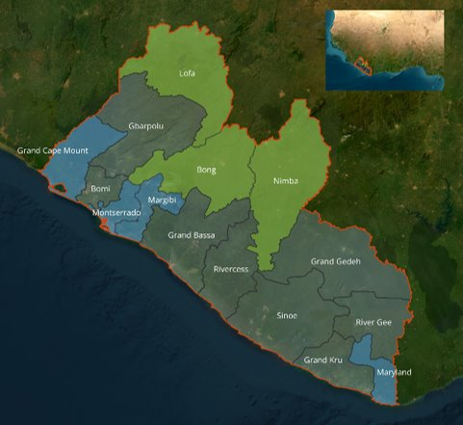
Map of Liberia with targeted coastal counties highlighted in blue, inland counties in green.​

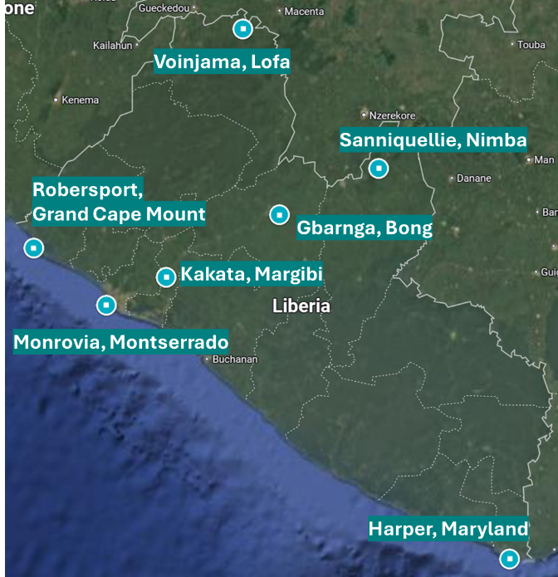
Capitals from the project interventions counties in Liberia

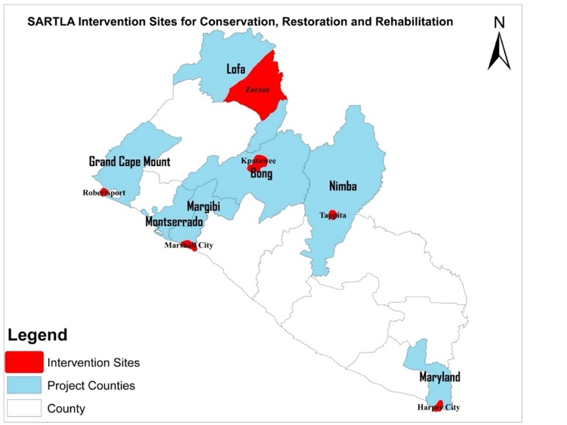
Intervention sites for conservation, restoration and rehabilitation in Liberia

OVERVIEW OF EXISTING CONDITIONS IN THE DIFFERENT COUNTIES

COUNTY  Characteristics of the county (population, ecosystems, livelihoods) | Existing Adaptation Practices | Main climate hazards | Environmental challenges | Challenges mentioned during PPG consultations
INLAND
BONG  Population: 467,561  Type of ecosystems: Tropical Freshwater ecosystems as Wetland, Waterfall and Riparian zone  Livelihoods: Subsistence agriculture, agro products processing, petty trade, eco-tourism. The common crops farmed includes, sugar cane, processed to local hard gin called Cane juice, oil palm processed to red oil, rice and cassava.  % of households engaged in agriculture: 47.2% | Agroforestry and Sustainable Agriculture | - Heat stress  - Heavy precipitation  - Flooding | - Caterpillar Infestation destroyed farm crops  - Illiteracy  - Shifting cultivation  - Illegal Logging  - Poverty and limited livelihood options  - Unsustainable mining and unsupervised application of mercury  - Degradation of riverbanks  - Water pollution and sedimentation in rivers due to illegal mining | Site of consultation: Kpatawee  - There is a noticeable change in the fish catch, possibly linked to mercury contamination of the major rivers including St. Paul and St. John rivers, which affects both food security and the livelihoods of local fisherfolks.  - Poor infrastructure, like roads, hinders the ability of communities to adapt to climate-related impacts, especially in rural areas where access to essential services and markets is limited.  - There is a prevalence of forest destruction due to mining and other activities which has contributed to the degradation of local ecosystems, reducing the natural carbon sequestration capacity and increasing the vulnerability of the areas to climate impacts like soil erosion and extreme weather.
LOFA  Population: 367,376  Type of ecosystems: Dense tropical rainforest, savanna & woodland, Agricultural landscape, river valleys, lowland swamps  Livelihoods: Subsistence and smallholder agriculture, Mining, Hunting, NTFPs  % of households engaged in agriculture: 71.5% | Community-based forest management | - Drought  - Heat stress  - Heavy precipitation  - River flooding | - Deforestation  - Artisanal mining  - Low Agricultural productivity  - Youth Marginalization and gender inequality  - Degradation of riverbanks  - River pollution with mercury | Site of consultation: Zorzor District  - There is water shortage due to prolong dry seasons, which in turn negatively affect agricultural productivity and livestock.  - Crops in some cases struggle to thrive, which leads to reduced yields and increasing food insecurity.  - The persistence of drought and higher temperature causes the scarcity of water resources.  - As a response to the decline in agricultural productivity, communities within district as an alternative engage in unsustainable land-clearing practices to expand farming areas. This leads to loss of biodiversity and decrease in ecosystems services, weakening the natural environmental’s resilience to climate shock.
NIMBA  Population: 621,841 (largest of Liberia's 15 counties)  Type of ecosystems: Secondary Forests, Upland Forest, tropical rainforest, rivers  Livelihoods: Subsistence and smallholder agriculture, Mining, Trade, charcoal production, petty trade, casual labor, Non-Timber Forest Products (NTFP), some farmers engage in small-scale beekeeping, snail farming, and fishery activities.  % of households engaged in agriculture: 54.7% | Community-based Forest Management; Agroforestry and Sustainable Agriculture | - Mean temperature  - Drought  - Erosion  - Heavy precipitation  - Pluvial and river flooding | - Habitat destruction due to deforestation  - Pollutants released into the rivers from mining  - Land tenure issues  - Limited access to extension services  - Degradation of riverbanks | Site of consultation: Tappita  - There is occurrence of flooding in low-lying areas prompted by intense and unpredictable rainfall, induced by climate change  - There is Inconsistency in rainfall during the growing season which affects the crops thus leading to reduced yields for staple crops including rice, cassava and vegetables.  - Farmers whose livelihoods depend on predictable climate patterns experience economic losses due to reduced yields and damaged resources.  - Communities tend to turn to deforestation for agriculture and charcoal production as alternative livelihood to cope with economic pressure.
COASTAL
GRAND CAPE MOUNT  Population: 178,867  Type of ecosystems: Estuaries, lagoon, lake, mangrove, sandy beach, rocky headlands, mangrove forest, coral reefs  Livelihoods: Fishing, Fish Mongering, fish processing, Petty trade, Eco-tourism, Catering and Small Businesses  % of households engaged in agriculture: 29.1% | Mangrove Conservation Initiatives; Ecotourism Development | - Mean temperature  - Marine heatwaves  - River flooding  - Sea-level  - Coastal flood  - Coastal Erosion  - Storm surges | - Marine pollution – Excessive plastic waste disposal and drainage runoffs into the oceans. Sargassum seaweed pollutes the beach front and affects the scenery. There is pollution of estuaries  - Habitat degradation – Crosscutting of the mangrove forest for construction, fish drying and tie & dye  - Fisheries/harvesting – High use of monofilament nets to fish. There is a lack of cold storage infrastructure, which represents difficulties to the fishers resulting in post-harvest losses. | Site of consultation: Robertsport  - Cumulative environmental stress is occurring through the continued exploitation and mismanagement of the natural resources in addition to climate change, which then weakens the resilience of ecosystems.  - Extensive impact on livelihood and food security from the combined effects of pollution, habitat degradation and unsustainable fishing practices reduces the fish catch, thus affecting primary sources of income. Additionally, there is a degradation of the aesthetic caused by pollution along the beach and the spread of sargassum seaweed that reduces the attractiveness of the areas for tourism
MARGIBI  Population: 304,946  Type of ecosystems: Estuaries, Mangrove forest, rivers, wetlands  Livelihoods: Fishing, fish mongering, and fish processing, petty trade, agriculture  % of households engaged in agriculture: 21% |  | - Mean temperature  - Heavy precipitation  - Marine heatwaves  - Sea-level  - River flooding  - Coastal flood  - Coastal erosion | - Habitat degradation – Crosscutting of the mangrove forest for fuel wood and fish drying. Backfilling of mangrove wetland. Sand Mining  - Fisheries/harvesting – Constant use of monofilament nets for fish and the application of dynamite as well as ghost fishing | Site of consultation: Marshall Landscape  - Limited visibility when fishing during the rainy season (July-Oct). The season also exacerbates the roughness of the sea conditions, leading to more dangerous waters for fishing activities.  - The roughness of the estuarine courses caused by changing climate conditions directly impacts the safety of small-scale fishers. Canoe accidents, which sometimes results in loss of life, damage equipment and loss of livelihood, are induced by climate-related shirts in weather patterns.  - The utilization of monofilament net due to the high cost of purchasing the multifilament net and unavailability of fishing gears in Liberia indirectly ties into broader economic vulnerabilities caused by climate change.  - Also, it leads to overfishing which induces the depletion of fish stocks, which is worsened by changing ocean conditions.  - Hygiene Issues-there is evidence of climate change-induced poverty, displacement and inadequate sanitation infrastructure that contributes to poor hygiene practices, such as open defecation on the beaches.
MARYLAND  Population: 172,587  Type of ecosystems: Sandy Beach, mangrove, Lagoon, coastal forest  Livelihoods: Fishing, Tourism, Farming, Agriculture, Sand mining  % of households engaged in agriculture: 26.6% |  | - Mean temperature  - Heavy precipitation  - Marine heatwaves  - Sea-level  - River flooding  - Coastal flood  - Coastal erosion  - Storm surges | - Fisheries/harvesting  - Habitat degradation | Site of consultation: Harper  - The coastal areas of Harper city, particularly around the seaport, is experiencing significant erosion. This is leading to loss of valuable land, and threat to infrastructures near the coastline, which impacts livelihoods, mainly for communities reliant on the coastal resources.  - Due to the coastal erosion, communities are displaced and forced to relocate, thus leading to socio-economic challenges, including loss of livelihood, increased poverty, and greater dependence on external aid.
MONTSERRADO  Population: 1,920,965  Type of ecosystems: Sandy Beach, Mangrove, Wetland, Rivers  Livelihoods: Fishing, Tourism  % of households engaged in agriculture: 8.3% |  | - Mean temperature  - Coastal Flood  - Coastal Erosion  - Heavy precipitation  - Sea-level  - Marine heatwaves | - Sand mining – In the St. Paul River and on the beach  - Marine & Freshwater Pollution  - Habitat degradation | Site of consultation: Virginia and Providence Island  - Excessive waste disposal and defecation into the du-river around the providence island that ruins the aesthetics and tourism potential of the island.  - Biodiversity loss due to mangrove wetland backfilling, and sand mining affecting fish catch.  - Land reclaimed by the sea and investment/property destruction due to coastal erosion in the Virginia area.
Note on access to land in the intervention areas:
Gender inequalities in access to resources and control over resources (land, money, credit, skills, etc.) is relevant as the legal frameworks stipulate equal access to resources regardless of gender and other statues. Land in particular is a critical driver of socio-economic status, especially in rural communities. It is also a key area to strengthen women’s economic rights and well-being, as customary practices and beliefs typically impede women’s access, ownership, and control over resources and their participation in resource management and governance. Women in rural areas tend to have less access to land ownership, credit, and resources, limiting their productivity and income generation. The 2018 Land Rights Act is fundamental to women's inclusion in land governance as the Land Rights Law has given powers in decision-making over land ownership to communities and provides mechanisms for communities to determine customary land claims. With the passage of the Land Rights Law, women and youth in Liberia can now equally participate in the development and management of land in their community unlike in the past where decision making on land use and management was almost exclusively in the hands of men. Nevertheless, the legal framework still faces some implementation and monitoring challenges in its efforts to ensure gender equality. Women are often not consulted in matters related to property ownership, despite the existence of concrete provisions in the Lands Right Act. While both men and women in rural areas have the same challenges with accessing formal justice systems due to literacy, access to information and travel costs, women face higher disparities due to higher rates of illiteracy and gender and social norms that prevent women from accessing these mechanisms.
The structure of local households is typically extended or nuclear, with male-dominated decision-making. Men are traditionally seen as the heads of households and primary decision-makers, especially concerning financial matters, land ownership, and long-term family planning. In rural areas, patriarchal norms are deeply ingrained, with men holding authority over the family’s economic resources, such as income from agriculture or small-scale trading. Women, particularly in counties like Nimba, Bong, and Lofa, are primarily responsible for managing the household, including cooking, childcare, and subsistence farming. While they play critical roles in maintaining the day-to-day operations of the home, their influence over larger financial decisions remains limited.
Land disputes are prevalent, particularly over land inheritance. Culturally, paternal lineage takes precedence in land inheritance, which often leads to conflicts over property rights, especially when land becomes more valuable after development. In some cases, community land is not formalized, leading to uncertainty in long-term farming investments.

ANNEX F: Environmental and Social Safeguards documents including Rating
Attach agency safeguard datasheet/assessment report(s), including ratings of risk types and overall project/program risk classification as well as any management plans or measures to address identified risks and impacts (as applicable).
Added as separate documents:
- Social and Environmental Safeguards Procedure (SESP)
- Environmental and Social Management Framework (ESMF)

ANNEX G: Budget Table

Quantum Outcome (GEF Component) | Quantum Output (GEF Component) | Quantum Responsible Party (UNDP, IP, or Responsible Party ) | Quantum Fund ID | Quantum Donor ID | Quantum Budgetary Account Code | Quantum Budget Account Description | Amount Year 2025 (USD) | Amount Year 2026 (USD) | Amount Year 2027 (USD) | Amount Year 2028 (USD) | Amount Year 2029 (USD) | Total (USD) | See Budget Note:
Component 1. Investment in conserving the agro-ecological landscape and food production systems | Outcome 1 Improved management of the agro-ecological landscape and climate resilient food production technologies for farmers and fishers | EPA | 62160 | 010003 | 71800 | Contractual Services-Imp Partn | 26,700 | 26,700 | 26,700 | 26,700 | 26,700 | 133,500 | 1
 |  | EPA | 62160 | 010003 | 71300 | Local Consultants | 121,500 | 36,000 | 36,000 | 0 | 0 | 193,500 | 2
 |  | EPA | 62160 | 010003 | 71600 | Travel | 52,500 | 15,000 | 25,500 | 10,500 | 10,500 | 114,000 | 3
 |  | EPA | 62160 | 010003 | 72100 | Contractual Services-Companies | 130,000 | 1,048,750 | 327,083 | 312,083 | 112,083 | 1,930,000 | 4
 |  | EPA | 62160 | 010003 | 75700 | Training, Workshops and Confer | 57,000 | 77,500 | 112,500 | 71,000 | 26,500 | 344,500 | 5
 |  | EPA | 62160 | 010003 | 72300 | Materials & Goods |  | 7,000 | 0 | 0 | 0 | 7,000 | 6
 | Total Outcome 1 |  |  |  |  |  | 387,700 | 1,210,950 | 527,783 | 420,283 | 175,783 | 2,722,500
 | Total Outcome 1 - UNDP TRAC |  |  |  |  |  | 0 | 0 | 0 | 0 | 0 | 0
 | Total Outcome 1 - GEF |  |  |  |  |  | 387,700 | 1,210,950 | 527,783 | 420,283 | 175,783 | 2,722,500
Total Component 1 |  |  |  |  |  |  | 387,700 | 1,210,950 | 527,783 | 420,283 | 175,783 | 2,722,500
Total Component 1 - UNDP TRAC |  |  |  |  |  |  | 0 | 0 | 0 | 0 | 0 | 0
Total Component 1 - GEF |  |  |  |  |  |  | 387,700 | 1,210,950 | 527,783 | 420,283 | 175,783 | 2,722,500
Component 2. : Livelihoods and value chain development | Outcome 2. Alternative, climate-resilient livelihoods, including ecotourism, supported by improved market access and value-added services in agricultural and coastal areas | EPA | 62160 | 010003 | 71800 | Contractual Services-Imp Partn | 9,600 | 9,600 | 9,600 | 9,600 | 9,600 | 48,000 | 7
Component 2. : Livelihoods and value chain development |  | EPA | 62160 | 010003 | 71300 | Local Consultants | 31,500 | 90,000 | 46,350 | 0 | 0 | 167,850 | 8
Component 2. : Livelihoods and value chain development |  | EPA | 62160 | 010003 | 71600 | Travel | 14,000 | 26,650 | 23,150 | 0 | 0 | 63,800 | 9
Component 2. : Livelihoods and value chain development |  | EPA | 62160 | 010003 | 72100 | Contractual Services-Companies | 0 | 400,000 | 1,048,000 | 180,000 | 180,000 | 1,808,000 | 10
Component 2. : Livelihoods and value chain development |  | EPA | 62160 | 010003 | 75700 | Training, Workshops and Confer | 28,000 | 34,000 | 34,000 | 0 | 0 | 96,000 | 11
Component 2. : Livelihoods and value chain development |  | EPA | 62160 | 010003 | 72200 | Equipment and Furniture | 0 | 60,000 | 909,283 | 47,283 | 47,283 | 1,063,850 | 12
Component 2. : Livelihoods and value chain development | Total Outcome 2 |  |  |  |  |  | 83,100 | 620,250 | 2,070,383 | 236,883 | 236,883 | 3,247,500
Component 2. : Livelihoods and value chain development | Total Outcome 2 - UNDP TRAC |  |  |  |  |  | 0 | 0 | 0 | 0 | 0 | 0
Component 2. : Livelihoods and value chain development | Total Outcome 2 - GEF |  |  |  |  |  | 83,100 | 620,250 | 2,070,383 | 236,883 | 236,883 | 3,247,500
Total Component 2 |  |  |  |  |  |  | 83,100 | 620,250 | 2,070,383 | 236,883 | 236,883 | 3,247,500
Total Component 2 - UNDP TRAC resources |  |  |  |  |  |  | 0 | 0 | 0 | 0 | 0 | 0
Total Component 2 - GEF Resources |  |  |  |  |  |  | 83,100 | 620,250 | 2,070,383 | 236,883 | 236,883 | 3,247,500
Component 3. Innovative finance | Outcome 3 Innovative financing architecture incentivizes private sector investment in climate-resilient agricultural technologies, livelihoods, and enterprises | EPA | 62160 | 010003 | 71800 | Contractual Services-Imp Partn | 32,700 | 32,700 | 32,700 | 32,700 | 32,700 | 163,500 | 13
Component 3. Innovative finance |  | EPA | 62160 | 010003 | 71300 | Local Consultants | 0 | 144,000 | 157,500 | 157,500 | 157,500 | 616,500 | 14
Component 3. Innovative finance |  | EPA | 62160 | 010003 | 71600 | Travel | 0 | 43,000 | 46,667 | 46,667 | 46,667 | 183,000 | 15
Component 3. Innovative finance |  | EPA | 62160 | 010003 | 72100 | Contractual Services-Companies | 70,000 | 177,500 | 177,500 | 177,500 | 127,500 | 730,000 | 16
Component 3. Innovative finance |  | EPA | 62160 | 010003 | 75700 | Training, Workshops and Confer | 20,000 | 49,000 | 78,000 | 78,000 | 52,000 | 277,000 | 17
Component 3. Innovative finance |  | EPA | 62160 | 010003 | 72300 | Materials & Goods | 0 | 80,000 | 80,000 | 80,000 | 80,000 | 320,000 | 18
Component 3. Innovative finance |  | EPA | 04000 | 010003 | 72600 | Grants | 175,000 | 175,000 | 175,000 | 175,000 | 0 | 700,000 | 19
Component 3. Innovative finance |  | EPA | 04000 | 010003 | 73400 | Rental & Maint of Other Equip | 38,000 | 3,000 | 3,000 | 3,000 | 3,000 | 50,000 | 20
Component 3. Innovative finance | Total Outcome 3 |  |  |  |  |  | 335,700 | 704,200 | 750,367 | 750,367 | 499,367 | 3,040,000
Component 3. Innovative finance | Total Outcome 3 - UNDP TRAC |  |  |  |  |  | 213,000 | 178,000 | 178,000 | 178,000 | 3,000 | 750,000
Component 3. Innovative finance | Total Outcome 3 - GEF Resources |  |  |  |  |  | 122,700 | 526,200 | 572,367 | 572,367 | 496,367 | 2,290,000
Total Component 3 |  |  |  |  |  |  | 335,700 | 704,200 | 750,367 | 750,367 | 499,367 | 3,040,000
Total Component 3 - UNDP TRAC resources |  |  |  |  |  |  | 213,000 | 178,000 | 178,000 | 178,000 | 3,000 | 750,000
Total Component 3 - GEF Resources |  |  |  |  |  |  | 122,700 | 526,200 | 572,367 | 572,367 | 496,367 | 2,290,000
Monitoring and Evaluation (M&E) | M&E (as per Table B of the CEO Endorsement Request) | EPA | 62160 | 10003 | 71800 | Contractual Services-Imp Partn | 24,000 | 24,000 | 24,000 | 24,000 | 24,000 | 120,000 | 21
Monitoring and Evaluation (M&E) | M&E (as per Table B of the CEO Endorsement Request) | EPA | 62160 | 10003 | 75700 | Training, Workshops and Confer | 18,000 | 0 | 0 | 0 | 0 | 18,000 | 22
Monitoring and Evaluation (M&E) | M&E (as per Table B of the CEO Endorsement Request) | EPA | 62160 | 10003 | 71600 | Travel | 6,000 | 6,000 | 6,000 | 6,000 | 6,000 | 30,000 | 23
Monitoring and Evaluation (M&E) | M&E (as per Table B of the CEO Endorsement Request) | EPA | M&E Total Implementing Party |  |  |  | 48,000 | 30,000 | 30,000 | 30,000 | 30,000 | 168,000
Monitoring and Evaluation (M&E) | M&E (as per Table B of the CEO Endorsement Request) | EPA | M&E Total UNDP TRAC resources |  |  |  | 0 | 0 | 0 | 0 | 0 | 0
Monitoring and Evaluation (M&E) | M&E (as per Table B of the CEO Endorsement Request) | EPA | M&E Total GEF resources |  |  |  | 48,000 | 30,000 | 30,000 | 30,000 | 30,000 | 168,000
Monitoring and Evaluation (M&E) | M&E (as per Table B of the CEO Endorsement Request) | UNDP | 62160 | 10003 | 71200 | International Consultants | 0 | 0 | 20,000 | 0 | 30,000 | 50,000 | 24
Monitoring and Evaluation (M&E) | M&E (as per Table B of the CEO Endorsement Request) |  | 62160 | 10003 | 71300 | Local Consultants | 0 | 0 | 8,000 | 0 | 10,000 | 18,000 | 25
Monitoring and Evaluation (M&E) | M&E (as per Table B of the CEO Endorsement Request) |  | 62160 | 10003 | 71600 | Travel | 0 | 0 | 7,000 | 0 | 7,000 | 14,000 | 26
Monitoring and Evaluation (M&E) | M&E (as per Table B of the CEO Endorsement Request) |  | M&E Total Implementing Party |  |  |  | 0 | 0 | 35,000 | 0 | 47,000 | 82,000
Monitoring and Evaluation (M&E) | M&E (as per Table B of the CEO Endorsement Request) |  | M&E Total UNDP TRAC resources |  |  |  | 0 | 0 | 0 | 0 | 0 | 0
Monitoring and Evaluation (M&E) | M&E (as per Table B of the CEO Endorsement Request) |  | M&E Total GEF resources |  |  |  | 0 | 0 | 35,000 | 0 | 47,000 | 82,000
Total M&E |  |  |  |  |  |  | 48,000 | 30,000 | 65,000 | 30,000 | 77,000 | 250,000
Total Component 4 - UNDP TRAC resources |  |  |  |  |  |  | 0 | 0 | 0 | 0 | 0 | 0
Total Component 4 - GEF Resources |  |  |  |  |  |  | 48,000 | 30,000 | 65,000 | 30,000 | 77,000 | 250,000
Project Management Cost (PMC) | PMC | EPA | 62160 | 10003 | 71800 | Contractual Services-Imp Partn | 69,600 | 69,600 | 69,600 | 69,600 | 69,600 | 348,000 | 27
Project Management Cost (PMC) | PMC | EPA | 62160 | 10003 | 72800 | Information Technology Equipmt | 12,000 | 0 | 0 | 0 | 0 | 12,000 | 28
Project Management Cost (PMC) | PMC | EPA | 62160 | 10003 | 72500 | Supplies | 500 | 500 | 500 | 500 | 500 | 2,500 | 29
Project Management Cost (PMC) | PMC | EPA | 62160 | 10003 | 75700 | Training, Workshops and Confer | 3,500 | 3,500 | 3,500 | 3,500 | 3,500 | 17,500 | 30
Project Management Cost (PMC) | PMC | EPA | 62160 | 10003 | 74500 | Miscellaneous Expenses | 3,984 | 3,984 | 3,984 | 3,984 | 3,984 | 19,920 | 31
Project Management Cost (PMC) | PMC | EPA | PMC Total Implementing Party |  |  |  | 89,584 | 77,584 | 77,584 | 77,584 | 77,584 | 399,920
Project Management Cost (PMC) | PMC | EPA | PMC Total UNDP TRAC |  |  |  | 0 | 0 | 0 | 0 | 0 | 0
Project Management Cost (PMC) | PMC | EPA | PMC Total GEF |  |  |  | 89,584 | 77,584 | 77,584 | 77,584 | 77,584 | 399,920
Project Management Cost (PMC) | PMC | UNDP | 62160 | 10003 | 74100 | Professional Services | 4,500 | 4,500 | 4,500 | 4,500 | 4,500 | 22,500 | 32
Project Management Cost (PMC) | PMC |  | PMC Total Implementing Party |  |  |  | 4,500 | 4,500 | 4,500 | 4,500 | 4,500 | 22,500
Project Management Cost (PMC) | PMC |  | PMC Total UNDP TRAC resources |  |  |  | 0 | 0 | 0 | 0 | 0 | 0
Project Management Cost (PMC) | PMC |  | PMC Total GEF resources |  |  |  | 4,500 | 4,500 | 4,500 | 4,500 | 4,500 | 22,500
Total PMC |  |  |  |  |  |  | 94,084 | 82,084 | 82,084 | 82,084 | 82,084 | 422,420
PMC Total UNDP TRAC |  |  |  |  |  |  | 0 | 0 | 0 | 0 | 0 | 0
PMC Total GEF |  |  |  |  |  |  | 94,084 | 82,084 | 82,084 | 82,084 | 82,084 | 422,420
Grand Total (UNDP+GEF) |  |  |  |  |  |  | 948,584 | 2,647,484 | 3,495,617 | 1,519,617 | 1,071,117 | 9,682,420
Grand Total - TRAC Resources |  |  |  |  |  |  | 213,000 | 178,000 | 178,000 | 178,000 | 3,000 | 750,000
Grand Total - GEF |  |  |  |  |  |  | 735,584 | 2,469,484 | 3,317,617 | 1,341,617 | 1,068,117 | 8,932,420

Budget Note No. | Budget Note (Description)
1 | Gender, Safeguards and Stakeholder Engagement Expert (PMU) - 100% @ USD 1,500 for 58 months (50% under outcome 1.1 and 50% under outcome 3.1) ; KM and Communications Officer (PMU - Component 1) - 100% @USD 1,500 for 60 months
2 | National consultant - GIS specialist to conduct the land use assessment based on satellite images @USD450/day for 60 days in Y1 ; National consultants to engaged targeted communities and stakeholders in land planning workshops, formulate a comprehensive plan to address ecosystem degradation and address community needs @USD450/day for 210 days (30 days per county) altogether in y1 ; NC to conduct assessment and provide recommendations to establish a research programme at university of Liberia) @USD450/day for 80 days in y2 ; NC to run a mentorship programme for women and persons with diabilities at the university of Liberia @USD450/day for 80 days in y3
3 | Travel for national consultant to ground truth land assessment @USD1500/trip for 7 trips Y1 ; Travel for national consultants to conduct participatory land use planning workshops @USD1500/trip for 14 trips Y1 ; Travel for safeguards expert to conduct FPIC trainings in y1 @USD1500/trip for 7 trips ; Travel expenses for PMU safeguards expert to conduct trainings @1500/training for altogether 35 trainings over 5 years ; Travel for NC to conduct assessment and provide recommendations to establish a research programme at universities @USD1500/trip for three trips in y2 ; Travel for trained extension workers to deliver the workshops @USD1000/workshop for 15 workshops atogether in y3
4 | Sub-contract national NGOs to conduct forest restoration activities with the communities @USD200.000 during Y2,3,4 ; Sub-contract national NGOs to conduct mangrove restoration activities with the communities @USD200.000 during Y2,3,4 ; Subcontract national NGO to rehabilitate 1000 hectares of degraded wetlands with the communites @USD200.000 during y2,3,4 ; Subcontract to an NGO to conduct a feasibility study for the establishment of a wetland conservaton area in Marshall @USD80000 in y2 ; Subcontract to an NGO to support the EPA/FDA in establishing a community mangrove conservation area including establishing eco-guards to enforce the process @USD100.000 across y3-5 ; Subcontract an NGO to Implement a large-scale awareness raising campaign about unsustainable livelihood practices (mining, sand mining, deforestation, littering) @USD100.000 in y1 ; Subcontract an NGO to support the enforcement of local by-laws for environmental protection  Community sensitization, traditional leadership involvement, and multi-stakeholder partnerships, training local enforcement officers,providing resources for their enforcement activities, and legal training for community members @USD200.000 during y2-5 ; Subcontract an NGO to design and deliver a series of capacity building workshops on risks and best practice management measures related to biodiversity conservation, invasive species, human-wildlife conflicts, illegal wildlife trade and other emerging issues. @USD100.000 in y2 ; Sub-contract to establish 10 demonsration sites for climate smart agroforestry, sustainable rice intensification or small scale irrigation linked to the agricultural colleges @USD35.000/site in y2 ; Sub-contract to train 500 farmers (50% women) in techniques that improve soil health, water retention, and crop yields @USD25.000 in y2 ; Subcontract to implement sustainable small-scale fisheries systems based on FAO Voluntary Guidelines for Securing Sustainable Small-Scale Fisheries in Marshall, Robertsport, and Harper. Buy material and provide training on climate-resilient fishing practices @USD75.000 in y2 ; Subcontract to promote livelihoods such as mangrove-based aquaculture (crab and oyster farming in Marshal). Buy the equipment, provide technical training in sustainable practices @USD75.000 in y2 ; Sub-contract to a national firm to develop and deliver a capacity buidling program for 50 extension workers on NbS, sustainable agriculture, and fisheries @USD50,000 Y2 ; Contract with a firm to establish the project website @USD30,000 ; Sub-contract to national firm to produce multi-media content and take care of the dissemination @USD75.000 in y2-5 ; Sub-contract to national firm to revitalize existing knowledge sharing platforms such as the EKMS and CCKSP and keep up to date @USD10.000/year for y2-5 ; Sub-contract to national firm to communicate and train the wider public and local stakeholders to use the EKMS and CCKSP platforms and to train journalists @USD15.000/year in y2 & 3
5 | 7 trainings on FPIC in y1 @USD2500/training ; 1 traning per year per county on safeguards and gender conducted by the PMU sfaguards expert @USD2500/trainng, total 35 trainings in 5 years ; 14 workshops in counties to engage and conduct participatory land use planning @USD 3000/workshop y1 ; One workshop outside Monrovia to discuss results of land use asssessment and prioritise communities for intervention in y1 @USD13000 ; Meetings for PLUP establisment and functioning @USD1000/year/county for 5 years ; 1 training per year on UNDP and government social and environmental safeguards and procedures @2000/training ; Workshop in Monrovia to discuss and present research programme recommendations @USD3500/workshop with 35 participants in y2 ; Workshop in Monrovia to discuss and present research programme recommendations @USD 5500/workshop with 35 participants in y2 ; Three workshops at the University of Liberia for the mentorship programme in y3 @USD 5500/workshop ; 15 workshops and hands-on demontrastions facilitated by the trained extension workers @3000/workshop in y3 ; Two workshops to get buy in of government staff and different ministries to use the EKMS and CCKSP platforms @USD4000/workshop in y2 and 3 ; Seven workshops to get buy in of local level stakeholders to use the EKMS and CCKSP platforms @USD3000/workshop in y2 and 3 ; 1 national knowledge sharing event in y 4 outside Monrovia @USD 30,000 ; Budget for participating in South-South exchanges @USD10000 lump sum to be spent in y3
6 | Satellite images for land use assessments @USD7000 Y1
7 | Driver 100% @USD800/month for 60 months
8 | 3 national consultants to support producers and entrepreneurs in the target communities @USD 450/day for 140 days altogether in y1 and 2 ; NC to advise on the potential requirements for procuring materials or including specific construction or access requirements to facilitate the inclusion of persons with disabilities in the hubs @USD450/day for 80 days in y2 ; NC to develop a business model for use of the facilities at the agri-business hubs by the different cooperatives and raise awareness @USD450/day for 53 days in y3 ; NC to provide capacity building for the government tourism body to be able to manage and drive the tourism interventions, including tourism promotion @USD450/day for 100 days in y2 and 3
9 | Travel for 3 national consultants to support entrepreneur groups in the target communities @USD2000/trip for 14 trips spread across y1 and 2 ; Travel for NC to develop and provide recommendations on requremenst for people with disabilities @USD1500/trip for 7 trips in y2 ; Travel for NC to develop and provide recommendations for the business model for use of the agribusiness hubs and raise awareness @USD1500/trip for 14 trips in y3 ; Travel for NC to provide capacity building for the government tourism body to be able to manage and drive the tourism interventions, including tourism promotion @USD4300 to be spent in y2 and 3
10 | Subcontract to firms to build climate resilient fishery and aquaculture processing, aggregation and storage units or warehouses in 1 location in y3. building (workshop) @ 50.000, Installations of storage facilities @ 20.000 , Workshop setup and maintenance area @ 17.000. adaptations for access to persons with disabilities @USD30.000 total @USD117.000 ; Subcontract to firms to build climate resilient processing, aggregation and storage units or warehousesin 3 locations in y3. building (workshop) @ 50.000 each, Installations of storage facilities @ 20.000 each, Workshop setup and maintenance area @ 17.000 each, adaptations for access to persons with disabilities @USD30.000 each total @USD351.000 ; Subcontract to conduct an agricultural production assessment in selected 7 counties to determine the optimal locations for establishing hubs@USD50.000 in y2 ; Subcontract to provide technical traning at the fisheres business hub @USD25.000/year for years 3-5 ; Subcontract to provide technical traning at the 3 business hubs @USD25.000/year/hub for years 3-5 ; Subcontract to provide business (operations, financial management, bookkeeping), marketing and branding skill trainings to all cooperatives at the 4 business hubs @USD20.000/year/hub for years 3-5 ; Subcontract to train 50 staff members comprising of regional agricultural specialists from the Ministry of Agriculture in climate smart agriculture for key crops (rice, vegetables) at the hubs @USD50.000 in y4 ; Subcontract for an NGO that identifies ecotourism opportunities with communities and trains them on setting up ecotoursm cooperatives and business skills @USD350,000 spread across y2 and 3 ; Subcontract for a firm that identifies briquette opportunities with communities and trains them on setting up cooperatives and business skills @USD350,000 spread across y2 and 4
11 | 14 workshops in counties to facilitate entrepreneurs and individuals @USD4000/workshop in y1 & 2 ; 7 workshops to assess business model and raise awareness about the business hubs @USD4000/workshop in y3 ; Three workshops in Monrovia for government tourism body @USD4000/workshop spread across y2 & 3
12 | Imputs for fishery hub @USD41.850 spread across y3-5 ; Inputs for agricultural hubs@USD100.000 spread across y3-5 ; Procurement of machinery and equipment for 1 fishery hubs  Refrigerating @50.000, smoking @ 40.000, Packaging equipment @ 40.000. Solar panes @12.000 Total @142.000 in y3 ; Procurement of machinery and equipment for the 3 agri hubs  Tractors @ 60.000, Harvesters @ 50.000 Treshers @ 50.000, Sorting and grading machines @ 40.000, Packaging equipment @ 40.000. Total @720.000 in y 3 ; Materials for sustainable cook stoves to reduce harmful practices @USD60.000 in y2
13 | Innovative finance expert - 100% @USD 2,000 for 60 months ; Gender, Safeguards and Stakeholder Engagement Expert (PMU) - 100% @ USD 1,500 for 58 months (50% under outcome 1.1 and 50% under outcome 3.1)
14 | National consultant to provide TA, training, capacity building on sustainable briquette production to private sector entities; @USD450/day for 80 days spread across y2-5 ; National consultant to provide TA, training, capacity building on agricultural value chain development (agricultural product/commodity sourcing/buying strategy and planning, processing units)@USD450/day for 200 days spread across y2-5 ; NC to provide TA, training, capacity building on fisheries and aquaculture @USD450/day for 100 days spread across y2-5 ; NC to provide TA, training, capacity building on ecotourism value chain development @USD450/day for 150 days spread across y2-5 ; NC to provide TA, training, capacity building on access to finance/insurance products; investment planning, leveraging co-investments and capital structuring (equity; loans; grants ) and supporting technology/equipment procurement to selected private sector entities/consortia. @USD450/day for 150 days spread across y2-5 ; National consultants to provide TA to partnerships between communities and private sector in y2-5 @USD450/day for 120 days ; National consultant to provide TA for research and design of incentive programme for communities to undertake ecosystem restoration @USD450/day for 75 days in y2 ; National consultant to conduct feasibility study for the establishment of an Agricultural Enterprise Development Bank @USD 450/day for 45 days in y2 ; National consultant for provision of TA to establish partnerships between communities and agro-processing / export-oriented companies @USD450/day for 150 days spread across y3-5 ; National consultant to provide TA to establish partnerships between communities and eco-tourism ventures, including linking larger tourism operators with agricultural and fisheries supply chains developed under Output 2.1.1 @USD450/day for 150 days spread across y3-5 ; NC to assist in the development of blended finance instruments and mobilization of capital to facilitate access to finance for high potential enterprises in output 3.1 and 3.2. @USD450/day for 150 days spread across y3-5
15 | Travel for the five national consultants that provide TA, training and capacity buidling for briquette, agricultural value chains, fisheries, ecotourism, access to finance to pivate sector entities @USD80.000 spread across y2-5 ; Travel for national consultant that provide TA for partnerships communities-private sector @USD1500/trip for 7 trips/year in years 2-5 ; Travel for national consultant to provide TA for research and design of incentive programme @USD1500/trip for five trips in y2 ; Travel for national consultant to conduct the feasibility study for Agricultural Enterprise Development Bank @USD5000 in y2 ; Travel for national consultant for provision of TA to establish partnerships between communities and agro-processing / export-oriented companies @USD1500/trip for 14 trips spread across y3-5 ; Travel for national consultant to provide TA to establish partnerships between communities and eco-tourism ventures, including linking larger tourism operators with agricultural and fisheries supply chains developed under Output 2.1.1 @USD1500/trip for 14 trips spread across y3-5 ; Travel fo NC for development of blended finance instruments and mobilization of capital to facilitate access to finance for high potential enterprise @USD6500 to be spread across y3-5
16 | Contract for a firm to establish the private sector engagement platform to be operational y2-5 @USD50.000 ; Contract with GA Program team and their selected service provider for disbursement and monitoring (GA Fund Manager Contract) @USD20.000/year ; Contract with service provider for establishment of funding windows, call for proposals, evaluation, approval, monitoring in years 1-4 @USD50.000/year ; Individual agreement with service provider to provide TA for basic business services like book-keeping, marketing, sales, distribution, daily operations etc., to the selected private sector entities under the funding windows @USD50.000/year in Y2-5 ; Contract for a firm to facilitate access to finance to communities, private sector and other value chain actors in partnership with World Bank Liberia Investment Finance and Trade (LIFT-P) Project in y2-5 @100.000 in total ; Service Contract @USD20.000/year for audit of private sector in year 2-3-4-5, for a total budget of USD80.000 in 5 years
17 | Training budget for TA provided by NC to private sector entities so they can access and benefit from the new funding windows under the UNDP GA @USD100.000 to be spent across y1-5 ; Budget to hold a hybrid (online + physical) meeting of the private sector engagement platform by UNDP and EPA at least once per quarter in y2-5 @USD2500 /meeting during years 2-5 ; Budget to host workshops for technical assistance to establish partnerships betwen communitiesand private sector @USD4000/workshop for 14 workshops across y2-5 ; Two meetings to discuss results of feasibility study Agricultural Enterprise Development Bank @USD2500/meeting in y2 ; Budget to host two workshops for technical assistance to selected private entities under the Private Sector Engagement Platform to develop partnerships between the private entities and CBOs, local communities and value chain actors outside of Monrovia @USD13000/workshop one in y3 and one in y4 ; Budget to host two workshops for technical assistance to selected private eco-tourism entities under the Private Sector Engagement Platform to develop partnerships with local communities and CBO outside of Monrovia @USD13000/workshop one in y3 and one in y4 ; Budget to host three workshops with high potential enterprises in output 3.1 and 3.2 on blended finance instruments @USD8000/workshop one each in y3-5
18 | Materials for sustainable briquette production TA @USD20.000/year in y2-5 ; Materials for agricultural value chain TA @USD20.000/year in y2-5 ; Materials for fish and aquaculture TA @USD20.000/year in y2-5 ; Materials for ecotourism TA @USD20.000/year in y2-5
19 | Grants to participating communities under the GA extension @USD700.000 spread across y1-4 from UNDP TRAC
20 | Project vehicle Land Rover Defender @USD35,000 from UNDP TRAC ; Vehicle maintenance, insurance, etc @USD 3000/year from UNDP TRAC
21 | M&E Officer (PMU) - 100% @ USD 2,000 for 60 months to take care of the M&E required work to report on progress made in reaching GEF core indicators and project results included in the project results framework
22 | Inception workshop @USD 18,000 in Monrovia
23 | Travel for PMU/M&E supervision missions to project sites @USD 1,500/trip for 20 trips
24 | International consultant to conduct MTR @USD 20,000 RP UNDP ; International consultant to conduct TE @USD 30,000 RP UNDP
25 | National consultant to conduct MTR @USD 8,000 RP UNDP ; National consultant to conduct TE @USD 10,000 RP UNDP
26 | Travel for international consultant for MTR @USD5000 RP UNDP ; Travel for national consultant for MTR @USD 2000 RP UNDP ; Travel for international consultant TE @USD 5000 RP UNDP ; Travel for national consultant for TE @USD 2000 RP UNDP
27 | Project Manager (PMU) - 100% @USD 2,900/month for 60 months ; Administrative and financial assistant (PMU) - 100% @ USD 1,450 for 60 months ; Procurement officer (PMU) - 100% USD 1,450 for 60 months
28 | IT equipment PMU @USD 2,000/unit for 6 units
29 | Office supplies PMU @USD 500/year for 5 years
30 | PSC Meetings (two per year @USD1750/meeting)
31 | Insurance costs @USD 1,464/year ; Telecommunication fees @approx. USD35/month/person for 60 months and 6 people
32 | Audit @USD 4500/year for 5 years RP UNDP

ANNEX H: Comment Audit Trail

 | Comment | Response
 | STAP – 22.01.2024 | 13.12.2024 and 05.03.2025
 | General
 | STAP acknowledges Liberia’s project, “Strengthening agricultural resilience through transformational livelihood adaptation”. The project intends to apply a systems-thinking approach to build resilience of communities and food production systems through alternative livelihoods and interventions that are robust to climate risks. STAP welcomes the holistic, inter-sectoral and ecosystem-based focus of these approaches and makes several recommendations below on how to apply them. Greater attention to climate risks in the project logic is a necessary condition that STAP urges the project team to address, given Liberia’s high vulnerability to climate change impacts.  STAP welcomes the use of innovative finance and value chains to diversify livelihoods. To manage the various risks affiliated with financial innovation and value chains, STAP highly encourages UNDP to develop good monitoring of component 3 to generate rapid learning that can be realized through adaptive management, and the consideration of social and behavioral change for the design of interventions relevant to component 1, and 2.  STAP ASSESSMENT  X Minor - STAP has identified some scientific and technical points to be addressed in project design | We have strengthened the description of the climate hazards, the climate impacts, risks and vulnerabilities that are to be expected under projected climate change and current socio-political conditions in Liberia, both under RCP 4.5 and RCP 8.5. We have highlighted the differential impact of climate change on different sectors, geographical areas and population groups.  The prodoc includes a full-fledges M&E design. The indicators allow for mid-term assessment of progress and for extraction of first lessons learnt. Similarly, the indicators to measure achievement of results under component 1 and 2 allow for measurement of behavioral change due to the interventions.
 | Project rationale, and project description – are they sound?
 | The project rationale is based on thorough information on climate trends and projections, and how they are likely to impact agricultural productivity and sea level rise in Liberia. This section also lists drivers of degradation (agricultural and forest) that may impact populations’ vulnerability to climate change. Figure 6 is particularly helpful in demonstrating the importance of climate change as a key driver. Baseline information about the project is also provided, and relevant – in particular the baseline narrative on the Growth Accelerator Program, which this initiative will build on. STAP appreciates the co-financing of 103 millon dollars and how the project will build on, and cooperate, with highly complementary projects (described in Table 2).  With regard to the project description, this section is unnecessarily long. A more succinct description is necessary to strengthen the project logic. Understanding the project reasoning is difficult due to the superfluous text.  Further thought also needs to be given to resilience. STAP saw little evidence of how climate risks are explicitly built into the project logic. Because Liberia is highly vulnerable to climate change impacts, addressing current, and future risks, is necessary. In addition, and aligned with systems thinking which the project supports, consideration of other drivers of change, such as population pressure and fluctuations in the economy, will be necessary to make the targeted systems resilient to unwanted changes. Thus, STAP is pleased with the project’s intentions to build with resilience and systems thinking in mind. Addressing STAP’s recommendations below can help the project achieve this intention.  STAP also welcomes the project’s focus to connect farmers and fisherfolk to value chains to strengthen their livelihoods; thereby, opportunities to improve their capacity to climate change. The project will build on UNDP’s Growth Accelerator Program’s baseline and experience on value chains and innovative finance. STAP appreciates figure 10, which is essentially a preliminary logic chain for component 3. Because of the nature of fluctuating markets and innovations that are accompanied by risks (social, environmental, financial), good monitoring for component 3 will be necessary so that learning can be captured through adaptive management. Below, STAP details further its advice.  STAP welcomes that the PPG phase will engage with Indigenous People and that this project will integrate indigenous knowledge with innovative and adaptive practices. Recent guidelines from the World Economic Forum “Embedding Indigenous Knowledge in the Conservation and Restoration of Landscapes” could provide guidance on business models that are inclusive of Indigenous People (e.g. for the innovative finance architecture to incentivize the private sector). | We have rewritten the project description and made it more succinct and logical to follow. We have removed superfluous text.  We have made climate risks more explicit and show how the project will address these risks. In addition, we highlight other drivers of change and their intersection with climate drivers.  The business models foreseen under component 3 will be inclusive of indigenous peoples, moreover we have explicitly incorporated safeguard activities under this component to ensure that the models are inclusive.
 | Specific points to be addressed, and suggestions
 | Add a description of the biophysical and socio-economic characteristics of each site. This information seems absent in the project document, and it is relevant to understanding the problem and the proposed solutions.  Additionally, it would be valuable to provide a reasoning as to why the target sites were selected. It is unclear if this information was provided as the project rationale and description were unnecessarily long, and details might have been lost. | A table detailing the conditions in the target counties has been included under Annex E of the CEO ER.  We have included a sentence that presents why the target counties were selected, and which was also presented during the PISC meeting namely: The counties were selected based on their high vulnerability to climate change and the potential to stimulate inclusive growth and contribute to poverty reduction. The commonality between the counties is the heavy reliance of the population on smallholder agricultural or fishery activities, the level of degradation of natural resources, their exposure to climate hazards such as heat, droughts and flooding, the need and potential for investments in smallholder agriculture and fishery value chains, the potential for eco-tourism development, and the overlap and complementarity with several exiting government and donor projects that will provide co-financing to leverage the results of the project at hand. More specifically, the three inland counties are selected based on the vulnerability of their food systems to climate change. These counties are also known as the bread basket of Liberia and climate risks hence pose food security challenges beyond local food systems. The four coastal counties were selected based on their high exposure to climate hazards such as sea level rising, coastal erosion and coastal flooding. These counties also have high potential for eco tourism development which can provide alternative livelihoods to fisherfolk.  All criteria were confirmed during PPG field visits to the counties
 | The climate rationale extensively describes climate change projects and trends in Liberia. To strengthen the technical robustness of the project and help reduce climate change vulnerability, STAP recommends embedding resilience throughout the project logic. The following resource on assessing the climate resilience of the project can be used during the project design: https://documents1.worldbank.org/curated/en/701011613082635276/pdf/Summary.pdf .The resource focuses on making interventions resilient to climate – for example, will the value chain crops associated with component 2 and 3 be resilient to climate risks? In addition, the resource focuses on resilient outcomes, which is also relevant to the project. That is, designing the project with the intent to improve communities’ resilience to climate through improved policies, incentives, improved capacities, or technologies. | Thank you, we have taken inspiration form this document to strengthen the resilience orientation of the interventions individually and combined.
 | The core indicators partly focus on monitoring resilience with output indicators (e.g., number of policies that strengthen climate adaptation). Nonetheless, STAP highly recommends complementing the core indicators with outcome measurements that monitor change. For example, these measurements could help track social change (e.g., change in values and norms), among other categories (e.g., complexity, adaptability) related to transformation, and which are relevant to component 2 and 3. These components rely on the successful adoption of nature-based solutions and commercialization of crops and forest products, or adoption of alternative livelihoods to work in tourism. More importantly, being able to monitor change will assist the project team assessing barriers and opportunities for scaling for transformation – which is committed to achieving. STAP’s advice on transformation metrics can be found here: https://stapgef.org/index.php/resources/advisory documents/achieving-transformation-through-gef-investments | We have complemented and refine the LDCF core indicators with a set of sub-indicators that allow measuring change. E.g. subindicator 5.1 Amount of investment mobilized (US$) from private sector sources allows measuring behavioural change in private sector with respect to investing in sustainable value chains and restoration activities  In addition we have also incldued indicators under the different outputs that allow measurung change.  e.g. Indicator 9:  % increase in income for women and youth led eco-tourism businesses
 | Key recommendations to keep in mind include:
6 | Undertaking a climate risk screening. Here is the World Bank’s screening tool, which STAP suggests, but other tools also could be used. What will matter is designing the project logic based on the actions recommended by the risk screening. https://climatescreeningtools.worldbank.org/ | The project logic is built around the though assessment of climate risks, detailed in the technical report ‘LIVELIHOOD-VALUE CHAIN  CLIMATE VULNERABILITY AND RISK ASSESSMENT REPORT  FOR COASTAL & INLAND COMMUNITIES IN LIBERIA’ by the national livelihoods and value chain and climate vulnerability consultant.
7 | Given Barrier #1 (pg 20), STAP recommends the PPG includes an appraisal of policy coherence (horizontal amongst the sectors relevant to this project) and vertical (national to county). STAP’s recent paper “Framing policy coherence for the GEF and Policy Coherence in the GEF can assist to that end. | A brief policy assessment was conducted during PPG. However the PPG team found that other projects were addressing policy coherence issues and as a consequence the team suggests to rather have a participatory land use planning activity thana policy coherence activity under component 1.
8 | Thinking broadly about how key drivers of change affect the biophysical characteristics of the land in the project sites, as well as the socioeconomic well-being of communities to adapt to climate change. In addition to climate change drivers, which are covered in the PIF, the project team is encouraged to embed other key drivers in the logic, such as population changes and fluctuations in the economy (e.g., COVID and ebola impacts). Both were mentioned as being key factors influencing degradation or unwanted changes – e.g. increased population has led to urban expansion and deforestation, as well as to increased sand mining for building homes. When carrying out this analysis, consider how these drivers are presently interacting, and will do so in the future, and how their relationships will affect the outcomes. Develop a simple, narrative of the future based on this analysis to inform the project logic. This future planning will complement the climate risk screening and help ensure the interventions and outcomes are resilient to unwanted changes. STAP’s advice on simple future narrative can be accessed here: https://stapgef.org/index.php/resources/advisory-documents/simple-future-narratives brief-and-primer and a decision tree for adaptation rationale | Other drivers are included in the context and problem description and their interaction with climate drivers is made explicit.  We have included a simple narrative of a possible future without intervention which shows the interaction of these drivers also in combination with projected climate change.
9 | STAP welcomes the opportunities to connect farmers and fisherfolk to agricultural and fisheries value chains. Components 2 and 3 could be strengthened, nonetheless, by defining thoroughly the impact pathway for each component. This includes identifying the risks (climate, environmental [land degradation], social, financial risks); defining assumptions clearly so they can be validated and generate knowledge and learning about the relationships between value chains and improved adaptive capacity, or climate resilience; and linking explicitly the pathways to climate adaptation outcomes. Indicators to monitor climate resilience outcomes, and other desired social, economic and environmental outcomes, from each type of value chain (agricultural, fisheries, briquette) or ecotourism, should be used | We have included specific indicators to the different value chain interventions to ensure this fine grained monitoring.
10 | STAP welcomes the integration of indigenous knowledge and the acknowledgment that ‘many farmers and fisherfolk are reluctant to shift to new practices’. It is, therefore, strongly suggested that the assumptions of the ToC include behavioral change (or the lack thereof and consequent implications for mainstreaming of NbS and other innovative practices). Thinking about what kind of the planned interventions could tackle behavioral change, and other recommendations have been included in STAP’s work on Why behavioral change matters to the GEF and what to do about it. Furthermore, recent research on Evaluating behavioural changes for climate adaptation planning could help as well (Tanvi et al., 2023: Journal of Environmental Planning and Management, 66:7, 1453-1471, DOI: 10.1080/09640568.2022.2028610) | We have included this under assumption 5 in the ToC  Specific activities are targeted towards changing behavior from natural resource degrading practices to sustainable practices in agriculture, and fisheries, both by actively training communities in sustainable practices and providing them with the appropriate material to do so (under component 1), to awareness raising around unsustainable practices and enforcement of environmental regulations (under component 2) and finally providing financial incentives to engage in restoration and conservation based practices (under component 3).
11 | The project has an important component on extension. Findings from the recent review “Agricultural extension in post-conflict Liberia: progress made and lessons learned” by Moore, A. (2017) in the publication “Building agricultural extension capacity in post-conflict settings” (pp. 1-22). Wallingford UK: CABI should be considered in the PPG. As well, for output 1.5 it is important that in addition to co-operate with projects mentioned in the section of the existing baseline, the project proponents do include local universities that are pioneering context relevant work to help in building knowledge. More to the point, works by one of the University of Liberia College of Science and Technology are promising and could bring more innovation to this project (i.e. Internet backpack for teaching agriculture as described in M. S. Torto, D. T. Smith, L. W. McKnight and P. K. Ghosh, "The Internet Backpack: Transforming STEM Education, Agriculture and Economic Development in Liberia, West Africa," 2022 IEEE International Symposium on Technology and Society (ISTAS), Hong Kong, Hong Kong, 2022, pp. 1-5, doi: 10.1109/ISTAS55053.2022.10226642. | We explicitly include and strengthen the University of Liberia under Output 1.4 which is centered around the extension services
12 | Figure 10, which STAP finds highly helpful and which could be considered as a logic for component 3, captures monitoring and evaluation. However, it would be valuable to add to the figure, as well as in the project document, a learning element that symbolizes that monitoring of the Growth Accelerator Program will be nimble and responsive to the needs of adaptive management that can arise as a result of changing market conditions, climate risks, or other factors. | Indicators have been included that allow monitoring performance of the GA in the context of the project and to quickly extract lessons learnt
13 | Lastly, and reinforcing the first point, STAP highly recommends to revisit the project rationale and description sections, and write them more succinctly. | Addressed

Note: Make this into a “pop-up” which appears only if PPG was selected, and if amount requested is above limits, they have to justify it
Outcomes are medium term results that the project makes a contribution towards, and that are designed to help achieve the longer-term objective. Achievement of outcomes will be influenced both by project outputs and additional factors that may be outside the direct control of the project.
Liberia Institute of Statistics, 2022. Liberia 2022 Census. Available from: https://lisgis.gov.lr/document/LiberiaCensus2022Report.pdf
Dodd, M., Duncan, J., Nagbe, I., et al. Women’s Land Rights In Liberia In Law, Practice, And Future Reforms. LGSA Women’s Land Rights Study. Landessa. March 2018
Thematic Report on Housing Conditions and Household Characteristics Report _2022 Liberia Population and Housing Census National Report
. This indicator captures the number of individual people who receive targeted support or assistance from a given GEF-financed project or program and/or who use the specific resources that the project maintains or enhances. Direct beneficiaries are all individuals receiving either: (a) Targeted support. This includes individuals whom can be identified as receiving direct support or assistance, can be counted individually and are aware they are receiving support in some sort and/or use the specific resources. This implies a high degree of attribution to the project; or (b) High intensity of support. This means receiving a high level of support/effort provided per person, assessed on a continuum with broad levels from Low to Medium and High, where only high intensity of support qualifies as direct beneficiary as per Table 1 (page 26) of the GEF’s Guidelines on the Implementation of the GEF-8 Results Measurement Framework
REFERENCES: - LIBERIA INSTITUTE OF STATISTICS AND GEO INFORMATION SERVICES, 2022. Thematic Report on Population Size, Distribution and Structure. Available from: https://lisgis.gov.lr/censusreport/thematic/ThematicReportonPopulationSizeDistributionandStructure.pdf
- World Bank Group. Climate risk country profile Liberia, 2024. Available from: https://climateknowledgeportal.worldbank.org/sites/default/files/country-profiles/16806-WB_Liberia%20Country%20Profile-WEB.pdf
- World Bank Group. Climate risk country profile Liberia, 2024. Available from: https://climateknowledgeportal.worldbank.org/sites/default/files/country-profiles/16806-WB_Liberia%20Country%20Profile-WEB.pdf
- Ministry of Agriculture, 2024. National Agriculture Development plan 2024-2030. Available from: https://moa.gov.lr/sites/default/files/documents/NADP_2024_2030_Full%20Final_July_10.pdf
- World Bank Group. 2024. Climate risk country profile Liberia, 2024. Available from: https://climateknowledgeportal.worldbank.org/sites/default/files/country-profiles/16806-WB_Liberia%20Country%20Profile-WEB.pdf
- USGS, 2023. The Deforestation of the Upper Guinean Forest. Available from: The Deforestation of the Upper Guinean Forest | U.S. Geological Survey (usgs.gov)
- Environmental Protection Agency (EPA), 2024. Liberia National Adaptation Plan 2024-2030. Available from: https://unfccc.int/sites/default/files/resource/LIBERIA_%20NAP_%20FINAL_%20DOCUMENT.pdf
- Ministry of Agriculture, 2024. National Agriculture Development plan 2024-2030. Available from: https://moa.gov.lr/sites/default/files/documents/NADP_2024_2030_Full%20Final_July_10.pdf
- Liberia Institute of Statistics, 2022. Liberia 2022 Census. Available from: https://lisgis.gov.lr/document/LiberiaCensus2022Report.pdf
- World Bank Group, 2024. Country Climate and Development Report. Available from: https://openknowledge.worldbank.org/server/api/core/bitstreams/17d0f4dc-b7ff-4618-b743-2087783c450c/content
- IPCC, 2022. Climate Change 2022: Impacts, Adaptation and Vulnerability. Available from: ipcc.ch/report/ar6/wg2/downloads/report/IPCC_AR6_WGII_FullReport.pdf
- ND-GAIN 2022. Rankings. Available from: https://gain.nd.edu/our-work/country-index/rankings/
- According to the National Gender Profile of Agriculture and Rural Livelihoods-Liberia (2018)
- Liberia Institute of Statistics, 2022. Liberia 2022 Census. Available from: https://lisgis.gov.lr/document/LiberiaCensus2022Report.pdf
- World Bank Group, 2024. Country Climate and Development Report. Available from: https://documents1.worldbank.org/curated/en/099032024143525952/pdf/P1798481a4fb560431a86a1bb83f1117b00.pdf
- Firewood and charcoal are an important source of energy for Liberian rural households as they lack access to modern and cleaner sources of energy for cooking and heating. Dependence on firewood is a major cause of deforestation in most parts of Liberia, including in all the 7 target counties of this project, while burning of agricultural waste biomass (as a practice to clear the land for next sowing season) is a key source of air pollution and fire hazard in the target counties which also leads to land degradation.
- World Bank Group, 2024. Country Climate and Development Report. Available from: https://documents1.worldbank.org/curated/en/099032024143525952/pdf/P1798481a4fb560431a86a1bb83f1117b00.pdf
- Environmental Protection Agency (EPA), 2024. Liberia National Adaptation Plan 2024-2030. Available from: https://unfccc.int/sites/default/files/resource/LIBERIA_%20NAP_%20FINAL_%20DOCUMENT.pdf
- World Bank Group, 2024. Country Climate and Development Report. Available from: https://documents1.worldbank.org/curated/en/099032024143525952/pdf/P1798481a4fb560431a86a1bb83f1117b00.pdf
- Environmental Protection Agency (EPA), 2024. Liberia National Adaptation Plan 2024-2030. Available from: https://unfccc.int/sites/default/files/resource/LIBERIA_%20NAP_%20FINAL_%20DOCUMENT.pdf
- Liberia Institute of Statistics, 2022. Liberia 2022 Census. Available from: https://lisgis.gov.lr/document/LiberiaCensus2022Report.pdf
- Ministry of Agriculture, 2024. National Agriculture Development plan 2024-2030. Available from: https://moa.gov.lr/sites/default/files/documents/NADP_2024_2030_Full%20Final_July_10.pdf
- World Bank Group, 2024. Country Climate and Development Report. Available from: https://documents1.worldbank.org/curated/en/099032024143525952/pdf/P1798481a4fb560431a86a1bb83f1117b00.pdf
- World Bank Group, 2024. Country Climate and Development Report. Available from: https://documents1.worldbank.org/curated/en/099032024143525952/pdf/P1798481a4fb560431a86a1bb83f1117b00.pdf
https://openknowledge.worldbank.org/server/api/core/bitstreams/17d0f4dc-b7ff-4618-b743-2087783c450c/content
Figure AR6 WG2 | Climate Change 2022: Impacts, Adaptation and Vulnerability (ipcc.ch)
https://climateknowledgeportal.worldbank.org/country/liberia
https://dicf.unepgrid.ch/liberia/economic-drivers#section-pressures
https://climateknowledgeportal.worldbank.org/country/liberia
openknowledge.worldbank.org/server/api/core/bitstreams/17d0f4dc-b7ff-4618-b743-2087783c450c/content
LIBERIA_ NAP_ FINAL_ DOCUMENT.pdf (unfccc.int)
15917-WB_Liberia Country Profile-WEB (1).pdf (worldbank.org)
https://climateknowledgeportal.worldbank.org/country/liberia/trends-variability-projections
Liberia - Heat Risk | Climate Change Knowledge Portal (worldbank.org)
Liberia - Heat Risk | Climate Change Knowledge Portal (worldbank.org)
Liberia - Climatology | Climate Change Knowledge Portal (worldbank.org)
https://climateknowledgeportal.worldbank.org/country/liberia/climate-data-historical
https://climateknowledgeportal.worldbank.org/country/liberia/climate-data-historical
https://climateknowledgeportal.worldbank.org/sites/default/files/country-profiles/16806-WB_Liberia%20Country%20Profile-WEB.pdf
https://climateknowledgeportal.worldbank.org/country/liberia
https://climateknowledgeportal.worldbank.org/country/liberia
Liberia - Mean Projections Expert | Climate Change Knowledge Portal (worldbank.org)
https://winrock.org/wp-content/uploads/2021/08/Liberia_Country_Profile-Final.pdf
15917-WB_Liberia Country Profile-WEB (1).pdf (worldbank.org)
https://winrock.org/wp-content/uploads/2021/08/Liberia_Country_Profile-Final.pdf
LIBERIA_ NAP_ FINAL_ DOCUMENT.pdf (unfccc.int)
https://openknowledge.worldbank.org/server/api/core/bitstreams/17d0f4dc-b7ff-4618-b743-2087783c450c/content
15917-WB_Liberia Country Profile-WEB (1).pdf (worldbank.org)
Liberia - Mean Projections Expert | Climate Change Knowledge Portal (worldbank.org)
Liberia - Mean Projections Expert | Climate Change Knowledge Portal (worldbank.org)
https://winrock.org/wp-content/uploads/2021/08/Liberia_Country_Profile-Final.pdf
Liberia - Mean Projections Expert | Climate Change Knowledge Portal (worldbank.org)
Relative sea level change refers to how the height of the ocean rises or falls relative to the land at a particular location. In contrast, absolute sea level change refers to the height of the ocean surface above the center of the earth, without regard to whether nearby land is rising or falling.
A global analysis of subsidence, relative sea-level change and coastal flood exposure | Nature Climate Change
An Analysis of Liberia’s Vulnerability to Climate Change in the Context of Least Developed Countries (LDCs): A Review (scirp.org)
SNC.pdf (unfccc.int)
https://climateknowledgeportal.worldbank.org/sites/default/files/country-profiles/16806-WB_Liberia%20Country%20Profile-WEB.pdf
Think Hazard - Liberia - Coastal flood
Sea-level rise exponentially increases coastal flood frequency | Scientific Reports (nature.com)
Global long-term observations of coastal erosion and accretion | Scientific Reports (nature.com)
LIBERIA_ NAP_ FINAL_ DOCUMENT.pdf (unfccc.int)
Longer and more frequent marine heatwaves over the past century | Nature Communications
Frontiers | Projected Marine Heatwaves in the 21st Century and the Potential for Ecological Impact (frontiersin.org)
Frontiers | Projected Marine Heatwaves in the 21st Century and the Potential for Ecological Impact (frontiersin.org)
- World Bank Group, 2024. Country Climate and Development Report. Available from: https://openknowledge.worldbank.org/server/api/core/bitstreams/17d0f4dc-b7ff-4618-b743-2087783c450c/content
- Environmental Protection Agency (EPA), 2024. Liberia National Adaptation Plan 2024-2030. Available from: https://unfccc.int/sites/default/files/resource/LIBERIA_%20NAP_%20FINAL_%20DOCUMENT.pdf
- World Bank Group, 2024. Country Climate and Development Report. Available from: https://openknowledge.worldbank.org/server/api/core/bitstreams/17d0f4dc-b7ff-4618-b743-2087783c450c/content
- World Bank Group, 2024. Country Climate and Development Report. Available from: https://openknowledge.worldbank.org/server/api/core/bitstreams/17d0f4dc-b7ff-4618-b743-2087783c450c/content
- The dry/hot scenarios model the 10th percentile of mean precipitation changes and the 90th percentile of mean temperature changes across SSPs 2–4.5 and 3–7.0 as well as a mean across the three other scenarios.
- The wet/warm scenarios model the 90th percentile of mean precipitation changes and the 10th percentile in mean temperature changes across SSPs 2–4.5 and 3–7.0 as well as a mean across the three scenarios.
- Environmental Protection Agency (EPA), 2024. Liberia National Adaptation Plan 2024-2030. Available from: https://unfccc.int/sites/default/files/resource/LIBERIA_%20NAP_%20FINAL_%20DOCUMENT.pdf
- FOOD AND AGRICULTURE ORGANIZATION OF THE UNITED NATIONS, 2008. Climate change and food security: a framework document. Available from: https://www.fao.org/4/k2595e/k2595e00.pdf
National Adaptation Plan of Liberia
- Zoe Yarwhere, 2012. The effects of climate change on the socio-economic conditions of the fisheries sector case study of west point communities, Liberia. Available from: https://www.grocentre.is/static/gro/publication/1723/document/Yarwhere22prf.pdf
- World Bank Group. 2024. Climate risk country profile Liberia, 2024. Available from: https://climateknowledgeportal.worldbank.org/sites/default/files/country-profiles/16806-WB_Liberia%20Country%20Profile-WEB.pdf
- https://www.grocentre.is/static/gro/publication/1723/document/Yarwhere22prf.pdf
- World Bank Group, 2024. Country Climate and Development Report. Available from: https://openknowledge.worldbank.org/server/api/core/bitstreams/17d0f4dc-b7ff-4618-b743-2087783c450c/content
- Liberia (2021). Liberia’s Second National Communication to the UNFCCC. URL: - https://unfccc.int/sites/default/files/resource/SNC.pdf
- https://www.scirp.org/journal/paperinformation?paperid=134259
- HELP Logistics. 2023. Unveiling Liberia’s Hidden Harvest Losses: A Path to Resilience. Available from: Unveiling Liberia’s Hidden Harvest Losses: A Path to Resilience | Kühne Foundation - HELP Logistics (help-logistics.org)
UNDP grant recipient launches climate-smart commercial lowland seed rice | United Nations Development Programme
Value Chain Analysis in Liberia - Cassava, Ministry of Agriculture, Liberia, 2022
- there are currently 19 registered Non-Bank Credit Only Microfinance Institutions (NBCOs) in Liberia, most of which are concentrated in the Montserrado County area near Monrovia
- In the context of the national PLUP methodology, traditional leaders, representatives of women’ s and youth groups are all included. It is compulsory that the land use planning process follow the national framework, in consultation with the Liberia Land Authority
- the proprietor of the Kwatawee eco-lodge is already undertaking some initiatives to hinder the deforestation problem. This site should benefit more from alternative livelihoods instead of restoration.
- This can be achieved through the land use planning process, where the community will set aside (particularly mangrove) areas for conservation, through a form of an agreement signed probably between UNDP or the GoL through the EPA and the community to conserve the selected areas. Lessons can be drawn from the Marshall gazettement project.
- Based on the existing situation, the problem is mainly about implementation. There is limited manpower, logistics to enforce the law, and coordination between the central gov office and the community/enforcement office to respond or take action.
- Liberia National Agricultural Development Plan 2020-2030
- This is different from the activities under outcome 2. Agro-hubs are broad information / demonstration / training centers. Whereas here it is specific to brokering partnerships - such as engaging private sector buyers/offtakers to sign agri product purchase (either raw rice or processed cassava flour for example) agreements
- The market hub can be a digital platform which is accessible on mobile phones. Also community kiosks can be part of the market information hubs.
- Loans can be offered at reduced interest rates for farmers who adopt sustainable practices, such as water conservation, soil management, and crop diversification. This will encourage smallholder farmers to engage in climate adaptation activities.
- Seeds, fertilizers, and other agro-inputs that support climate-resilient farming can be provided at subsidised prices. This will reduce the cost burden on farmers for essential inputs.
- A monthly conditional cash transfer arrangement to community members involved in climate adaptation, ecosystem restoration and conservation activities, ensuring they have a steady income to support their livelihoods. This will provide financial stability to vulnerable community members and incentivize them to engage in restoration and conservation efforts.
In the context of the national PLUP methodology, traditional leaders, representatives of women’ s and youth groups are all included. It is compulsory that the land use planning process follow the national framework, in consultation with the Liberia Land Authority
- Afriland First Bank Liberia Limited, Citi Trust Microfinance Company, and the Liberian Enterprise Development Finance Company
- The sub-components of the project includes; 1. Strengthening sustainable crop production and intensification; 2. Value Addition and Market Linkages; 3. Strengthening participatory farmer advisory services; 4. Strengthening the capacity of Ministry of Agriculture in Investment planning and implementation.
- Project sites include the Mesurado Pier area (Montserrado county) and yet-to-be-identified specific sites in Margibi, Maryland, Grand Bassa, Sinoe and Grand Kru Counties.
- Grand Bassa, Grand Cape Mount, Grand Gedeh, Lofa, Monsterrado, Nimba and Sinoe
. This indicator captures the number of individual people who receive targeted support or assistance from a given GEF-financed project or program and/or who use the specific resources that the project maintains or enhances. Direct beneficiaries are all individuals receiving either: (a) Targeted support. This includes individuals whom can be identified as receiving direct support or assistance, can be counted individually and are aware they are receiving support in some sort and/or use the specific resources. This implies a high degree of attribution to the project; or (b) High intensity of support. This means receiving a high level of support/effort provided per person, assessed on a continuum with broad levels from Low to Medium and High, where only high intensity of support qualifies as direct beneficiary as per Table 1 (page 26) of the GEF’s Guidelines on the Implementation of the GEF-8 Results Measurement Framework
Ministry of Agriculture, 2024. National Agriculture Development plan 2024-2030. Available from: https://moa.gov.lr/sites/default/files/documents/NADP_2024_2030_Full%20Final_July_10.pdf
The NADP is aligned to the National Agriculture Development Agenda 2024–2029, the Liberia National Rice Development Strategy II 2018–2030, and the Liberia National Climate Adaptation Plan 2020–2030. At the same time, it is linked with the Economic Community of West Africa Agricultural Policy (ECOWAP), adopted by the Economic Community of West African States (ECOWAS), and the ECOWAP Regional Agriculture Investment Plan. It also is linked to the ECOWAP 2025 strategic orientation framework and the objectives and priority areas of the African Union Agenda 2063.
https://moa.gov.lr/sites/default/files/documents/CSA%20Fact%20sheet-%20-%20Bong%20Lofa%20%20Nimba%20%28002%29.pdf
The Ministry of Information, Cultural Affairs and Tourism (2024). Gol Validates ARREST Agenda As Part of National Development Plan. Available in: https://micat.gov.lr/media/lina-daily-news-bulletin/gol-validates-arrest-agenda-part-national-development-plan
Liberia Sustainable Tourism Plan 2019.
- UNDP publishes its project information (indicators, baselines, targets and results) to meet the International Aid Transparency Initiative (IATI) standards. Make sure that indicators are S.M.A.R.T. (Specific, Measurable, Attainable, Relevant and Time-bound), provide accurate baselines and targets underpinned by reliable evidence and data, and avoid acronyms so that external audience clearly understand the results of the project.
- Baseline, mid-term and end of project target levels must be expressed in the same neutral unit of analysis as the corresponding indicator. Baseline is the current/original status or condition and needs to be quantified. The baseline can be zero when appropriate given the project has not started. The baseline must be established before the project document is submitted to the GEF for final approval. The baseline values will be used to measure the success of the project through implementation monitoring and evaluation.
- Target is the change in the baseline value that will be achieved by the mid-term review and then again by the terminal evaluation.
- Data collection methods should outline specific tools used to collect data and additional information as necessary to support monitoring. The PIR cannot be used as a source of verification.
- . This indicator captures the number of individual people who receive targeted support or assistance from a given GEF-financed project or program and/or who use the specific resources that the project maintains or enhances. Direct beneficiaries are all individuals receiving either: (a) Targeted support. This includes individuals whom can be identified as receiving direct support or assistance, can be counted individually and are aware they are receiving support in some sort and/or use the specific resources. This implies a high degree of attribution to the project; or (b) High intensity of support. This means receiving a high level of support/effort provided per person, assessed on a continuum with broad levels from Low to Medium and High, where only high intensity of support qualifies as direct beneficiary as per Table 1 (page 26) of the GEF’s Guidelines on the Implementation of the GEF-8 Results Measurement Framework

